Pieta van Beek

‘Risen from the ashes’
Burned eulogies by Rotger zum Bergen
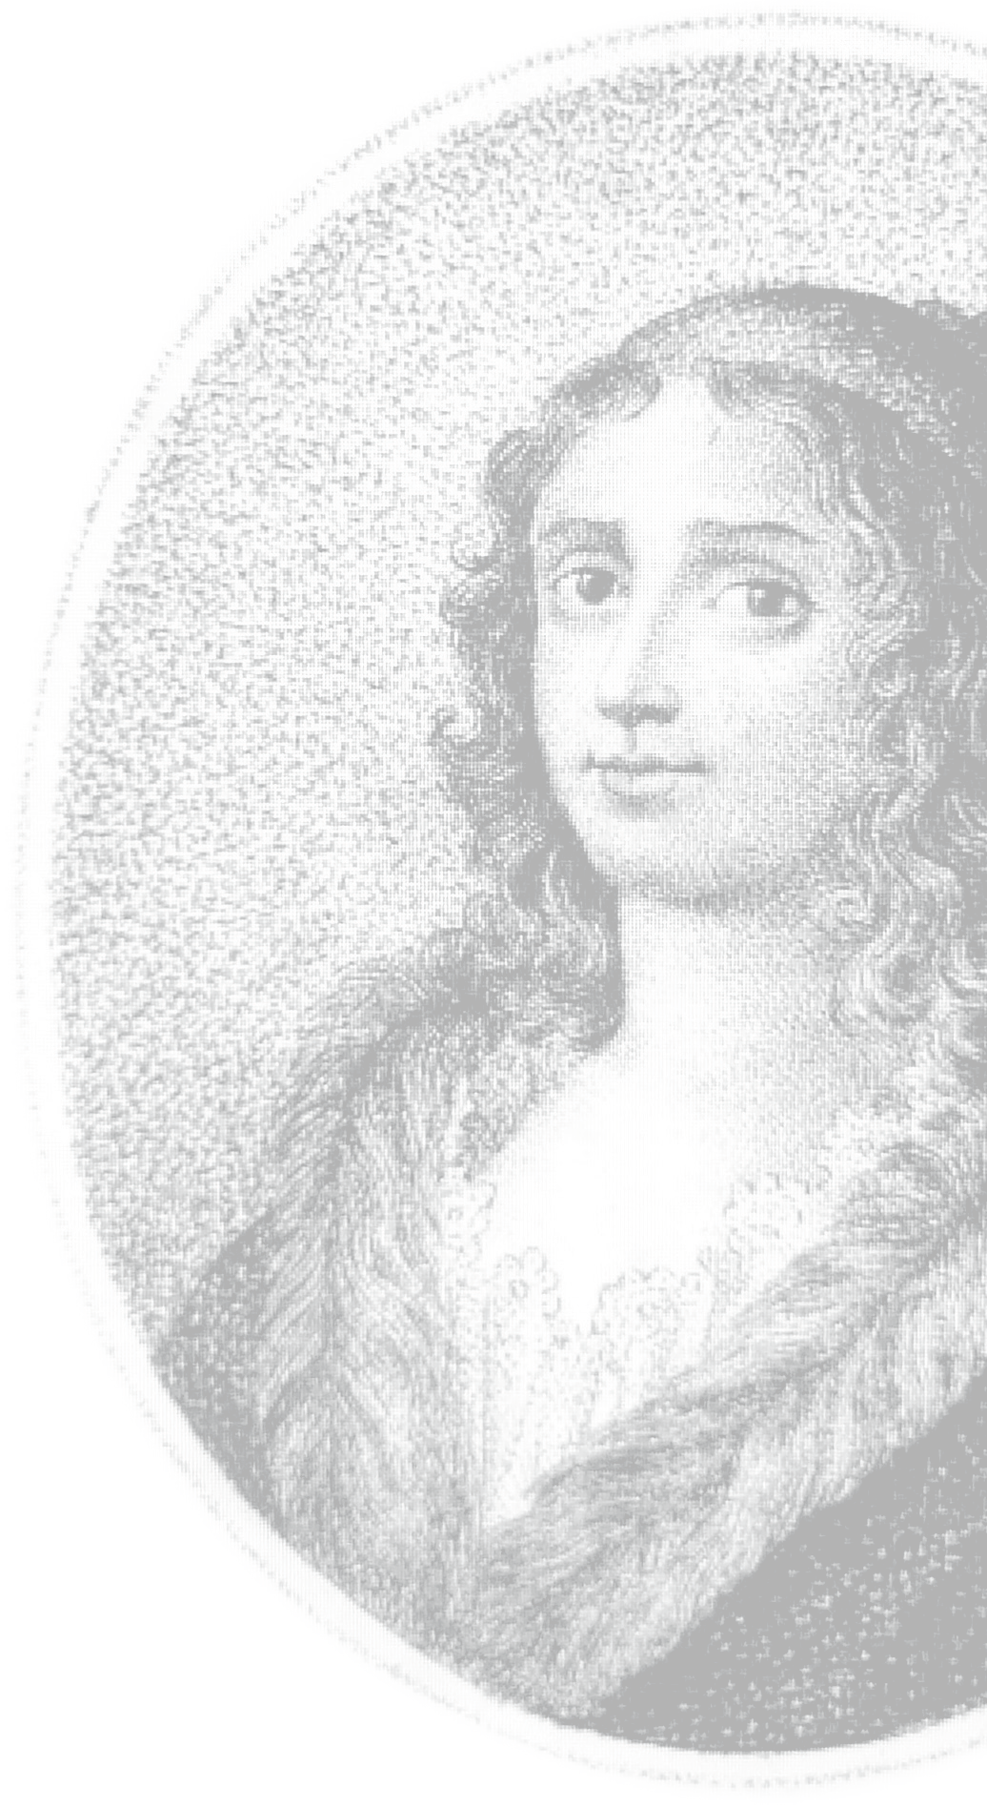
on Anna Maria van Schurman (1649-1655)

Schurmanniana Series no. IV

Provily Pers
Dedicated to Dr Otto Plassmann

In loving memory of my parents
J. van Beek and L. van Beek-Provily

‘Risen from the ashes’: Burned eulogies by Rotger zum Bergen on Anna Maria van Schurman (1649-1655)
Schurmanniana Series no. IV
© Pieta van Beek – Provily Press, Ridderkerk, 2022
Photographs (in the original Dutch publication): Pieta van Beek (p. 5, 6, 8, 9, 10, 25, 28, 30, 32, 40), Museum Martena (p. 10), Erik Heijerman (p. 39). The photographers of the remaining photographs are unknown.
Translated from the Dutch (‘Herrezen uit de as’; verbrande lofgeschriften van Rotger zum Bergen voor Anna Maria van Schurman (1649-1650, 2015) by Dineke Ehlers
Cover illustration: Anna Maria van Schurman, in: Christian August Vulpius, Pantheon berühmter und merkwürdiger Frauen. Dritter Teil. Leipzig, 1812.
See also www.annamariavanschurman.org
Contact details of author: p.vanbeek@uu.nl or pvb@sun.ac.za

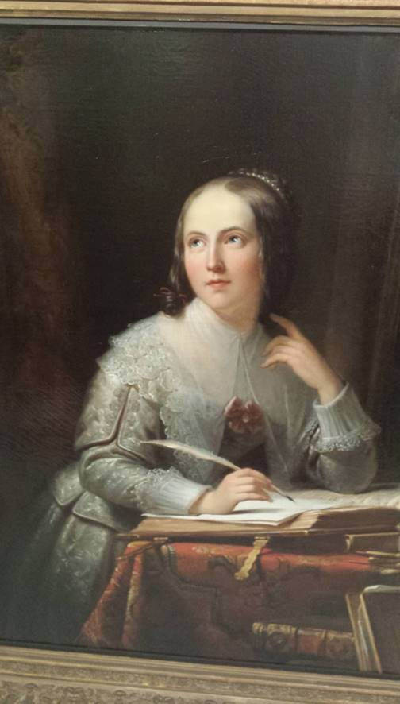
Anna Maria van Schurman, portrayed by Jan Adam Kruseman, 1846
University Museum Utrecht

Preface
In the Schurmanniana Series some (small) source publications about Anna Maria van Schurman will be published, in Dutch as well as in English. Over the past few years I have discovered much previously unknown and undiscovered material. Even though subsidies for philological publications have decreased substantially in recent times, it remains important that sources on and by Anna Maria van Schurman are translated, contextualised and published.
This fourth publication deals with four unknown writings in Latin, dating from 1649, 1650 and 1655, from the hand of Rotger zum Bergen from Riga, which he published separately in Königsberg (present-day Kaliningrad) in honour of Anna Maria van Schurman. During the disastrous destruction of this city in and after the Second World War, the texts were destroyed. But copies of the text had also reached Weimar, where they were unfortunately also lost in the fire which devoured the attic floor of the beautiful Duchess Anna Amalia Library in 2004. I was lucky to discover them in another place in Europe some years later. As a gesture of redress, I am publishing them here, also in translation with comments; even though I know that thorough research on the virtually unknown Rotger zum Bergen is still lacking. The publications from Königsberg also illustrate how wide the fame of Anna Maria van Schurman had spread in Europe. It also becomes clear from zum Bergens work Vita bonum fragile est that already in 1655, he was of the opinion that she had passed away. In addition, the writings bring new facts to the fore, among others on the visits by various queens to Van Schurman in Utrecht. As always, the short biography on Van Schurman contains some new information for the observant reader.
I owe a debt of gratitude to Dr Otto Plassmann, Dr Verena Demoed and Marleen Mulder for their assistance in the translation of the texts from Latin.
Houten, September 2022 (English translation)
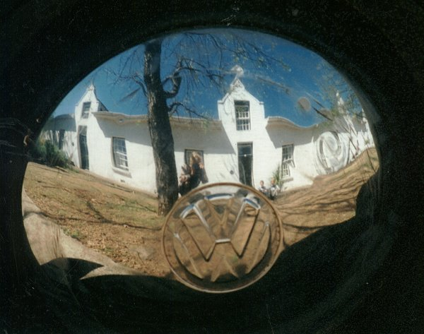
The little slave cottage in Hertestraat 29, Stellenbosch, South Africa, where the news of the library
fire first reached my ears


Fire in the Duchess Anna Amalia Library in Weimar, 2004.

‘Risen from the ashes’: Burned eulogies for Anna Maria van Schurman
When fire broke out in 2004 in the beautiful Duchess Anna Amelia Library in Weimar, and quite a number of precious works went up in flames, this news also reached the little slave cottage in Stellenbosch, South Africa, where I was living at the time. I was immediately distressed by the news, realising it was too late now to do some planned work in this library. Although I spent days and nights in libraries when visiting Europe for my research, I had not yet managed to visit this library, although I knew that the top floor of that library contained some unknown work by a writer who was known to have visited Anna Maria van Schurman, the first female university student and a very learned woman, namely Rotger zum Bergen from Riga. Schotel had written the following in his 19th-century monograph Anna Maria van Schurman:
Zelfs in het verre noorden werd haar naam met eerbied genoemd. Denemarken, Noorwegen en Zweden stichtten haar altaren en bewierookten haar als eene godin der letteren. Zij leeft in de geschriften van Thomas Bartholinus, Otto Sperlingius, Olaus Borrichius, Joh. Esbergius, hoogleraar te Upsal, Rotger zum Bergen, van Riga.
[Even in the far north her name was mentioned with reverence. Denmark, Norway and Sweden dedicated altars to her and praised her name to the skies as a goddess of literature. She lives in the writings of Thomas Bartholinus, Otto Sperlingius, Olaus Borrichius, Joh. Esbergius, professor in Uppsala, Rotger zum Bergen, from Riga.]
Most of zum Bergen’s writings are not known today or cannot be found. However, it was possible via other biographers such as Mollerus (1744) to obtain a taste of zum Bergen’s praise for her. He had written that she was the only specimen who combined all marvels in one learned person; a true miracle of her sex, but then without its shortcomings.
Schotel also wrote that Rotger zum Bergen had visited her and that she was alive in his writings:
Hoe groot de rij harer vrienden in Nederland ook was, nog aanzienlijker moet die in andere deelen van ons werelddeel geweest zijn. […] Van hare noordsche vrienden kunnen wij alleen Bartholinus en Rotger zum Bergen noemen. Hunne brieven zijn gelijk de hare verloren gegaan, maar hunne lofredenen op haar zijn tot ons gekomen.
[However large her circle of friends had been in the Netherlands, this circle probably was even greater in other parts of our continent. […] Of her northern friends we can only mention Bartholinus and Rotger zum Bergen. Their letters to her, just like hers to them, have been lost, but their eulogies have come to us.]
After permanently returning to Europe, I could do research to my heart’s content in European libraries, und unexpectedly I came across writings by Rotger zum Bergen; not only letters but also poems. As an act of redress for the libraries of Weimar and Königsberg (present-day Kaliningrad) I would like to figuratively rise these writings from the ashes by publishing them with a translation and commentary. This will have the concomitant benefit to direct our focus on the life of the unknown Rotger zum Bergen, born in Riga but later from Königsberg, his relationship with Van Schurman and the nature of his writings, resulting in the adaptation of Van Schurman’s biography on some points.
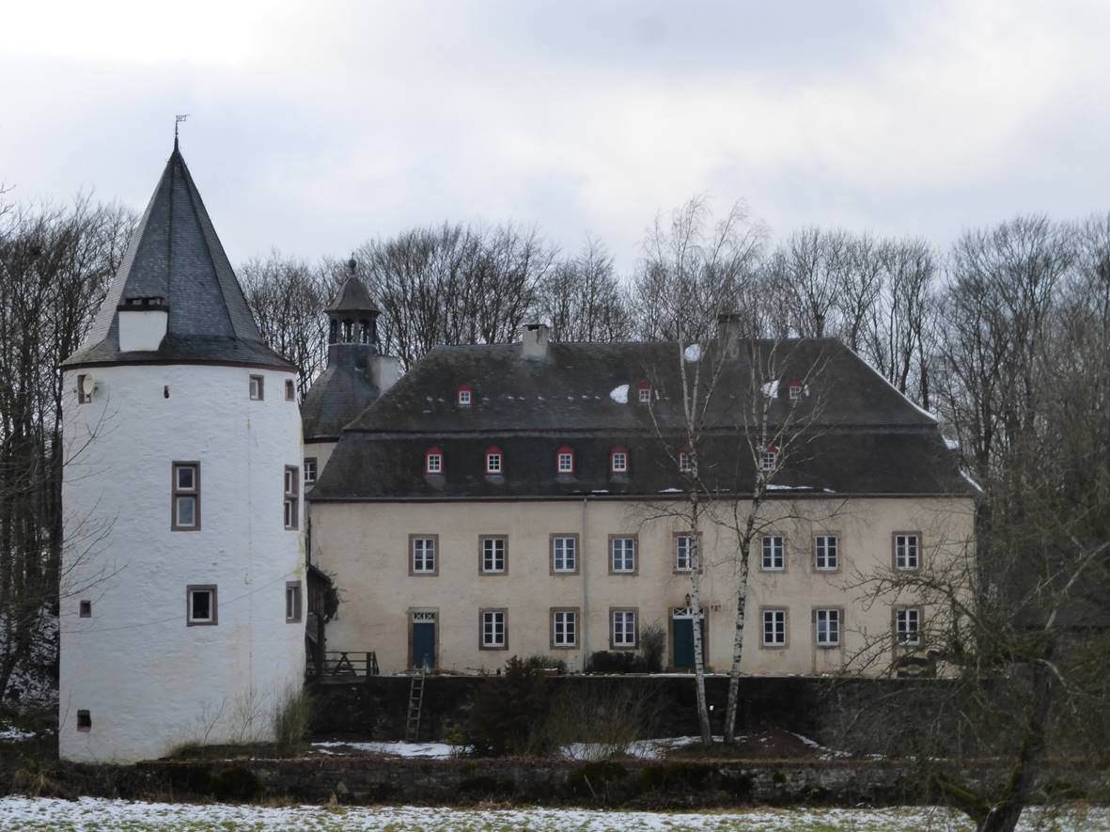
Maternal family castle at Dreiborn, near Schleiden in Germany

Anna Maria van Schurman (1607-1678)
Even today one can see, from the road leading to the castle in Dreiborn, the iron pennant with the Von Harff family crest swinging in the wind. But much of the castle’s former glory has disappeared. Anna Maria van Schurman, born in 1607 in Cologne as the only daugher between her brothers Hendrik Frederik, Johan Godschalk and Willem, lived in the castle for a few years together with her Protestant parents Frederik van Schurman and Eva von Harff who in 1610 fled the religious persecution in the Catholic city of Cologne. For some years the castle served its purpose as a safe haven for the family. It was in this dwelling that, together with her brothers, Anna Maria learnt to read, make music, and there she also learned the Heidelberg Catechism by heart and had her first spiritual experience, which she remembered for the rest of her life. Later in her life, in her autobiography, she would document this experience as follows:
Want onder andere schiet my in, dat als ik nauwlijks een meisje van vier jaaren was, by gelegentheit van dat ik met mijn dienstmaagt, die zulks bevolen was, eenige kruiden verzamelde, en op den oever van een beekje zat, en als ik door haar anmanen de antwoort op de eerste vrage van den Heidelbergsen Catechismus uit het hooft opzeide, op de woorden, dat ik niet mijns maar mijnes getrouwen Zaligmaakers Jesu Christi eigen ben, dat mijn herte met zulk een groote en aangename vreugt en een innig gevoelen van de liefde Christi is overgooten geworden, dat alle volgende jaaren de levende geheugenis van dien tijdblik noit hebben konnen uitwisschen.
[Among other things, I suddenly remember that when I was a girl of just four years old, I went with a maidservant, who was instructed to do so, to collect some herbs, and we sat down on the bank of a little stream. When asked to do so by her, I recited the answer to the first question of the Heidelberg Catechism by heart; on saying the words “That I am not my own, but belong to my faithful Saviour Jesus Christ” my heart started to overflow with such vast and agreeable joy and an intimate feeling of Christ’s love, that all the years coming thereafter have not been able to erase the memory of that moment in time.]
As of 1615 Anna Maria van Schurman would spend by far the largest part of her life on and around the Dom Square in Utrecht, initially on its western side above the remains of the Lofen palace, and as of 1629 on the eastern side of the Dom’s graveyard, now named Achter de Dom. She spent some time in Franeker (1623-1626), Cologne (1653-1654) and later in Amsterdam (1669-1670), Herford (1670-1672), Altona (1672-1675) and Wieuwerd (1675-1678), where she passed away. She read the Book of Martyrs when she was approximately eleven years old, and managed to convince her father, who personally tutored her older brothers in Latin, that she, although a girl, could and should also learn Latin, even though she would not be able to attend university and gain an important position in life. Her destination as a girl was to marry and have children. In countering the risk of her reading fictitious, classical-mythical and sometimes promiscuous texts when learning Latin, her father Frederik van Schurman found a solution by censoring her reading; she started out by mainly reading the Holy Scriptures, and some ‘safe’ writers such as Seneca. Learning Latin added wings to her education, especially since it was the language of communication within the learned European Republic of Letters. Aside from teaching her Latin, her father also asked her to promise on his deathbed in November 1623 to lead a celibate life and never marry. She made this promise and ever since she dedicated her whole life to religion, the arts and science, under the motto ‘my love has been crucified’. In 1636 she was already so famous for her learning that Professor Voetius – who was her minister as well as her neighbour – asked her to celebrate the establishment of the Utrecht University by writing a Latin poem on the occasion. This she did, but in this traditional Latin laudatory poem she also complained about the exclusion of women and pleaded for their admission. She herself received permission to attend lectures and thus she became the first female university student at the university.
By way of her studies in literature, philosophy, theology, philology and medicine she became the most learned woman of her time. She was proficient in at least fourteen languages (German, Dutch, French, English, Italian, Latin, Greek, Hebrew, Aramaic, Arabic, Syriac, Samaritan, Persian and Ethiopian). She wrote poems in various languages; her miniature works of art and her calligraphic multilingual specimen pages were sought after.
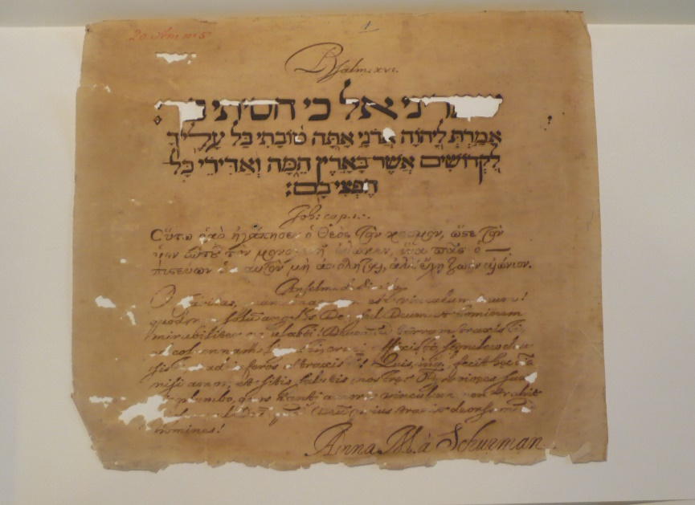
Multilingual sheet written by Anna Maria van Schurman, University of Amsterdam Library

In addition to the many Bibles she owned, she was also in the possession of a copy of the Qur’an in her home which she studied. The first Surah (chapter) in Arabic she wrote down in decorative script and with golden lettering on an old medieval decorative sheet, just as she had previously done with the Lord’s Prayer.
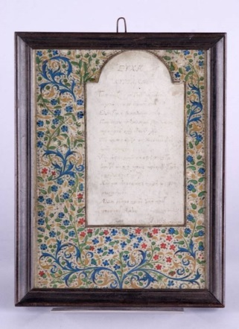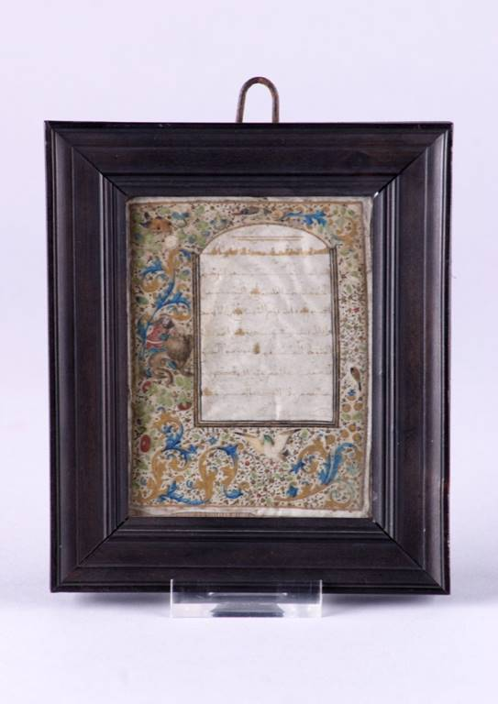
On the left the Lord’s Prayer in Greek; on the right the beginning of the Qur’an in Arabic. Museum Martena, Franeker
She published the Dissertatio de ingenii muliebries ad doctrinam et meliores Litteras aptitudine (1641) (a study on the capability and right of women to study), and joined the at the time prevailing international discussion on the end of human life with her essay De Vita Termino (1639). These two works, together with many of her other writing, were published in her main work Opuscula Hebraea Graeca Latina et Gallica, prosaica et metrica, a book which would be reprinted a number of times, not at least because it was listed on the Index Librorum Prohibitorum (the list of prohibited books of the Roman-Catholic church). Much of her work was also translated, not only during her lifetime but also in the centuries which followed. For example, her Dissertatio was translated into English as The Learned Maid (1659), in French as Question Celèbre; in 1730 in Paris, Mrs De Zoutelandt published parts of her correspondence on De Vitae Termino as well as the Vraaghbrief on the healing of the blind-born man in French under the title Lettres de la très fameuse Demoiselle ANNA-MARIE SCHURMANS, Academicienne de la Fameuse Université d’Utrect, and the poet laureate Dorothea Loeberia edited a reprint of her Opuscula Hebraea Graeca Latina et Gallica (Leipzig, 1749).
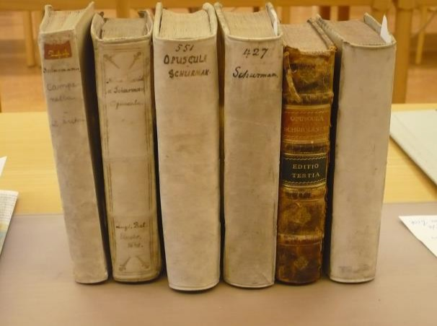
A row of copies of the Opuscula Hebraea Graeca Latina et Gallica in the university library of Uppsala, Sweden

Everyone agreed: si vir esset, had she been a man, she would have become a professor. Her fame spread all over Europa and this can also be seen from the many inscriptions in alba amicorum as well as from pictures, books, poems, portraits and laudatory writings (elogia) of which she was the subject or which were presented to her. A few examples: in Amsterdam, art dealer Clement de Jonghe sold her portrait in his gallery, and her portrait also graced the walls of his own house, probably the painting in which he himself had participated. Her self-portrait with the Utrecht Dom as its background was printed in Jacob Cats’ panegyric on her, and was thus redistributed with every reprint of this popular work. This even lasted to 1830 when the panegyric, translated into French, was published in a beautiful book on costumes worn in the Low Countries, illustrated by a picture of Van Schurman based on the picture published in Cats’ work. She is portrayed in flowery, colourful clothing with her shoes peeping out from under her costume.
The mayor of Hoorn, Jan van Foreest, sent her a copy of his work Hymen Auriacus (written and published in honour of the wedding of the Dutch prince William II with Mary Stuart (1641)); he referred to her in his neo-Latin poems as the ‘darling of Mother Nature’ and ‘the living Thalia’ (one of the Three Graces).
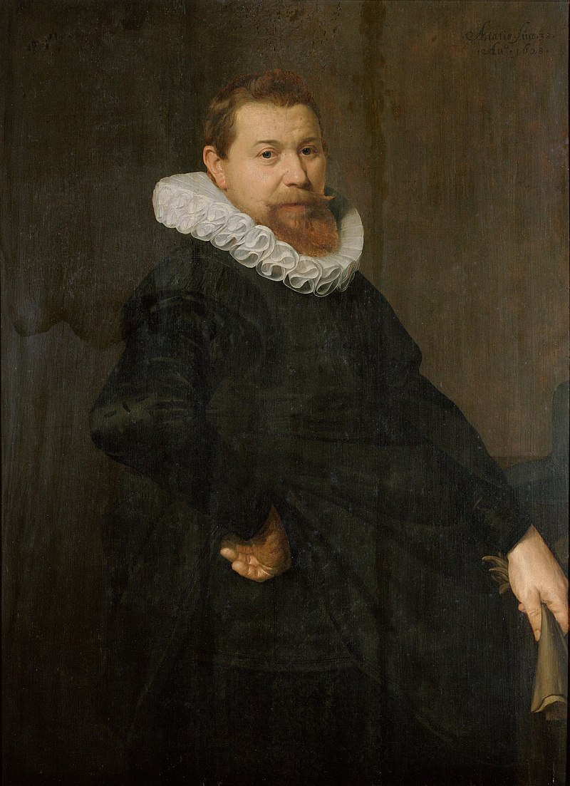
Jan van Foreest, the later mayor of Hoorn, portrayed in 1628
In Rome, Domenico Gilberto da Cesena published his Italian panegyric on her, La Fama Trionfante Panegyrico alla Bellissima, Castissima e Dottisima Signora ANNA MARIA SCHVRMAN (1642). In Utrecht, the French writer Des Hayons published a volume entitled Epigrammes consacrez à la vertu de Madamoiselle Anne Marie de Schurman (1649), and in Breslau (present-day Wrocław) Augustinus Wiseaus published a booklet with praise on the three most learned women of his century: De literaris virginibus tribus nostri saeculi (1643). According to him, these three women were Sophia-Anna Corbiniani, Anna Memorata and Anna Maria van Schurman. Rotger zum Bergen also published his eulogies on her, in Königsberg (see discussion below) in 1649, 1650 and 1655.

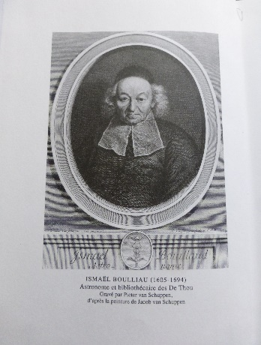
Anna Maria van Schurman received thousands of letters and visitors to her house Achter de Dom. Not only students, scholars, artists and pious people from Utrecht made their appearance, such as Arnoldus Buchelius, Gisbertus Voetius, Jodocus van Lodenstein, Justus van den Bogaard, Margaretha Borre van Amerongen, Marie du Moulin and Sara Nevius, but a varied parade from all over the Netherlands and Europe passed by: Jacob Cats, Constantijn Huygens, Johan van Beverwijck, Dorothy Moore, Daniel Heinsius, Jacobus Revius, Frederik Spanheim sr. and jr., René Descartes, Claudius Salmasius, Gerard van Honthorst, Crispijn van der Passe, Simonds D’Ewes, James Harrington, Thomas Browne, Archibald Hamilton, Georg Stiernhielm, Thomas Bartholinus, Philipp von Zesen, Martin Opitz, Daniel Caspar van Lohenstein, Justus Georg Schottel, Daniel Georg Morhoff, Paul Fleming and Christian Hoffmann von Hoffmannswaldau; furthermore members of the Dutch House of Orange (among others Frederik Hendrik, Amalia van Solms, William II, Mary Stuart), queens, such as the ‘Winter Queen’ Elizabeth Stuart, Christina of Sweden, Maria de Medici of France, Henrietta Maria of England, and princesses such as Elisabeth of the Palatinate, Maria Louise de Gonzaga (the future queen of Poland) and Duchess Anne de Geneviève carried her name and fame home and often recorded details of their visit in a report. The learned French astronomer and librarian Ismael Boulliau visited her in 1651, though not ‘sans peine’ (without difficulty). He wrote about her in letters to the Paris brothers Dupuy and to another learned woman, the astronomer Maria Cunitz, and referred to Van Schurman as ‘une damoizelle aussi sage et modeste qu’elle est scavante’ (a woman as wise and modest as she is learned). The list of visitors included Rotger zum Bergen.
Ismael Boulliau, astronomer and librarian in Paris
Anna Maria van Schurman temporarily returned to her city of birth, Cologne, for over a year (1653-1654), together with her brother Johan Godschalk and two aged aunts, Sibylle en Agnes von Harff, in order to proceed with a legal procedure to claim the return of a stolen property. On her return to Utrecht, she started to withdraw from, and increasingly utter criticism on, the Dutch Reformed Church. Wild rumours were flying around, among others that she had converted to Roman-Catholicism or even that she had passed away. Rotger zum Bergen even published an In memoriam for her in 1655 entitled Vita bonum fragile est [Life is a fragile possession). From time to time, she still received visitors and wrote a few ‘worldly’ poems in which God is not mentioned, for example her Dutch poem for the calligrapher Coppenol. She became more radical in her views after making the acquaintance of the passionate former Jesuit Jean de Labadie. Even so, the pious and learned world to which she belonged, especially her former teacher and mentor professor Gisbertus Voetius, was shocked to the core when in 1669 she sold her house in Utrecht as well as part of her library, and moved to the Lauriergracht in Amsterdam, to join Jean de Labadie and his followers who referred to themselves as ‘particuliere gereformeerde ofte sig reformerende kleine rechtsinnige huijskerke’ (private reformed (or reforming itself continuously), small, orthodox house church). Instead of praise and glorification she now was at the receiving end of libel and vicious criticism.
As a passionate member and co-leader of this ‘nomadic’ group, which had to move soon after to Germany, Denmark and Friesland, she defended this choice in her autobiography Eukleria seu meliores partis electio (‘Choosing the best part’); in this work she labelled much of her former work as vain and frivolous. In Altona she and the other followers sold the largest part of the Labadist book collection. In May 1678 she was buried in Wieuwerd in Friesland, possibly with the singing of the ‘Lied van de Geluksaligheid van een Christelyke DOOT’ (Hymn on the blessedness of a Christian death) from the volume Heylige Lofsangen, a volume she had personally translated from French:
Ze is als een lieve uitverkoren,
nu verloren
in den Oceaan van lust;
in genieting van het wesen,
daar na desen
alle haar begeerte rust.
[As a dear chosen one
she is now lost
in an Ocean of passion,
in enjoying the being
to which after this
all her desires come to rest.]

Rotger zum Bergen (1603-1661)
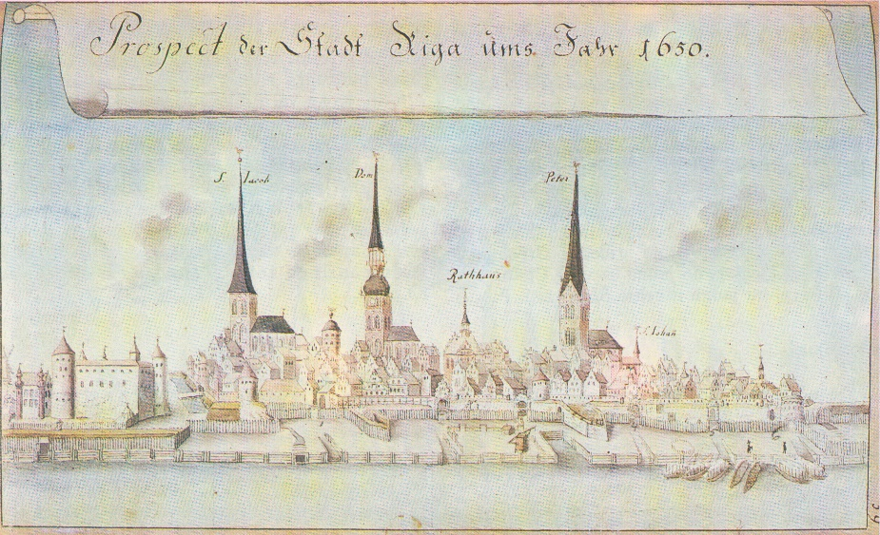
Rotger zum Bergen was born on 10 January 1603 in Riga; the son of Kaspar zum Bergen, royal Polish councillor, and Katharina von Tieffenbruch. After their death, Rotger went to study in Königsberg (1622) and Rostock (1623–1627); after completing his studies his customary Grand Tour led him to the Netherlands (Leiden, 1627 and again in 1632–1633), to England (Oxford, July 1628), France (Paris, 1629) and Germany (Strasbourg, 1629). On his journeys he met, among others, Hugo Grotius (Paris), Petrus Cunaeus (Leiden) and Matthias Bernegger (Straatsburg) and he kept in touch with them afterwards by way of correspondence. He finally settled in 1633 in Königsberg, the economic and cultural centre of East Prussia and the most north-eastern German city which was also under the sphere of influence of Poland and Sweden. In 1636 he was appointed secretary of the king of Poland and in 1656 as member of the Council of the Margraviate of Brandenburg. These seem to be honorary titles, not implying any real professional activity.
View of Riga, 1650
Rotger zum Bergen spent the major part of his life in the academic, noble and literary circles of Königsberg and its surroundings, among others with professors of the Albertina, the local university already famous at the time, which had been established in 1544. The city was pluriform in its religion; zum Bergen himself was a Lutheran. As a wealthy man and owner of the Brasneken estate in the vicinity of Königsberg, he acted as a Maecenas, among others for the poet Simon Dach. Just like Dach he was a member of the flourishing poetry society Kürbishütte, also known as Gesellschaft der Sterblichkeit Beflissener. The society met on the banks of the Pregel river and members often engaged in the singing of (spiritual) songs. Poets and musicians with whom he stood in close contact, were the poet Robert Roberthin; the organist of the Cathedral and composer Heinrich Alberti; Joachim Pastorius (a physician); Gottfried Zamel (a councillor from Elbing); Valentin Thilo jr., as well as the blind person Schönberger, to name but a few.

In a poem written by Simon Dach, we are allowed a glimpse into the life of Rotger zum Bergen: together with Dach he creates a song for a future bride, Ursula Thege:
Herr zum Bergen satzte sich,
Schlug das Instrument,
Und ich Geigte sechs Stück oder sieben,
Und indessen sahest du
Still und sitzam allem zu,
Den du wustest nichts von lieben.
[Mr zum Bergen sat down
and plucked the instrument
and I played six or seven pieces on the violin.
In the meantime, you were watching
everything in silence and modesty
since you knew nothing of love.]
Rotger zum Bergen passed away on 16 March 1661. J. Bolius delivered the funeral sermon, the Senate of the Academia Regiomontana celebrated his life, and he was buried in the cathedral of Königsberg.
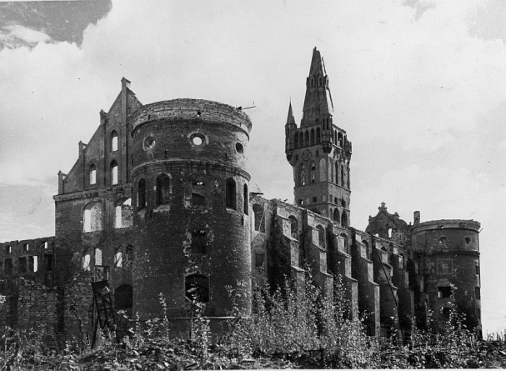
The ruins of the cathedral of Königsberg, present-day Kaliningrad

Work
Rotger zum Bergen wrote a large number of occasional poems and writings. Due to the horrific destruction of Königsberg during the Second World War by both the Allied and Russian forces, much of the work has been lost. Aside from the four publications on Van Schurman discussed here, recently some letters, songs and poems in Latin and German have surfaced; some in manuscript form, others published in print. From these we can deduct that he worked together with the musician Georg Neumark: he would provide the text and Neumark the music, as can be seen from the bridal dance for seven voices, written for the bridal couple Abraham Josaphath von Kreytzen and Juliana-Elisabeth Rauschke in 1650. This was printed also at the publishing house Johan Reussner in Königsberg, with the appropriate motto ‘Was Gott zusammenfuegt, sol der Mensch nicht scheiden’ (What therefore God hath joined together, let not man put asunder). His correspondence with Hugo Grotius and Matthias Bernegger he published personally. Whether he met, in the course of his journeys, other famous men in person, such as the Dutch ‘supreme ruler’ of the Republic of Letters Daniel Heinsius, the ‘Nestor’ Jacob Cats and others such as Johan van Beverwijck, Constantijn Huygens and Jacobus Crucius, we do not know, but he is conversant with their work. He also wrote poems on the Polish kings Władysław IV and his successor John II Casimir, who not only succeeded him as king but also as the husband of the dead king’s wife, Queen Marie Louise de Gonzaga. He wrote anagrams on Jacob Cats and as from 1645 he annually donated a study stipend to the value of a thousand Prussian guilders. Whether Rotger zum Bergen did have children? We do not know; we do know that he had a little dog close to his heart which was grieved for by him and his poet friends in fine epigrams, Das Leichenbegängsnis eines Hundes (1652). When his wife Margarethe zum Bergen (née König) passed away in 1649, he and his colleagues wrote a poem of consolation.
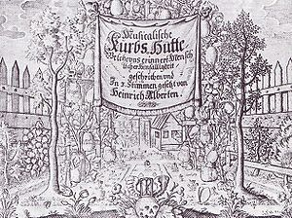
The Königsberg poetry society Die Kürbishütte
In addition to occasional poems and letters, some religious work of Rotger zum Bergen has also survived, for example Profluit ex Christi vulndere nostra salus. Oder Allerhand Discursen so zu nützlicher Betrachtung des bitteren Leidens und Sterbens unsers Herrn Jesu Christi. In his letters he also refers to a satirical work, which is still lost to this day.
His Latin is smooth and flowing, although his grammar constructions and style are sometimes out of the ordinary, for example his habit of forming uncommon compound words from adverbs, adjectives and nouns (mire-barbata, epistola non-epistola, vere-stuporem). Zum Bergen was well read, and cited various authors, some famous like Vergil, others lesser known, such as Matthiolus and Nicephorus, but with a preference for Plautus. A sense of humour was important for him, as becomes clear from this line from his hand ‘Koortwylen in Ehren, dat kan wol passeren’ (‘Entertainment with honour is allowed to take place’). One of his jokes was the following: ‘Een wedmann kumbt my verr gelyck een suer Citron / Hier tho soet Sucker ys een Junffer Ryck vnd Schoon’ (A bridegroom appears to me to be a sour lemon, but sweet sugar to this is a rich and beautiful maid).
In the introduction to this same occasional poem, he wrote with self-mockery on his knowledge of Latin:
Ick moet myn Latyn met vlyt thosamen schrapen!
Und sehn off ick kann ock up Latynsch wat maken.
A Thalamo vestro absint, quae cere-per-terebrent-brum
Et cunctus populus clamitet Amen.

[I have to scrape together my Latin with diligence
and see whether I am able to make something in Latin as well.
Let boring things which torment the brain stay away
and let the people call out: Amen.]

Part of his sense of humour was also to use pseudonyms or series of initials, for example RZB, Christanus Brasneken, R.Z.B.R.S.H.I.B, B.R.Z., Pascalnas Paraorum, C.M.A.M.B. or Zelus Beatus Recti.
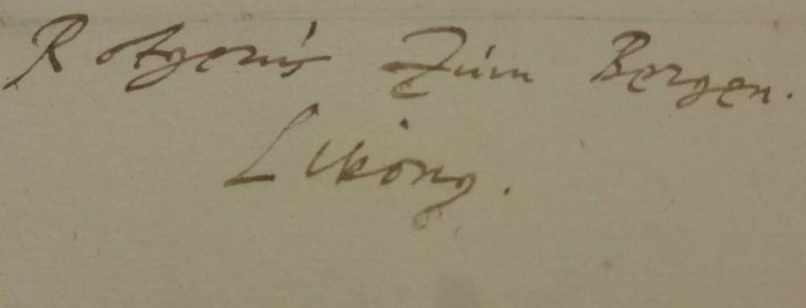
Signature of Rotger zum Bergen, Livonus

The content of Rotger zum Bergen’s eulogies on Anna Maria van Schurman
In 1649 and 1650 Rotger zum Bergen published three letters with poems, followed in 1655 by a far too early In memoriam (entitled Vita bonum fragile est) in honour of Anna Maria van Schurman (she died more than 20 years later, in 1678). Zum Bergen’s writings form part of the category elogia, laudatory writings. Before describing his work within the framework of elogia, I will first provide a short description of the content. The first long letter, which includes poems and has as its title epistola non-epistola, can be regarded as an attempt to introduce himself. He expresses the hope that she will reply to his letter with a letter at least as long. Hy had heard about her through publications, but also via her cousin Anna Margaretha van Schurman, who had recently settled in Königsberg. Zum Bergen praises Anna Maria in every possible way; she is the pinnacle of learning in women, yes, she is an extraordinary person. The trumpeters of her fame were Jacob Cats, Daniel Heinsius, Constantijn Huygens, Caspar Barlaeus, Jacobus Crucius and Willem Staackman. He praises her knowledge of languages and her books, especially the Opuscula Hebraea Graeca Latina et Gallica. He is not in a position to visit her, but he can visit her in writing. He wishes that she, as a dignified high queen Juno, will find a Jupiter to marry and will have children. Then he checks himself, what he is writing is too impertinent, but her courtesy will forgive him. She is the female monarch of all learning; that is the reason why she should continue to publish.

To his great disappointment he did not receive any reply at all. Notwithstanding this he writes and publishes a short second letter (epistola altera) in which he expresses the assumption that she is ill. He hopes for a speedy recovery of the maidenly learned woman, and hopes to receive a long letter in reply. She must know that she will not find a more passionate admirer on Prussian soil. He continues to prove this by adding some poems in which he sings her praises on her quick mind, places her name among the stars and calls her Apollo’s sweetheart.
Unfortunately, once again he does not receive a reply. However, he does not give up. He writes and publishes his short third letter, epistola tertia, in which he assumes again that she could not write back because she was recovering from her illness. He is still completely obsessed by her and continues to heap praise on her. She is so learned that she has enthralled Minerva herself, the goddess of wisdom.
Five years later he then unexpectedly publishes an In memoriam in honour of Van Schurman in a letter to his friend Joachim Pastorius, entitled Vita bonum fragile est (Life is a fragile possession). The title page has in its entirety been dedicated to Van Schurman’s assumed passing. The letter to Pastorius is unclear in places because it contains various obscure (at least to us today) references and abbreviations referring to persons belonging to a Königsberg circle of poets. It is too specific in respect of time and place for us. But the laudatory part with the poems for Anna Maria van Schurman speaks volumes. Zum Bergen asks his friend Pastorius to share his sorrow on the loss of this ‘unique example of supreme learnedness’. From the added epigrams which include a detailed description of the house Achter de Dom in Utrecht, it seems likely that zum Bergen has visited the place.

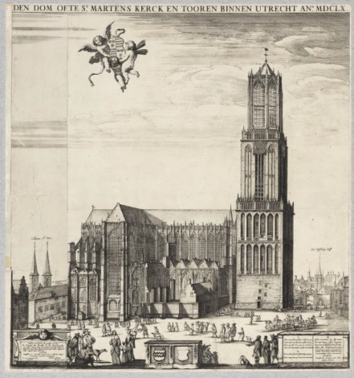
The ‘residence of Miss Schurmans’, behind the Dom, 1660

Laus (praise)
The writings on Anna Maria van Schurman by Rotger zum Bergen continue a long rhetoric tradition known as laus (praise). Of course, praise and compliments are part of the human condition, but it depends on the country, period of time and culture how praise is dealt with. In some countries complimenting or praising yourself is fairly acceptable and regarded as a sign that you believe in yourself; in others, such as the present-day Netherlands, this is just ‘not done’. Praise is thus not a monolithic concept, not even when you go back in time. In the Renaissance elogia, laudatory writings, were held in high regard because virtue was placed above all. All praise was directed at virtue (Lat. virtus); this is why a virtuous person or his or her work should be praised. In the Republic of Letters, it was customary to write laudatory poems and other writings for each other, often in Latin. But there was some reticence in religious circles: praise and glory were only due to God and not to fragile earthly beings. Van Schurman participated in the custom of writing and receiving elogia, but not wholeheartedly. For instance, she wrote to the bishop of the Greek Orthodox church in Ephesus, Meletios Pantogalus, that she welcomed praise when it was in line with the truth, but that he could keep his exaggerated praise to himself. This shows that she had a sufficient level of self-awareness to know that she deserved praise for her achievements and abilities. The at times exaggerated praise still found its way into her book Opuscula Hebraea Graeca Latina et Gallica in a separate section Elogia, albeit under protest. Why did she include these laudatory writings? Just like Voetius and others, she believed that this was necessary in order to outline and disseminate one’s own views, one’s own truth. In order to reach this goal, the exaggerated praise should be accepted as inevitable. Later in her life she would adjust this opinion and would even burn the elogia.
These elogia were strongly influenced by Classical authors, especially by Quintilian. They appeared in different forms; from hymns, encomia and laudatory speeches to occasional poetry in the form of epigrams, wedding poems and eulogies, headings and subheadings, and elegies. They were very popular among humanists and were written according to the rules of rhetoric. Panegyrics were laudatory speeches or poems on emperors, kings and other high-ranking persons; these were originally read in public. Nearly a hundred panegyric writings were written on the person of Queen Christina of Sweden alone, many of them recited and published. In the short biography on Van Schurman above, it already became clear that she inspired writers on a national and international level to write about her; many laudatory writings, including panegyrics, were written in her honour. Rotger zum Bergen wrote that a thousand pens could not describe her adequately.
According to Kajanto, the exemplificatio takes the central position in elogia. This refers to a form of rhetoric embellishment where a person is praised by comparing him or her to famous figures from mythology or history. Quintilian divides such exempla in two types: those comparisons based on similarity, or those based on contrast or distinction. In most comparisons Van Schurman is compared with similar figures from Antiquity (for instance, as a poetess, she was compared to the poetess Sappho), but often the comparison ends with a contrast: Van Schurman did not only have the light of nature as did Sappho, but she also possessed the light of truth shining from inside her. Zum Bergen, for example, compares her to Minerva in terms of wisdom, but Van Schurman outclasses Minerva because she even manages to shackle Minerva to her as a phantom.
A set component of the elogia is the use of hyperboles. Already on the title page of zum Bergen’s first letter the superlatives abound, for example ‘nobilissima’, ‘clarissima’ ‘doctissima’, ‘immortale ornamentum’ and ‘vere stuporem’, and this style does not decrease in the other parts of his eulogies.

Praise on learned women
Before examining the laudatory writings of Rotger zum Bergen any further, it must be kept in mind that elogia on learned women through the ages show much similarity. When one compares the laudatory writings on the Seymour sisters in England, the daughters Morel in France, Christina of Sweden, Elizabeth Weston from Prague, Anna Maria van Schurman and Sophia Elisabeth Brenner, it is clear that they are all called the tenth Muse, the fourth Grace, the new Sappho, etc. Often in the topoi surrounding learned women the following trio of attributes was praised in particular: their chastity, piousness and learnedness, and preferably their chastity and piousness should trump their learning. Learned men were not subjected to this requisite of chastity. Learned women were always compared to famous women from mythology and history, never to men. However, Queen Christina of Sweden sometimes was compared to Alexander the Great. Van Schurman was always compared to women; only once to male artists such as Lysippos, Apelles and Parrhasius. She was indeed often compared to gods and goddesses of Antiquity such as Apollo or Pallas Athene (Minerva), but such comparisons were purely allegoric, representing characteristics such as wisdom, powers (of nature), virtues and moral strength. However, in his poems zum Bergen makes Van Schurman into the sweetheart of Apollo, who would like to lay her down on a mattress to cure her of the disease of virginitas.

Praise for Van Schurman
In the elogia on Van Schurman the following topics are usually the object of praise: her noble descent, her learnedness, piousness, modesty, virginity and the city and/or country where she resided or came from. In respect of her noble descent, zum Bergen praises her, just like every other eulogist, as ‘nobilissima domina’ (most noble woman’); he does not elaborate on this any further. The usefulness of the word ‘nobilissima’ is that it can refer to her belonging to the nobility, but can also mean ‘famous’ or ‘excellent’. Her scholarship was praised as being self-evident, and this is why she is praised as the ‘glory of her sex’ or a ‘miracle of nature’. Crucius also lauds her knowledge of so many languages, of theology and philosophy. She was often compared to the goddess of wisdom, Pallas Athena or Minerva. The Muses Urania and Polymnia were the ones deemed to have taught her to sing as well as to play the zither or the lyre. In comparing her with other learned women, we often find a comparison with Aspasia of Athens, the Queen of Sheba or the Sybils – but Van Schurman surpasses them all. Rotger zum Bergen also regards her as a ‘miracle’ of learning.
People do not lie when they say that she does not have an intellect. They are right, since the virgin does not have intellect, she has intellect squared!
He also compares her to Minerva, the goddess of arts and science, but most often he compares her to the male god of arts and sciences, to Apollo. She is Apollo’s beloved; he longs for her and for her love, but, mitigating his comparison, it is love for her intellect. He does regard her as a human being, but an extraordinary one (‘Homo es ... non ordinarius, sed extra-ordinarius’). Rotger zum Bergen praises all publications written by Van Schurman: De Vitae Termino (1639), Dissertatio (1641) and the Opuscula (1648). He also compliments her on her proficiency in languages, adding Spanish to the list (for which there is not a shred of evidence), but omits to mention her knowledge of Aramaic, Persian, Samaritan and Ethiopian. He is conversant with the elogia on her person by the hand of Jacob Cats, Van Beverwijck, Staackman, Huygens and Barlaeus. Since she has been lauded by men of such stature, he cannot stay behind.

It is strange that he does not mention her piousness anywhere, let alone praise her for it, even though Van Schurman was renowned as the incarnation of female piousness and science. It is even stranger that he does not mention Voetius, to whom she was indebted for so much of her learning. This gives food for thought. In later years, Van Schurman herself would write that the panegyrists never praised her piousness. In respect of Rotger zum Bergen this was true, but it did not apply to all panegyrics written for her (for instance those by Crucius and others).
Although we must keep in mind that it was fashionable to praise modesty, one should be reminded that it was a virtue especially valued in women. Van Schurman participated in this custom, by often describing herself as less than she was in reality. Rotger zum Bergen does not mention her modesty explicitly, but he does spur her on to make known to the world any writings that might still lie around within the walls of her house.
Praise on poetry is also absent, but zum Bergen does refer in general to the Muses; yes, she is like the Nine Muses incorporated into one person. In one of his epigrams, he is more specific and has the virgin Van Schurman sing on the bank of a river. The river listens to her singing and stops its sloshing to be able to hear her singing more clearly.
Praise on her virginity is often encountered in elogia on Van Schurman. Indeed, a multitude of men, often not known for their own chastity or celibacy, regarded virginity as the highest virtue for a woman, especially for learned women. In the same vein women were often censured from an early age, for example Van Schurman’s father who kept her away from ‘promiscuous’ Classical writings, because exposing girls to such thoughts was unthinkable. Voetius was also of the opinion that only women leading a life of celibacy should strive for learning. In the elogia on Van Schurman, her virginity is often praised ad nauseum; others, such as Huygens and Barlaeus, mocked her and wrote bawdy jokes on this topic. Rotger zum Bergen advises her to marry as soon as possible! Just like Juno she should find a Jupiter quickly and have children in order to pass on her intellect. The possibility that this could be read as a marriage proposal in disguise I do not exclude, since his wife Margaretha zum Bergen had recently died, in 1649.
Praise on the city and country of her birth we find among others in the work of Smetius (‘Belgica Batava’) and Crucius (‘Virgo Batava’). That same kind of patriotic praise we also see in eulogies on other learned women. For example, Anna Memorata was praised as ‘Virgo Polona’, and Elisabeth Weston as ‘Virgo Angla’. Van Schurman was named the ‘ornament of the fatherland’ or ‘crown jewel of the city and university of Utrecht’. In the eulogy on her presumed death, zum Bergen praised her in a poem following the tradition of ‘viator’ poems, written by travellers who visit gravesites on their journey. In this poem, he imagines himself walking past the house of Van Schurman in Utrecht, and writes the following:
There are no other buildings making the city of Utrecht as famous as this house.
Finally, her beauty was often praised. Rotger zum Bergen combines her virtues as follows:
Hic specie Venus est sita, sed sermone Minerva,
Moribus exiimis Juno, lepore Charis.
[Here lies Venus in terms of beauty.
in her way of speaking, Minerva
for her excellent morals Juno
and for her charm one of the Graces.]

New information
The writings of Rotger zum Bergen in honour of Anna Maria van Schurman are also of interest because they bring new information to the fore; for example, on her until now recently unknown cousin Anna Margaretha from Utrecht, who came to live in Königsberg, or on the visit of queens, among them the Queen of Poland. Furthermore, Rotger zum Bergen provides a favourable reader response to the Opuscula Hebraea Graeca Latina et Gallica, prosaica et metrica by Van Schurman, this being the first known reaction from so far away.

Anna Margaretha van Schurman and Anna Maria van Schurman
From the first letter Rotger zum Bergen wrote to Anna Maria van Schurman in an attempt to introduce himself to her, it becomes clear that he was well informed. This was made possible because he met Anna Maria’s cousin Anna Margaretha van Schurman, via mutual friends, after she had come to live in Königsberg. His friend was Ambrosius Scala, an advocate, who in turn was friends with Sebastian Gross Pfersfelder, the husband of Anna Margaretha van Schurman. They had been married in Utrecht and had subsequently moved to Königsberg, where Sebastian Gross Pfersfelder had been appointed senior gamekeeper at the court. Just like her famous cousin, Anna Margaretha van Schurman had befriended the poet Philipp von Zesen, who had settled in the Netherlands as of 1642 but who had also lived in Königsberg and who knew Simon Dach. Both cousins Van Schurman appear in the work of von Zesen. Anna Margaretha wrote a little poem in French for him. In any case, she might have told him the story of the queen bride of Poland’s visit to her cousin Van Schurman.

Which queen: Maria Louise de Gonzaga or Christina of Sweden?
Rotger zum Bergen writes in some detail about the visit of the Polish Queen Maria Louise de Gonzaga to Anna Maria van Schurman (around Christmas 1645). Van Schurman sketched the queen’s portrait in such a lifelike fashion that the queen nearly swooned. When Van Schurman was examined by learned Jesuits in various languages and knew how to reply to every question put to her, it was suggested that she was assisted by a house spirit. Wittily but sharply, she replied that this would be the same spirit as the one through which she lived and breathed. The strange thing was that until now this story about the house spirit who would have assisted her, has always been described in connection with the visit by another queen, namely Queen Christina of Sweden. However, the latter visited van Schurman only in 1654, after she had abdicated the throne, and thus long after Rotger zum Bergen had published the letter describing the incident (1649). A possible reason could be that the person reporting the visit of the Queen of Poland, the historian Jean le Laboureur, had himself been one of the Jesuits interrogating Van Schurman, and that he was ashamed of being shown up by a learned Protestant woman, and had for that reason remained silent on the incident and had not mentioned it in his report.

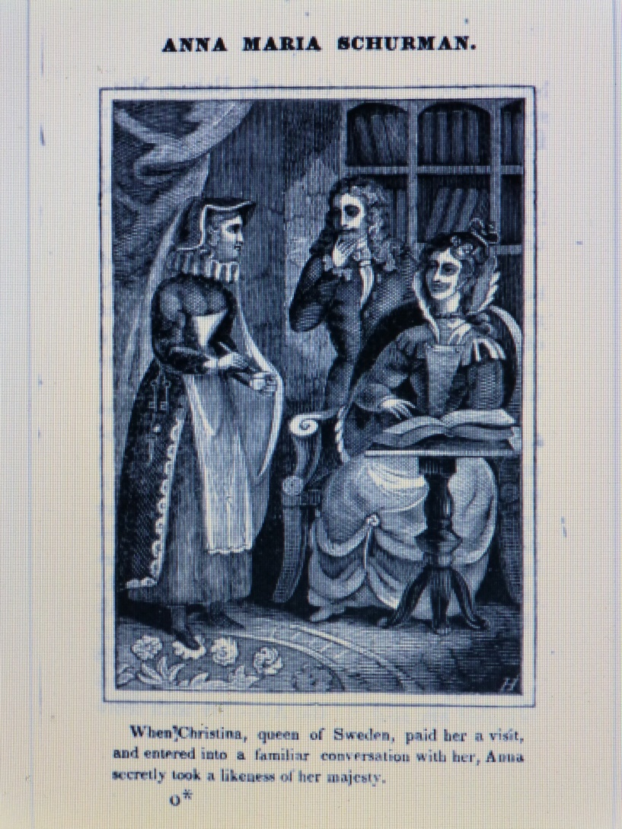
Queen Christina of Sweden visiting Van Schurman in her house in Utrecht.
Van Schurman is busy sketching her portrait.

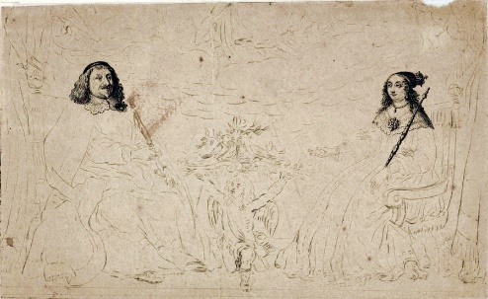
King Władysław IV and Queen Maria Louise de Gonzaga, drawn by Hondius

The first reader response to the Opuscula Hebraea Graeca Latina et Gallica
Rotger zum Bergen had studied several of Anna Maria van Schurman’s works: De Vita Termino 1639) and the Dissertatio (1641), but also one of the most recent publications at the time, the Opuscula Hebraea Graeca Latina et Gallica, which was published in August 1648 and which also contained the two previously published works mentioned here. The Opuscula was unique in the history of books; not only had it been written by a woman in Hebrew, Greek, Latin and French, with sprinklings of Syriac, Aramaic and Arabic, but it also dealt with complicated text sections from the Bible (for example 1 Corinthians 11, on the baptism of the dead), on the end of human life and on the cognitive abilities of women. It also contained poems in Latin as well as letters in Greek, Latin and Hebrew. From all these contributions, a parade of European learned persons (including a number of women) comes to the fore, including professors, queens, princesses and scholars whom she had befriended. In the front matter appeared her self-portrait and at the back, after the section elogia, a catalogue by Louis Jacob of elogia as well as an overview of her work. It constituted as it were a showcase of learning and artistry. The Leiden professor Frederik Spanheim had good reason to write the following in the preface:
Reader, in your hands you have a book unlike any other you have ever seen. As the only country [in the world], the Netherlands show you a young woman who is not only fluent in languages which normally are the exclusive domain of male scholars, but who is also experienced in nearly all branches of learning. She is the best endeavour of nature in the female sex.
The book was reprinted time and again and can be found in the collection of nearly every European library that matters. It becomes clear that at the time the book had also found its way to Königsberg. Zum Bergen refers to her elegant, recently published Opuscula in Greek, Latin, French and Hebrew, in poetry and prose, on (even for her) complex matters necessitating complex explanations. He states that every reader will not only experience her high level of learning, but will also not be able to stop talking about it. It is possible that he did not read De Vita Termino and the Dissertatio, which were included in the Opuscula, as previously published separate works, but did so as part of this book.

From praise to fame
According to Arnoud Visser, someone’s fame can be deducted from the person’s books, the eulogies, the works of art and the artefacts of material culture. When measuring Van Schurman’s legacy against this hallmark, her fame is undeniable. Her books were printed, reprinted and translated not only during her lifetime, but for centuries after her death. Her works of art and portraits were sought after and gained a place in shops, houses as well as on the wall of the Academy of Sciences in Italy; notwithstanding the avalanche of highly critical ‘vituperatio’ writings which were directed at her towards the end of her life. She was the first female university student; as a woman writer she published a book that became a bestseller and was distributed all over Europa, even though it had been written in Greek, Latin, Hebrew, French, Syriac, Aramaic and Arabic. A large number of men dedicated their books to her and wrote eulogies on her person.

Fame can also be deducted from the renown of her name. How often was she mentioned, and in which way? The number of references to her person and work reaches one thousand, only counting references during her life and shortly thereafter. Most writers were positively disposed towards her and praised her to the heavens, but if she made statements outside the accepted tenets of faith in her circle she was criticised, also on her views on the development of women. Sometimes she was mocked or taunted; for instance, the German poet Joachim Rachelius did so in his 8th ‘Satyre’: ‘um aller Welt Gewinn / Bringt ihr mir nimmermehr noch eine Schurmannin’ (For all the money in the world, please do not ever bring me another female Van Schurman).
Of course, her fame was helped along by the fact that the famous Dutch poet Jacob Cats had sung her praises extensively in his work and had also included her portrait. Aside from the Bible, his work was the most widely read in the Netherlands; in 1655 he had already sold 300 000 copies of his work. In this way she shared in his success. But apart from Cats, there were many more writers and visitors who praised her in their writings. Due to the great mobility of students, male scholars and other visitors, her fame crossed the European borders and her name was heard everywhere within the European Republic of Letters. In the case of Rotger zum Bergen, it was probably her cousin Anna Margaretha van Schurman who proclaimed her name and fame in Königsberg. Sometimes it was not even necessary to mention her name; one could suffice by mentioning the ‘Pallas of Utrecht’ or the ‘Dutch Virgin’. She received many books dedicated to her as a gift, among others from Voetius, Buchelius, Andreas Rivet, Johannes Cloppenburg and Johannes Leusden. She became a topic of discussion in the academic Dissertationes and disputations, for example those by Herbinius in 1657, and in 1650 by Isaac Leikherus. And this praise did not end when she died. For example, she still was the topic of discussion in the Dissertatio Historica De vita et meritis Annae Mariae Schurmanniae by Andres Wickelius, Petrus Hedengrahn and Hans Schönbeck in 1796 in Lund, Sweden. Even though much criticism was directed at her after her transition to Labadism, where former admirers wrote that she experienced ‘een wolk voor haar verstand’ (‘clouded judgement’), the general opinion on her remains positive until far into the twentieth century. All the great names within the Republic of Letters, including the handful of learned women in her network, trumpeted her name and fame. Rotger zum Bergen stands out because of the content and publication of his four booklets as well as the considerable distance he and his writings covered from Königsberg to Utrecht and vice versa.
One can also gain name and fame through association. Thus we see Van Schurman personally initiating contact with Andreas Rivet, the famous Leiden professor and educator of Prince William II. She was looking for a soundboard in discussing the cognitive abilities of women and because she wanted to sharpen her mind. Whether this can be regarded as an early example of self-fashioning since he was such a famous scholar? In my opinion it was rather her thirst for knowledge and insight, which was so much larger than her desire for fame and honour.
Her fame can also be seen from the portraits, monuments and sacred places where she lived and died. The Utrecht house Achter de Dom had already become a ‘must’ for visitors during her lifetime. The house was pictured on a map of the Dom church, dating from 1660, with the accompanying text on the map ‘De Wooningh van juffr. Schurmans’ (Miss Van Schurman’s residence). Rotger zum Bergen also must have visited her here, probably between 1650 and 1653, in any case before her temporary move to Cologne. She has been portrayed and has been the subject of poems by famous painters and writers of the seventeenth century, and her fame continues to this day. Streets have been named after her, and a special tower bell was cast in her honour which is known as ‘Klokke Anna’ and is hanging in the bell tower of the Academy Building of the University of Utrecht. Her last resting place in Wieuwerd was not visited often directly after her death in 1678, but has since 1765 become a tourist attraction when mummified corpses were found in the local Wieuwerd church.

Reaction
How did Van Schurman react to the eulogies written by zum Bergen? As far as we know, she did not react at all. Was this because of her wariness for the elaborate and excessive level of praise? Inability because she really was seriously ill? But during this same period of time, she did write to others. Was she revulsed by his at times lascivious remarks? Did she interpret his correspondence as a marriage proposal in disguise? In any case, she did not take the booklets with her from Utrecht to Amsterdam or even further on her journeys, since they are not listed in the catalogue of the Labadist library when their books were sold in 1673 in Altona. It is highly probable that she burned them. She had started to hate the laudatory writings on her person. In her autobiography she explained herself in this regard:
dat ik my (hoewel een zeker verborgen grond van mijn gewisse my dikwijls tegenriep) onder schijn van eenige deugt of pligt, of van een gemein goet der Geleertheit, tot dat Schoutonneel van een doorlugtige naam, waarvan men zig daar na seer beswaarlyk ontslaan kan, al voet voor voet heb laten opleiden, en dat ik, ik weet niet door wat onbedagtsaamheid of verblinding, stoffe of gelegentheit gegeven heb tot de afgoderye der geleertheyt, aan welke zig schuldig maken, alle liefhebbers der ydele eere, of (gelyk iemand niet ’t onregt gezegt heeft) de leugenagtige Lofredenaars, welke zig door onderlinge loftuiterye betooverende, zig tot Regte Eer-dieren veranderen; aan welke verre-gaande zonde ik my door de uitbasuiners van mijn uitmatigen lof so ver schuldig bevinde, als wanneer men my (een sterffelijke mensje, en wormtje der aarde en die ik om mijn menigvuldige zonden tegens den hemel, en so wel om de overërfde als dadelijke ongelovigheit de eeuwige ketenen en kerker der duisternis weerdig ben) ten hemel verhief, en my niet alleen seer reukeloos in den rang van Heidensche Goden stelde, maar ook als men my met de eigenschappen van den waaragtigen God stelde, maar ook als men my met de eigenschappen van den waaragtigen God, als daar is de Alwetenheit, en ik weet niet met wat al voor hatelijke eertijtelen godslasterlijk overlied: dat ik my nergens met behoorlijke kragt, of door eenig openbaar tegen-betoog of verantwoording tegen haar onsinnigheit, of zal ik zeggen godloosheit, verzet hebt, ‘twelke dan tegenwoordig als met verfoejing van mijn pligtverzuim gehouden ben te doen.
En daarom wederroep ik op dese plaatse, voor de Sonne, (na het voorbeelt van Augustinus dien opregten Outvader) alle mijne Schriften, die na zulken lossigheit van mijn gemoed of na dien ydelen en wereltsen geest rieken; nogh ik kenze niet langer voor de mijne: daarom schuive ik verre van my af en verwerpe, als met mijn belijdenis en gelegentheit niet overëenkomende, op eenmaal, alle Schriften van andere, en voornamelijk die Lofvaarzen, die met deze ydele eere, of met dat teiken der godloosheit gebrandmerkt zijn.
[that I allowed myself to be led, one step after another, under the pretext of any virtue or duty, or from a common cause of learnedness, to that showground of an illustrious name, from which it is so difficult to escape (although a certain hidden ground of my conscience often protested against this),
and that I, I do not know by which thoughtlessness or blindness, have given cause or opportunity for the idolatry of learnedness, of which are guilty all those who love idle honours, or, as someone did say not unwarranted, those deceitful singers of praise who, charming each other by mutual choruses of praise, change into true animals of honour.

I find myself guilty of this great sin to such an extent that the trumpeters of my praise lifted me to heaven; me, a mortal being, a worm of the earth, who is only worthy of eternal chains and the dungeon of darkness because of my many sins against heaven as well as inherited and factual lack of faith; and who without any qualms not only placed me within the range of heathen gods, but also attributed to me characteristics of the true God, such as omniscience, and overloaded me blasphemously with I do not know how many more hateful titles of honour.
That I did not at any time resist their absurdity, or shall I rather call it ungodliness, with sufficient power, or by any public contra-argument or sense of accountability, whereby I am now under an obligation to do so, in order to rectify this neglect of my duty.
Therefore, I recall in this writing, before the sun (following the example of Augustine, that true Church Father) all my writings which smell of such loose morals or of such vanity and worldly spirit, nor do I acknowledge them as being my work.
Henceforth I push away far from myself, and reject once and for all, all writings by others which are not in line with my confession and conviction, and especially those laudatory poems who are marked with signs of such frivolous honour, or with signs of ungodliness.
When writing this part of her autobiography, the laudatory writings by Rotger zum Bergen must have come to mind. It is a twist of fate that ten years after Rotger zum Bergen’s death, another laudatory poet in Königsberg rose up: Martin Kempe, historian of the Margraviate of Brandenburg. In spite of the fact that during this time Van Schurman was subjected to strong criticism, he still praises her as ‘Der Wissenschaften tieffes Meer’ (‘The deep sea of sciences’), and writes the following:
Kunst-Orackel, Schmuck der Welt
Weisheits-Fackel, Tugend Sonne,
Zeiten Wunder, Musen Wonnen
Gottes Schrein und Gaben-Zelt.

[Oracle of art, jewel of the world
torch of wisdom, the sun’s virtue
miracle of our time, delight of the muses
shrine of God and canopy of talent.]

Nachleben
Königsberg was known in earlier times as a rich city of books, and rightly so if one looks at the four attractive printed publications Rotger zum Bergen wrote on Anna Maria van Schurman. This can also be seen from his volume containing all kinds of occasional writing which is held in the Preussische Samlungen of the Staatsbibliothek in Berlin. Due to the fact that these works were distributed all over Europe, the booklets survived elsewhere in Europa notwithstanding the disastrous destruction of Königsberg in wartime. Even the tragic fire in the Weimar library of 2004 could not prevent the booklets to figuratively rise from the ashes again, thanks to copies that survived in Amsterdam and Berlin.
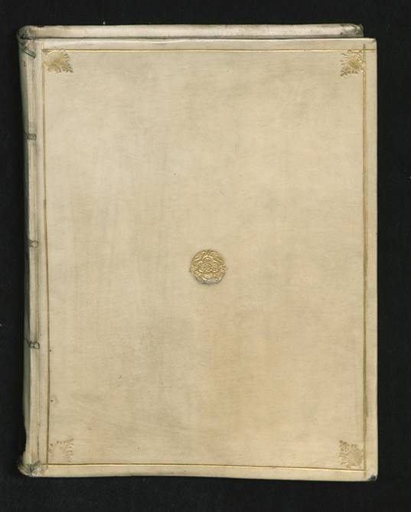
Volume containing, among other work, the Vita bonum fragile est by Rotger zum Bergen. Berlin, Staatsbibliothek

Translations with commentary
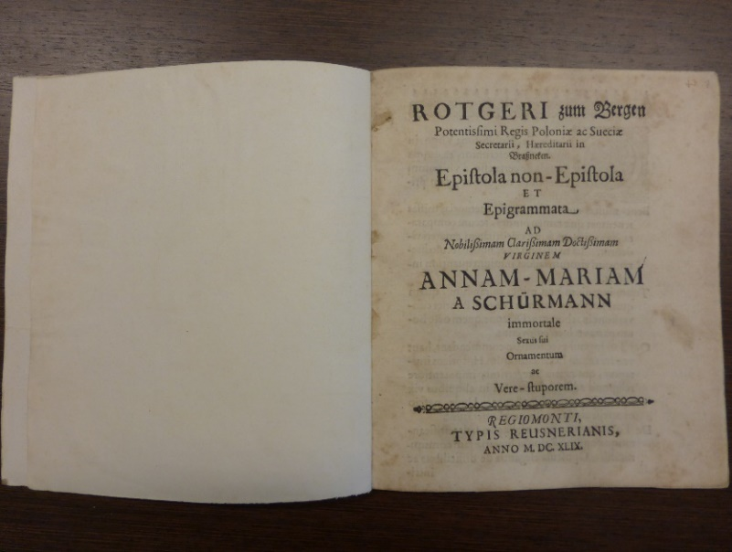

Epistola non-Epistola / First letter
A letter that is not a real letter from Rotgerus zum Bergen, secretary of the very mighty King of Poland and Sweden, feudal baron of Brasneken, as well as epigrams on the very noble, famous and learned virgin Anna Maria van Schurman, the true miracle and immortal ornament of her sex. Königsberg, printed by Reusner, 1649.
Very noble virgin, for some time now I have heard from without exception truly authoritative men that everything said about you in public is clear and true. There are many learned women who have earned a place in history books, but in comparison with you, they do not seem to deserve but a small grain of their name and fame. In the same way in which you make the utterances of praise directed at them seem lacklustre, this also applies to the learned men of our age. Your intellect is not less worthy of praise than the story told by Nicephorus about how Gregorius Pontius changed into a tree, or into a dragon which could not be moved from its place even though a team of eight oxen was used. Those extolling the magnitude of your intellect do not follow the older church historians who – even though they may be quite honourable in other cases – allow their writings, by an excessive notion of religion, to teem with errors which can scarcely be tolerated. By doing so they conveyed many despicable errors of fact on the saints.
That all the information conveyed about you are not lies, is evident from all that you contributed to the Republic of Letters. Your elegant and recently published (against your will) work Opuscula Hebraea Graeca Latina et Gallica contains complicated (even for you) matters that need complicated explanations, which do not only elicit the acclaim of everyone on your greater learning, but forces them to acknowledge this. Oh, may your other writings to the advantage of mere mortals be published as well; writings you are guarding, to the vexation of the Muses, deep within the sanctuary of Vesta, with a not very forthcoming guardian. Continue to plant trees that will make forthcoming generations happy. The fruits of your intellect, which is clearly male and not female, will continue to exist. Once upon a time an author published a discourse in which he did his utmost to prove, not in earnest but as an exercise to train the mind, that the non-warlike sex [women] are not humans. You are indeed not a war-mongering person, in any case not with an axe, but with the pen. Let someone say this about you but then based on quite a different consideration: namely because you know far more than the average person.
Very noble virgin, you are not an ordinary person but an extraordinary one. You are aware of and know by heart the way in which Italians call people ‘common’ or ordinary, even including doctors, thereby referring to the kind of people in whom everything is peasant-like, who do not show anything extraordinary or transcend the level of the rabble. Although Latin writers of later times, contrary to the oldest writers, always interpret the word ‘ordinary’ in the most positive way, thereby ennobling its negative meaning. You are fortunate, widely famous noblewoman, to have that famous Dutch nestor, a man who cannot be named but with the greatest praise, Jacob Cats, as a herald and describer of your virtues. In this respect I am silently ignoring Daniel Heinsius, sole ruler of the Republic of Letters, as well as Huygens, Barlaeus, Crucius and Staeckmannus, and other men mainly for their erudition which is far from ordinary.
Who would not, among innumerable other things, be surprised by what Anna Margaretha van Schurman, the most amiable wife of the excellent man, Mr Sebastian von Grosspfersfelder, told to the competent man Mr Ambrosius Scala, highly meritorious advocate of the electoral court of law?
Encouraged by the fame of your name, she [Maria Louise de Gonzaga], when she still was a bride married by proxy, visited you, Schurmanna, in the Netherlands. In your study you sketched, off the cuff, with your expert pen on a sheet of paper, a portrait of the exalted (at present) wife of our king, after you had observed her intently with your eyes for some time, and in such a way that our gentle queen was nearly beyond herself with enthusiasm, because your highly skilful hand had portrayed her so beautifully. The Jesuit brothers, very perspicacious men, who accompanied the royal fiancée on her visit, entered into a discussion with you on matters of great importance. They could scarcely bear the sun of your judgment in the way you replied to their questions, and thus they suggested that you were helped by a house spirit. Wittily but sharply, you replied to his that indeed you had one; the same one through which you breathed.
Philosophers who state that women, just like men, are fully capable in whatever subtleties and in all branches of science insofar as more diligent attention is given to their education, do not ruin their fame or destroy their own esteem at all. Such matters, very noble virgin, you have explained some years earlier with great acumen and in an agreeable way for the common good and in the public interest. Every scholar can deduct easily from this very learned discourse how far the full host of Muses has settled in full confidence in your mind. Your flaming and passionate reply to the famous Mr Beverovicius [Van Beverwijck] about that (in the words of Plautus, the king of jokes) most unfathomable matter, namely whether the end of human life or death could be moved forward – who would not read that at present but with the greatest admiration; who would not above all utterances of praise characterise this as true when he attempts to give an opinion on this without hatred?
More than all European women together you know the Oriental languages as well as the Occidental languages in all their peculiarities, to the amazement of all. Oh, three times above all others blessed [are those] who see you, speak to you; you, I say, very excellent virgin, in a unanimous poem of praise coming from the scholarly world as a whole.
Since I cannot come to you personally, I am glad, so to say, to be able to visit by way of a winged writing pen. It is the absolute truth that Jacob Martin from Paris has to say about you: One world is not sufficient to contain the fame of Van Schurman.
But I will stop, very noble virgin, to burden the reticence of your face too heavily by directing even more praise at your person, although such praise would not have been invented or untrue. May it not irritate you that in praising you the shimmering ivory becomes blotchy, and noon itself is covered in a thick mist. You need to be softly told, very famous virgin, that those who do not seek the showground, are all the more placed on it.
But allow me to add one last thing. Oh, may God infuse you with the longing to bind your right hand with the bonds of marriage to a certain Jupiter, as a dignified Juno. In this way your very own progeny would soothe and mitigate your very bitter demise from this life – oh, may this day still be far in the future!
But where is this leading us? Please forgive me, very learned virging, for our somewhat candid interview with you by way of letters. We do not despair to be easily forgiven by you, since you are so civilised, for this all to great boldness. May you not despise the attempt of our Muse, whatever its quality might be, nor disapprove of the dessert of our poetry. People who do not have hares, oysters or thrushes to serve, have to serve onions, pork lard, thick oatmeal porridge and cheeses in any form from all over the world.
Please stay healthy for a long time; that is my wish for you from the bottom of my heart. Very noble virgin, in begging you for a reply, we also promise you one in good faith. You should not interpret incorrectly our long-windedness; our innate love for you instructed us to broaden the laws of writing letters.

Epigrams on the very noble Anna Maria van Schurman
I
I will summarise the acclaim for Anna Schurman in one line of verse;
Rightfully, she does not have to stand back for anyone else’s intellect.

Another
II
People do not lie when they say that she does not have an intellect.
They are right, since the virgin does not have intellect, she has intellect squared!

On the illness of Anna Maria van Schurman, whose fame also disturbs the Helicon of this place.

The author to Phoebus
Do not refuse, Phoebus, to tell me the reasons
why false tears are falling from your eyes.

Phoebus replies to the author
The virgin Van Schurman is tormented by a grievous illness
That is why tears are flowing from both my eyes
Oh, that my virgin would be cured soon from this affliction,
because only then I will be able to breathe again with relief.

IV.
The virgin shows herself as the Nine Muses in our time
O virgin who has to be honoured by learned men.

Another

V
Someone who starts admiring you, has never before admired adequately.
Even Maro cannot sing your praises conclusively.

VI
Phoebus names this maiden his own unique beloved and sweetness
I beg you, devout virgin, to receive me in your pleasant arms,
I am completely exhausted by the love for your intellect.
Take care to continue your work to enhance our kingdom with your writing
and let your favour towards me be without limitation.

For the very noble Anna Maria van Schurman, unique example of everything admirable in a learned person, and an absolute miracle of her sex, but without any shortcomings.
Spontaneously and with pleasure this was made by Rotger zum Bergen, royal secretary, feudal baron at Brasneken.
This is all for now.

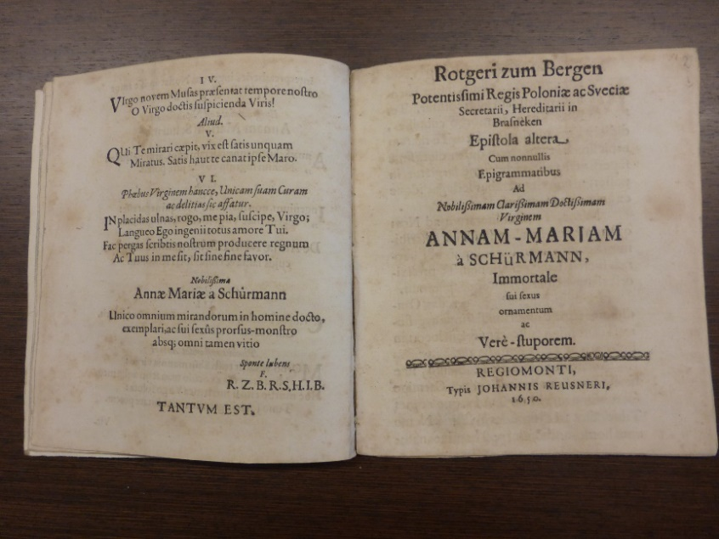
Epistola altera / Second letter
Second letter by Rotger zum Bergen, secretary of the very mighty King of Poland and Sweden, feudal baron of Brasneken. With some epigrams on the very noble, famous and learned virgin Anna Maria van Schurman, the immortal ornament of her sex and the true miracle. Königsberg, published by Johannes Reusner, 1650.
Be greeted, very famous virgin. By leaving out the preface I come directly to the point in a Spartan way. I have been informed by trustworthy people that you, very noble maiden, have been taken down by illness. May God determine that you, being such a great delight to the literary world, will stay alive for as long as possible, and may He grant you in his mercy that in future you are not just stretching out your life, but live truly, and that from the driving force of your soul.
I am surprised that no letters from your hand have reached me; we will attribute this delay to your being ill. As soon as you will have recovered from the symptoms that are still present, we hope from our heart that this delay will be redeemed by an even longer letter from your hand.
Very noble virgin, you have to believe that nowhere you will find truer admirers of your name, or persons more averse to pretention, than those brought forth from Prussian soil.
A love potion, but without any medicine, without healing herbs, without the spell of a brutal woman mixing poison – such is your excellent mind, with which you have bound to you all scholars so intimately.
No other person has been as kind to another person like you have been to the order of literature lovers, and I wish from my heart that you will remain its ornament for as long as possible.
The better part of the Roman people (as told in the ancient historical tale) came to glorify the joint consuls Brutus and Valerius, by performing an annual tribute of mourning, because they had defended public liberty according to their conscience.
No lesser tribute is due to you by scholars for reason of the most excellent gifts of your intellect after your death (may this day not be coming anytime soon!).
Before closing I just want to add the following. The philosopher Secundus owned a parrot that was carefully taught by him these words which the animal repeated without fail: One should do justice to a philosopher. You, very famous virgin, should do further justice to Anna Maria van Schurman, in other words, you should promote the immortality of your name in writings.
You might recently have read my biting work Menippus, although the father of Schlukerus, the son-in-law of Knodostus, the father-in-law of Potinus, the brother of Grobianus and all other comrades who are true slaves of drunkenness, would bear that with difficulty. They are afraid even of the shadow of this satirical text because of their spiritual scabbiness. Farewell, very famous virgin, and please count me as one of the truest admirers of your talents.
Trio of epigrams
on the very famous virgin Anna Maria van Schurman
I.
Unlike any other human you donate the amazing gifts of your mind to the world.
You write words that sing the praise of the incisive mind.
Furthermore, you have to dedicate yourself to the Godly Muses; in this way
Fama will transport your name to the stars by way of high-sounding trumpets.

II.
The divine Apollo to his beloved Schurman
Whatever I do, the image of the nymph Schurman
haunts my spirit. Loving care which delights me.
Should I see her face-to-face, I would really be totally
reduced to ashes, when there is not enough water.

The author to Van Schurman
The wonder of the world, the virgin Schurman, was singing songs at the bank of a softly flowing water.
As the river heard the goddess sing, it stopped sloshing to hear the singing.

Highly committed to your fame, I remain Rotger zum Bergen, secretary of the king, feudal baron of Brasneken

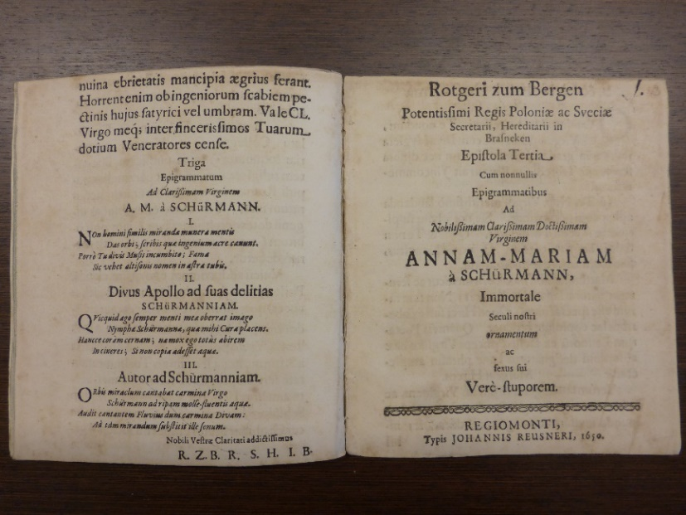
Epistola Tertia / Third letter
Third letter of Rotger zum Bergen, secretary of the very mighty King of Poland and Sweden, feudal baron of Brasneken, accompanied by some epigrams on the very noble, famous and learned virgin Anna Maria van Schurman, the immortal ornament and true miracle of her sex. Königsberg, printed by Reusnerianus, in the year 1650.
Be greeted, very noble, famous, learned Virgin! Since I have been informed that you, very famous virgin, have not yet returned in the fullest confidence in the good graces of the divine Hygieia, I will be brief and will not burden you with an extensive letter (as Plautus says).
We are still totally engaged, very noble virgin, by the justified praise heaped on you. The honourable virtues of your mind keep recommending this to us. And I trust you will not experience it as being negative. Whatever is discussed here, is dealt with without resorting to blind love and bias.
Matthiolus, a rather well-known physician and very meritorious researcher of nature, states that it is not uncommon for male goats to produce overflowing quantities of milk from their udders. Although the most prominent of Latin poets, Vergil, would undoubtedly mark this as absurd, he embraces this phrase: let him milk the male goats. But that there does exist a very ingenious virgin – and, truly, Van Schurman is the one who has affirmed this unknown spectacle not seen before on earth – is a fact that is not bending the truth.
As you have come to expect by now, we add a few epigrams. On another day you would find here without any doubt other Apellesses who, when portraying you, would have drawn more fortunate lines which would not have deformed the majesty of your intellect. From all these great matters we want to foreground some small trifles about you, the very sacred ruler of your sex, although we are of the opinion that a thousand pens would be scarcely sufficient to sing your praise. We do not say these things out of flattery, like parasites, or because your praises are dependent on our judgement, but because Lady Justice will not be dismayed when everyone receives not only the praise deserved, but also ignominy. May God make true more and more the promises I make sacredly and conscientiously for your preservation. Fare thee well, very noble maiden, and do not withhold from the public good the talents which you have received from heaven. Fare thee well once again, very famous maiden, and celebrate a lengthy bacchanal, if you will allow me to speak in this way with the elders, who used this widely known and customary formulation to send off those whom they wished a good life.

Epigrams on the very noble, famous and learned virgin Anna Maria van Schurman
I.
You are the sole ruler of all learning, virgin Schurman.
These will also be the words of the grateful posterity.

II.
Whatever the Schurman virgin announces to the world,
lies together with you, Apollo, on a mattress.

III.
I fail to describe the gifts of your divine spirit,
I should not examine them but only honour them
unto black India, where they trumpet the divine power in fields,
flies the excellent fame of Schurman’s intellect.

IV.
While the chaste Minerva reads the very learned writings
which you make known around the whole world, my sweetheart,
she stands as if nailed to the ground
as a rocky cliff with unmoving stature,
because she cannot believe that a human being writes like this.

V.
Either the maiden Van Schurman rightfully is described as alle geniuses in one
or this maiden is the progeny of al geniuses brought together.
Our biting Menippus will now soon make his appearance before a crowd of people just like Gallonius – the phrase is Cicero’s – carrying judgement with indifference.
That is all for now.

Vita bonum fragile est
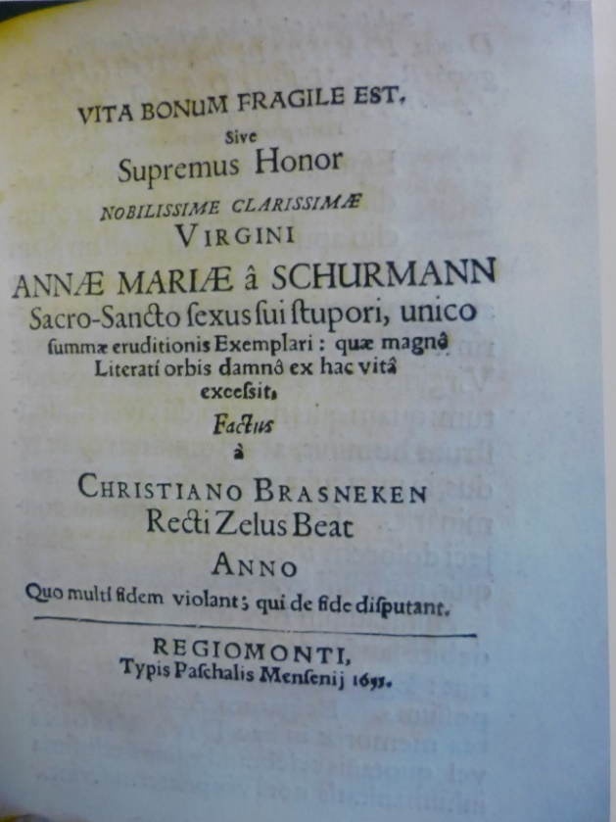
Life is a fragile possession, Or else the highest honour for the very noble, famous maiden Anna Maria van Schurman, the sacrosanct miracle of her sex and the unique example of the highest level of learning, who, to the detriment of the world of learning, passed from this life. Made by Christiaan Brasneken (Diligence for the good makes happy). In the year in which many who dispute on matters of faith at the same time violate faith. Königsberg, printed by Pascal Mensenius, 1655.
Very noble, famous and excellent man, Mr Joachim Pastorius, royal historian, doctor of medicine, teacher at the Gymnasium of Elbing, physicist of the same state, very admirable protector! I am looking forward to the reply you owe me, in a more passionate way than the miser Euclio was looking for and longing for his pot of gold which he had lost.
It is with great distress of my spirit, and not without a sharp experience of sorrow, that I have understood that the very noble maiden Anna Maria van Schurman has died; she to whom a certain person during her life referred, rightly so, as a faultless person, a star that appeared to the amazement of her sex. The things I have thrown together in this letter bear witness to my sorrow, which boils over and destroys me from here, so [I hope] that some of it may evaporate.
Others could have participated in the race of singing the justified praises of this Minerva at a suitable time, but in this matter, I cannot depend on my own small powers. The universities of the Dutch would only be able to ignore their part in the expected annual celebration of this divine maiden by tainting themselves with the heinous shame of inhumanity.
You, very famous man, when you are maintaining friendships, you should always follow Pomponius Atticus, not the least person of Roman nobility, who in an everyday discussion postulated this rule to be emulated, and also brought it into practice in his own life: that he does not befriend wealth but people. Fare thee well. Do reply. Do love, and may you together with me sigh with sad mourning on the passing of the ornament of all learning.
I recently read the powerful writing about Mr H.N. But writings of this nature do disappear easily, just like lamps that have been provided with only a very small quantity of oil or fat. When one takes the decision to oppose such false accusations, let our Achilles refute this Amasius, in a way similar to Vespasianus who once endured the fashionable words of the orators and other people by whom he was attacked, in a friendly and modest way. Maybe he will pay the fool’s tax for others as well. If, when this afternoon has passed, the opposing party at last has given Mr M.B. permission to go ahead with a burial with all rituals, let this good deed with the greatest right not be named Hermonius; what it is instead, you know well enough, even though I am no interpreter. Fare thee well once again. Your devoted in everything Rotger zum Bergen

Epigrams
No-one can deny it; it is amazing to all: this maiden has but one head but ten tongues. She knows as many languages: French, Italian, Spanish, German, Latin, Greek, Hebrew, Syriac, Samaritan, Arabic. See on this the very famous, noble Cats in his book about marriage.

Epitaph to the traveller
Whoever you are, come nearer, three times dear traveller
When reading all this, I ask you to rouse your spirit.
Here lies Venus in terms of beauty.
in her way of speaking Minerva
for her excellent morals Juno
and for her charm one of the Graces.
The maiden Van Schurman was worthy of eternal life.
How virtue weeps after having pulled out her own hair!

Another

Here lies the very noble and famous maiden Anna Maria van Schurman.
Her virtues were of such heavy weight that she could bring erudition itself out of balance
Whoever you might be among travellers, and whatever idea you might have about supreme learning,
it will not be inappropriate when you apply it to the universal learning of our heroine.
Please leave, reader, and may it not be disagreeable to you to scatter the tomb of the rose-red as well as admirable maiden generously with roses.

With this we have to conclude.

On the house in which the very fortunate maiden A.M. van Schurman has lived
To the reader
This house does not consist of red-gold sun metal,
nevertheless, it is worthy to be clad with beams of gold.
There are no other buildings making the city of Utrecht as famous as this house. Farewell.

Another:
Van Schurman is dead; she also made a last will in which she left me the lesson that it is sad to grieve. That is enough.
The same person as above, Rotgerus zum Bergen

Latin texts
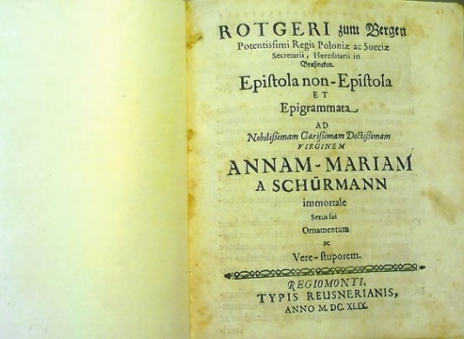
EPISTOLA NON-EPISTOLA
ROTGERI zum Bergen Potentissimi Regis Poloniae ac Sueciae Secretarii, Haereditarii in Brasneken. Epistola non-Epistola ET Epigrammata AD Nobilissimam Clarissimam Doctissimam VIRGINEM ANNAM-MARIAM A SCHÜRMANN immortale Sexus sui Ornamentum ac Vere-stuporem. REGIOMONTI TYPIS REUSNERIANIS, ANNO M.DC. XLIX.

Quae de Te, Nobilissima Virgo, in publicum proferuntur, ea omnia liquida ac certa esse, à viris omni exceptione majoribus, jam pridem didici. Bene-multas doctas Virgines in memorias missas tenemus; quae tamen omnes, tecum comparatae, vix exiguam famae celebritatem emereri videntur. Ita tu illarum ut et nostro seculo literatorum virorum laudes nimium quantum infuscas.
Tuum ingenium non minus mirandum, quam quae Nicephorus refert de Gregorii Pontici conversione in arborem ac Dracone, quem octo bouum paria vix loco emoverint.
Qui Tui ingenii excellentiam commendant, haut veteres rerum Ecclesiasticarum Historicos imitantur, qui caetera integerrimi, impotentiore religionis adfectu scribta sua in aliquibus vix tolerandis naevis adsperserunt. Unde, nescio quae rejicula de Sanctis conglomerârunt.
De Te autem omnia non falsa esse, satis testificantur, quae optimo Reipublicae literariae jam communicâsti. Opuscula elegantia de difficilibus ac intricatos explicatûs habentibus materiis Graeca, Latina, Gallica Hebraea, Prosaica, Metrica etiam ingratiis tuis pronuper publicata omnium adsensum de solidiori doctrina tua non tam eliciunt, quam exprimunt. Utinam et reliqua Tua scribta mortalium usibus concederentur, quae, Musis ringentibus, intra Vestae penetralia minus liberali adservas custodiâ. Perge arbores serere seram posteritatem beaturas. Durabunt ingenii Tui faetus, qui plane-viros, non faeminas spirant.
Edidit olim non in-argutus autor discursum, quo statuminare, non seriò, sed ingenii, sic ego judico, extentanti causâ connititur. Sexum imbellem (et Tu imbellis haut pennâ sed bipenni) non esse homines. De Te hoc quis dicat, sed longè aliâ ratione, quippe quî supra hominem sapias.
Homo es, Nobilissima Virgo, non ordinarius, sed extraordinarius. Nôsti, pernôsti, quosnam Itali vocent homines ac Doctores ordinarios, tales scilicet, in quibus omnia sunt protrita, in quibus, nihil singulare, ac supra caeterum vulgus: quamvis Latini scriptores posteriorum temporum contra vetustissimos in meliorem semper partem hoc verbum capiant atque ejus turpitudinem ita nobilitârint.
Felicem Te! Clarissima Virgo, quî Belgicum illum Nestorem, Virum nunquam nisi summâ cum Laude loquendum Jacobum Catzium nacta sis praeconem ac Virtutum Tuarum ex professo ingenuum commentatorem. Mitto perpetuum literariae Reipublicae DICTATOREM Danielem Heinsium, Hugenium, Barlaeum, Crucium Stackmannum, ac alios haut vulgariâ eruditione praelustres VIROS.
Quis non inter alia infinita stupeat? quod Consultissimo VIRO, Domino Ambrosio Scalae, Aulici Electoralis Judicii Advocato meritissimo, Anna Margaretha Schûrman, Magnifici VIRI, Domini Sebastiani à Grosspfersfelder amabilissima Uxor narravit. Regis Nostri Augustissimae nunc-Conjugis effigiem, (cum illa adhuc Regia Sponsa ad TE Schûrmannianam in Belgio famâ tui nominis accensa invisisset) postquam Heroinam illam inconnivis oculis parumper adspexisses, in Stuba Tua ex tempore sic à Te artifici pennâ Chartae commissam, ut Regina Nostra clementissima ob tàm felicissimam tuam in se expingendo manum, extra Se quasi posita fuerit. Patres Jesuitae, Viri acutissimi (qui unâ aderant cum Regiâ Sponsâ) de rebus magni momenti tecum sermonem consociantes, vix solem Tui in respondendo judicii ferre potuerunt, hinc dixerunt: Spiritum tibi esse familiarem. Quos argutè momordisti replicando habere te spiritum familiarem, scilicet, quo spirares.
Haut illi Philosophi famam suam conturbant ac existimationi suae decoquunt, qui faeminas aequè ut viros quorumvis subtilium ac omnium artium plenissime-capaces statuunt; modò diligentior earum in literis literatis accedat institutio. Quam materiem, Tu ipsamet Nobilissima Virgo ante aliquot annos acutè enucleatam ac delectabiliter expolitam communis boni ac publici juris fecisti. Ex quo eruditissimo discursu cuivis doctiorum colligere pronum est, quàm omnis Musarum cohors in pectore Tuo familiarissmè commoretur. Nervosissimam responsionem Tuam ad Clarissimum Dominum Beverovicium de quaestione illa (ut Rex salium Plautus loquitur) contortuplicata; Num fatalis vitae terminus sit mobilis cum summa admiratione quis hodie non legat, quis hanc non supra omnes laudes adfirmet? modò sine odio de hac pronuntiare sententiam aggrediatur.
Praeter omnes Europaeas sive Orientalem sive Occidentalem linguam etiam exactissime ad omnium stuporem calles. O ter supra cunctos unicè beatos! qui te vident, alloquuntur, Te, inquam, virginem consono totius orbis literati elogio maximam. Ego cum corpore nequeam pennato, ut sic loquar, calamo, Te adire gestii. Verissimè de Te dicit Jacob Martin Parisinus. Unus Schurmannae famae non sufficit orbis.
Sed desino Oris Tui, Nobilissima Virgo, verecundiam prolixiore laudum Tuarum ut ut non ementitarum recensione oneratum ire. Non Tibi dividiae sit. Nos in Te Laudando candidum, quod ajunt, ebur commaculare ac meridiem ipsum spissâ caligine involvere. Hoc tamen Tibi, Clarissima Virgo, insusurrandum. Maxime obtinent Theatrum, qui Theatrum non curant.
Id etiam addo. Utinam Deus Tibi inspiraret desiderium cum quodam Jove, Te Junone dignissimo dextram in Conjugii foedera jungendi. Si ex Te non degener proles acerbiorem Tuum ex vitâ excessum (ô sera sit illa dies!) mitigaret ac componeret.
Sed quo ferimur! ignosce Doctissima Virgo, liberiusculo nostro per literas tecum colloquio. Hujus frontis nostrae plus aequo ferreae facilem veniam à Tua Humanitate nulli desperamus. Qualem, qualem Musae Nostrae conatum haut despernas, nec Tibi Carminum nostrorum bellaria ablubescant. Qui leporibus, Ostreis, turdis, carent: illi caepas, lardum, pultem avenariam ac caseos quorumvis orbium ac formarum apponunt.
Vale ex voto diutissimê. Responsionem, Nobilissima Virgo, dum officiosè petimus; bonâ fide pollicemur. Prolixitatem nostram non sinistrè interpretaberis, ingenuum Noster in Te amor nos jussit Epistolicas leges migrare.
Epigrammata ad Nobilissimam
Annam Mariam Schûrman
I.
Annae Schûrmannae referam uno Carmine laudes:
Nullius ingenio cedere jurè potest

Aliud
II.
Ingenium, non mentitur, Tibi qui negat esse:
Ingenia haec virgo, non habet ingenium.

De Annae Mariae Schûrmannae morbo,
cujus fama & Hujus loci Heliconem externabat.
Autor ad Phoebum

III.
CAusas, Phoebe, mihi non commemorare graveris.
Cur fluat ex oculis lacryma falsa Tuis.

Phoebus respondet Autori
MOrbo vexatur tristi Shûrmannia virgo;
Hinc lacryma ex ocuolo manat utroque meo.
Hoc morbo cito si fuerit mea Virgo soluta:
Tunc Jovis in gremio me cubitare putem.

IV.
VIrgo novem Musas praesentat tempore nostro
O Virgo doctis suspicienda Viris!

Aliud
V.
QUi Te mirari caepit, vix est satis unquam
Miratus. Satis haut te canat ipse Maro.

VI.
Phoebus Virginem hancce, Unicam suam Curam ac delitias sic affatur.
IN placidas ulnas, rogo, me pia, suscipe, Virgo;
Langueo Ego ingenii totus amore Tui.
Fac pergas scribtis nostrum producere regnum
Ac Tuus in me sit, sit sine fine favor.

Nobilissimae
Annae Mariae a Schûrmann
Unico omnium mirandorum in homine docto
exemplari, ac sui sexûs prorsus-monstro
absque omni tamen vitio
Sponte lubens
F.
R.Z.B.R.S.H.I.B

TANTVM EST.

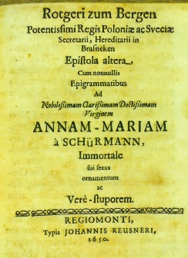
EPISTOLA 2
Rotgeri zum Bergen Potentissimi Regis Poloniae ac Sveciae Secretarii, Hereditarii in Brasneken Epistola altera Cum nonnullis Epigrammatibus Ad Nobilissimam Clarissimam Doctissimam Virginem ANNAM-MARIAM à SCHÜRMANN, Immortale sui sexus ornamentum ac Verè-stuporem. REGIOMONTI, Typis JOHANNIS REUSNERI, 1650.
Salve & O. Clarissima Virgo.
MIssâ omni praesatione, more Laconum rem ipsam aggredimur. Te, NobilissimaVirgo, in morbo cubuisse, didici à Viris fide dignis. Deus Te tantam orbis literati voluptatem qùam diutissimè superstitem velit, ac benignè largiatur, in posterum non vitam trahas sed agas idque ex animi Tui sententiâ.

Miror, Te nihil literarum ad Nos; quàm moram invaletudini Tuae adscribimus, à cujus etiamnùm reliquiis ubi liberata fueris; hanc cessationem Te prolixiori calamo expiaturâ, jucundè speramus.

Hoc mihi, Nobilissima Virgo, accredas, Candidiores atque ab omni simulatione aversiores Tui nominis cultores nuspiam locorum inveneris ac Terra Borussia alit.

Amatorium sine medicamento, sine herbis, sine dirae alicuius Veneficae Carmine est sublime ingenium Tuum, quo omnes Tibi doctos arctissime devinxisti. Nemo unus homo, uni homini post homines nato tàm amabilis fuit, quàm Tu es literatorum ordini, cujus ut longisimum sis delitium animitus voveo.

Brutum ac Valerium in Consulatu Collegas (ut Veteres memoriae loquuntur) quia publicam libertatem religiose defenderant pars melior populi Romani honore luctus annalis honoratum ibat. Tibi ob excellentissimas ingenii dotes non minor favor etiam post obitum (tardissimus ille sit!) à Doctis meritò debetur.

Vnicum adduco, antè ego quàm claudam. Philosophus Secundus Psittacum habuit has voces, quas subinde repetebat, accuratè edoctum. Philosopho digna agas. Tu Clarissima Virgo porrò digna agas Anna Mariâ à Schürman hoc est nominis Tui immortalitatem scribtis propages. Menippum meum acetosum brevi legeris; quamvis hoc scribtum Schlukeri Pater, Knodosti Gener, Potini Socer Grobiani Frater omnes illi socienni genuina ebrietatis mancipia aegrius ferant. Horrent enim ob ingeniorum scabiem pectinis hujus satyrici vel umbram. Vale Clarissima Virgo meque inter sincerissimos Tuarum dotium Veneratores cense.

Triga Epigrammatum Ad Clarissimam Virginem A.M. à SCHüRMANN.
I
NOn homini similis miranda munera mentis
Das orbi; scribis quae ingenium acre canunt.
Porrò Tu divis Musis incumbito; Fama
Sic vehet altisonus nomen in astra tubis.

II
Divus Apollo ad suas delitias SCHüRMANNIAM.

QVicquid ago semper menti meae oberrat imago
Nymphae Schürmannae, qua mihi Cura placens.
Hancce coram cernam; nae mox ego totus abirem
In cineres; Si non copia adesset aquae.

III
Autor ad Schürmanniam

ORbis miraclum cantabat carmina Virgo
Schürmann ad ripam molle-fluentis aquae
Audit cantantem Fluvius dum carmina Divam:
Ad tam mirandum substit ille sonum.

Nobili Vestrae Claritati addictissimus
R.Z. B.R. S. H. I B.

EPISTOLA 3

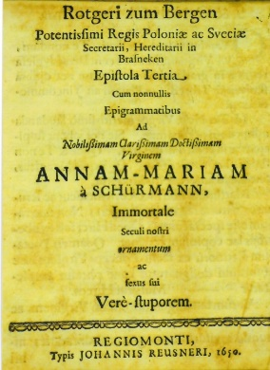
Rotgeri zum Bergen Potentissimi Regis Poloniae ac Sveciae Secretarii, Hereditarii in Brasneken Epistola Tertia Cum nonnullis Epigrammatibus Ad Nobilissimam Clarissimam Doctissimam Virginem ANNAM-MARIAM à SCHÜRMANN, Immortale seculi nostri ornamentum ac sexus sui Vere-stuporem. REGIOMONTI, Typis Johannes Reusneri, 1650.

Salve & O. Nobilissima Clarissima Doctissma Virgo.

QVandoquidem intellexi, Te nondum, Clarissima Virgo, optimà fide cum diva Hygieia rediisse in gratiam; breve faciam nec diffusâ scribtione Tibi ero (ut Plautus ait) incommodisticus.

In Te, Nobilissima Virgo, meritissimò laudandà adhucdum occupamur. Sic nos jubent suspiciendae ingenii Tui virtutues. Quod & Te non sinistre laturam, confido. Quicquid hîc agitur, sine caeco amore ac studio agitur.

Matthiolus non incelebris medicus ac scrutator naturae sagacissimus refert; Non tam rarum esse spectaculum; Quod Hirci suis ex uberibus lac copiosum reddunt. Quamvis Poëtarum Latinorum ex facili. Princeps Virgilius näae absurdum designaturus hanc phrasin amplectatur ----Mulgeat Hircos.

Verûm tàm ingeniosissimam Virginem, ac Schürmannia est, qui Spectaculum antehàc mundo invisum ac incognitum adfirmarit; nihil in ipsam veritatem fuerit injurius. Adiicimus more nostro quaedam Epigrammata. Alios Apelles alio die hîc procul dubio inveneris, qui in Te expingendà feliciores lineas nec devenustaturas ingenii Tui majestatem duxerint. Nos ex maximis minima quaedam de Te Sacrosancto sexus Tui Horrore promere voluimus, cujus laudibus recensendis vix mille calamos suffecturos censemus.

Haut supparasitandi causa isthaec eloquimur aut quòd judicio nostro Tuae laudes sive stent sive cadant; sed quia cuique suum decus ut et infamiam rependi, Iustitiae non est disconveniens. Deus vota mea, quae Sanctè ac religiosè nuncupo pro tua incolumitate, ea magis ac magis rata faxit. Salvè agas, Nobilissima Virgo ac quae divinitus accepisti, publicis usibus non invideas. Vale iterum ClarissimaVirgo ac Bachanal diutissimè exerce, liceat mihi sic cum veteribus loqui, qui passivâ ac vulgatâ hac sermonis formula prosequebantur, quos delicatè vivere praeoptabant.

Epigrammata Ad Nobilissimam, Clarissimam, Doctissimam Virginem
ANNAM MARIAM à SCHÜRMANN,
I.
OMnis doctrinae Virgo Schürmanna Monarcha es:
Sic et vox gratae posteritatis erit.
II.
ORbi divulgat quicquid Schürmannia Virgo
Hoc unà tecum culcitrâ, Apollo, jacet.
III.
MVnera divinae nequeo describere mentis,
Non rimanda mihi, sunt Veneranda mihi.
Indos ad nigros, queîs Numen mugit in agris,
Schürmannae ingenii fama superba volat.

IV.
CAsta Minerva legens doctissima scribta per orbem
Quae vulgas, cordis pars bene magna mei
Illa velut cautes immoto saxea visu
Haesit, non credens scribere sic hominem.
V.
AVt omnes Genii merito Schürmannia Virgo est;
Cunctis ex Geniis aut ea Virgo Sata est.

Menippus noster acetosus brevi prodibit in publicum Gallonorum (Ciceronis verbum est) iudicia indifferentèr ferens.

Tantum est

VITA BONUM FRAGILE EST

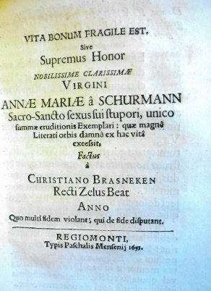
VITA BONUM FRAGILE EST Sive Supremus Honor NOBILISSIMAE CLARISSIMAE VIRGINI ANNAE MARIAE â SCHURMANN Sacro-Sancto sexus sui stupori, unico summae eruditionis Exemplari: quae magnô Literati orbis damnô ex hac vitâ excessit. Factus à CHRISTIANO BRASNEKEN Recti Zelus BEAT ANNO Quo multi fidem violant; qui de fide disputant. REGIOMONTI Typis Paschalis Mensenij 1655.

Nobilissime, Clarissime, Excellentissime vir, Domine IOACHIME PASTORI, Historiographe Regie, Medicinae Doctor, Gymnasii Elbingensis Professor Ordinarie, ejusdemque Reipublicae Physice, Fautor plurimum colende.
REsponsum, quod mihi debes, avidius expecto, quam triparcus Euclio apud Plautum amissam suam ollam quaerit, et desiderat. Cum magna animi mei consternatione, nec sine acerrimo doloris sensu percepi, Nobilissimae Virginis ANNAE MARIAE â SCHURMAN, obitum: quam quis meritò, dum viveret, monstrum hominis, absque omni naevo, ac sydus, in miraculum sexûs sui exortum, nominârit. Quaedam in chartulam conjeci dolorem meum, qui me hinc discoquit, nonnihil evaporandi gratiâ.

Alij stadium hoc Minervam hancce debitè laudandi, suo tempore decurrerint: Ego meis viriculis hîc fidere nullus possum. Belgarum Academiae, partes memoriae in hac DIVA VIRGINE vel quotannis celebrandae, sine foedissima inhumanitatis notâ vix praetermiserint.

Tu, clarissimeVir, in amicitijs percolendis constanter deinceps aemulare. Pomponium Atticum, Romanae nobilitatis non postremum, qui illud observatu dignum quotidiano sermone usurpavit, et ipso etiam facto animavit: se non fortunae, sed hominibus esse amicum. Vale. Rescribe. Ama, ac mecum ob obitum omni Doctrinae Ornamenti
…ferali ducas suspiria planctu.
Legi nuper virulentum scriptum in D.H. N. Verum ejusmodi scripta, ut lucernae pauxillô oleo sive sebo instructae, facilè evanescunt. Si tamen convellere stat has calumnias, refutet noster Achilles hunc Amasium, ut olim Vespasianus dicteria Rhetorum ac populorum, quibus impetebatur, ferebat: Leniter scilicet ac modeste. Fors aliis etiam solvet, tributum βλακεννόμιον.Si p.m. D. M. B. adversa pars sepeliri cum omnibus caeremoniis tandem concesserit: nae hoc beneficium, summo jure vocetur Hermonium, quid sit me non interprete satis nosti. Vale iterum.

Tuissimus omni nexu ROTGERUS ZUM BERGEN.
EPIGRAMMATA
Nemo negare potest; mirandum est omnibus: Unum
Dum caput et Linguas Virgo habet illa decem.
Exacte noverat Linguas. Gallicam, Italicam, Hispanicam, Germanicam,
Latinam, Graecam, Hebraicam, Syriacam, Samaritanam, Arabicam. Videatur Clarissimus Nobilissimus Catzius in Lydio conjugii lapide.

EPITAPHIUM ad VIATOREM
QUisquis es accedas propius ter-chare Viator.
Haecce legens animum arrige quaeso Tuum.
Hic specie Venus est sita, sed sermone Minerva,
Moribus exiimis Juno, lepore Charis.
Vivere digna fuit semper Schurmannia Virgo:
Quam plorat virtus dilaniata comas!

ALIUD
Hic sita est Nobilissima Clarissima
VIRGO ANNA MARIA â SCHURMANN
Cujus virtutum tanta gravitas, quae ipsam
Eloquentiam debilitatum eat.
Quisquis Viatorum es
FINGAS
Quam cunque Summae Doctrinae Ideam, non ex falso sit.
Si huic nostrae in omni doctrina Heroinae applices,
Abito Lector, ac Rosis generosis tàm Roseae ac mirandae Virginis
Tumulum conspergere, non Tibi displicitum sit.
TANTILLUM EST.

In aedes, quas inhabitavit Beatissima Virgo A.M. â Schurmana.
LECTORI
HAut rutilô solis constat Domus haecce Metallo:
Ex auro digna est stare tamen trabibus.
Nullae sunt aedes urbem magis Ultrajectum,
Quae celebrem praestent, ac Domus haecce.Vale.

ALIUD
Mortua Schurmanna est: fecit quoque Testamentum,
Quo mihi legavit Triste dolore. Sat est.
Idem quod supra:
R. Z. B.

EPISTOLA 1
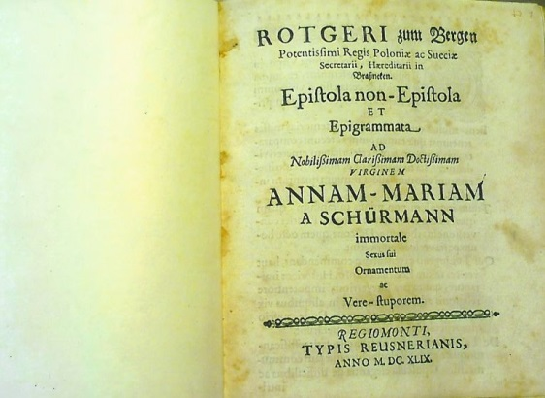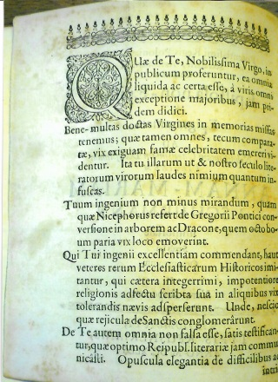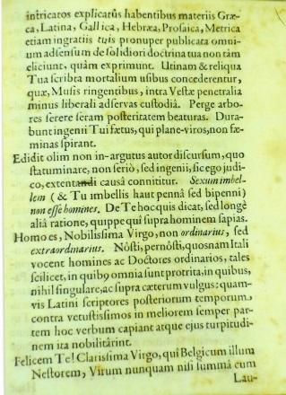
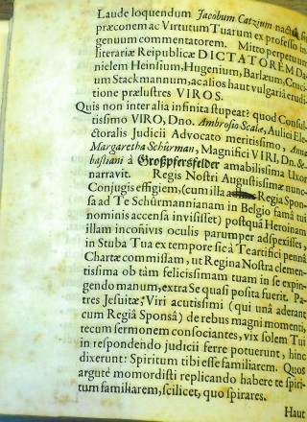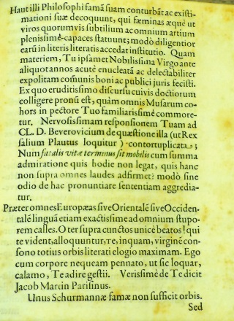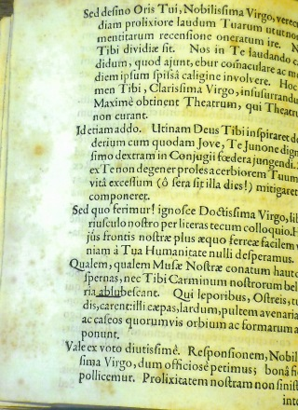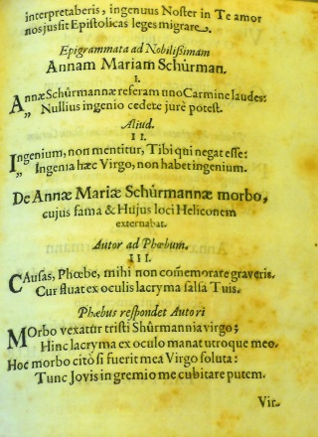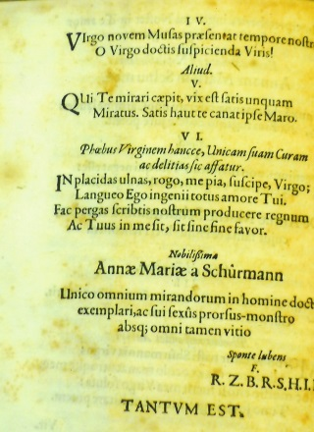

EPISTOLA 2
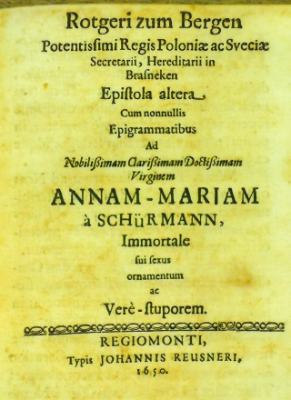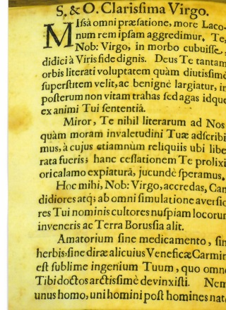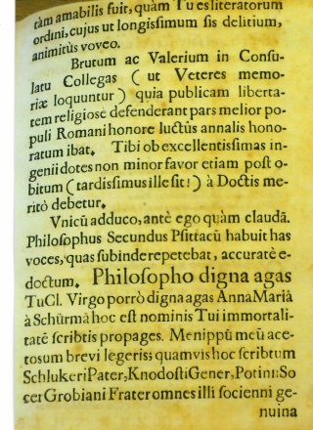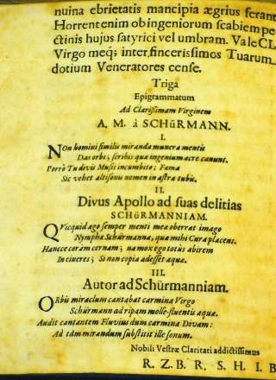

EPISTOLA 3
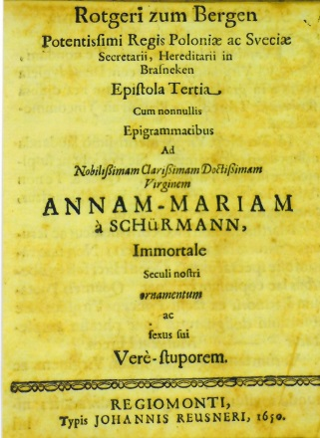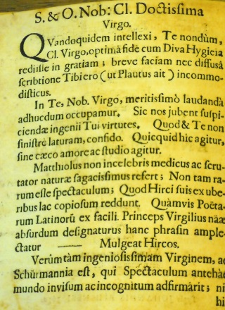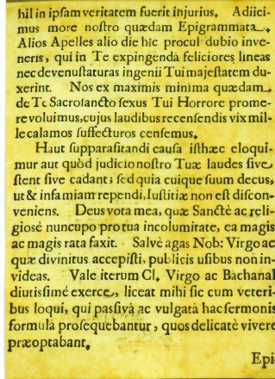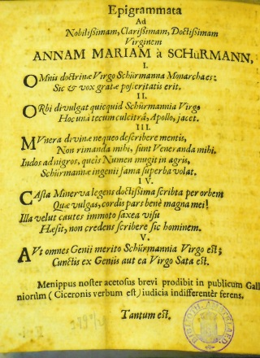

VITA BONUM FRAGILE EST
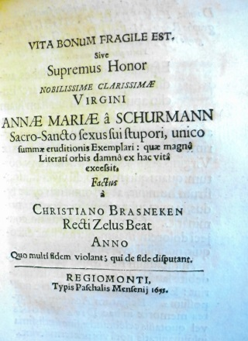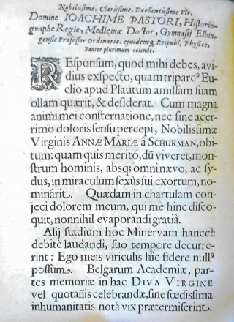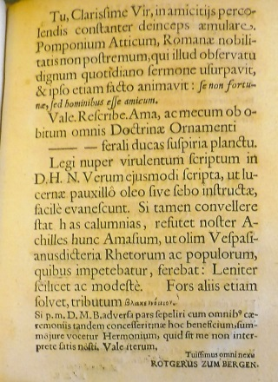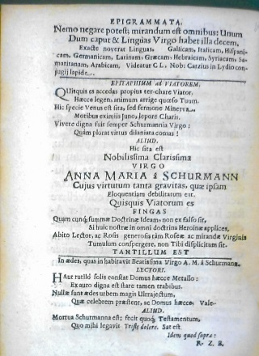

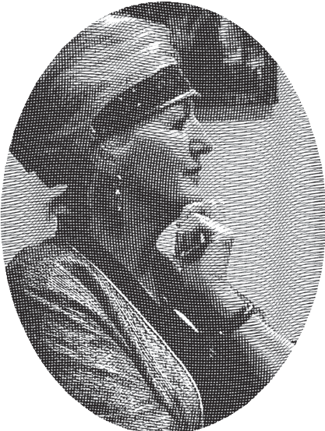
Curriculum Vitae
Pieta van Beek (1958) studied Dutch language and literature at the University of Utrecht (MA 1987), Classical Languages (DLitt; Stellenbosch University, 1997) and Ancient Near Eastern Studies (MA cum laude, Stellenbosch University, 2004). For years she taught Classical Languages as well as Dutch and Afrikaans at schools and universities. In 1997 she was awarded a doctorate with a thesis on Anna Maria van Schurman’s Opuscula Hebraea Graeca Latina et Gallica, prosaica et metrica. In 2004 she published De eerste studente: Anna Maria van Schurman (1636), in 2010 translated as The first female university student: Anna Maria van Schurman (1636) (available in digital form at http://dspace.library.uu.nl/handle/1874/235540).
As from 2013 she lectures on Ida Gerhardt at the HOVO of the Erasmus University in Rotterdam and the Radboud University in Nijmegen. She is a research associate at both the University of Utrecht and Stellenbosch University, South Africa, and president of the Gerrit Achterberg Society. The book Achterberg: Een kind dat alles maken kan, which she edited together with Jaap Breunesse, was published in 2015. The book on woman writers in South Africa which she co-authored with Annemarié van Niekerk was published in 2019: My mother’s mother’s mother: South African women’s writing from 17th-century Dutch to contemporary Afrikaans (Leiden: Leiden University Press). Commissioned by the rector magnificus of the University of Utrecht, G. J. van der Zwaan, she is currently working on a book on the name and fame of Anna Maria van Schurman in Europe as a pendant to the book roll on the same subject (https://utrechtuniversity.on.worldcat.org/oclc/1005207607 ). In the meantime, she has started with the study of Arabic.
For a list of her publications and lectures on Anna Maria van Schurman, forgotten South African women writers writing in Dutch and Afrikaans, Ida Gerhardt, on Women and Spirituality past and present, Women writing Greek and Latin, see the following:

https://www.annamariavanschurman.org
https://www.uu.nl/medewerkers/PvanBeek
http://www.stellenboschwriters.com/vbeekp.html

Published in this series:
Schurmanniana Series no. 1
Pieta van Beek, ‘Over God’: een onbekend florilegium van Anna Maria van Schurman (ca. 1625). Ridderkerk: Provily Press, 2013.
Schurmanniana Series no. I (English version)
Pieta van Beek, ‘On God’: An unknown florilegium by Anna Maria van Schurman (ca. 1625). Ridderkerk, Provily Press, 2014 (translated by Dineke Ehlers)
Schurmanniana Series no. 2:
Pieta van Beek, ‘Uw lieftalige brief’: een onbekende brief van Anna Maria van Schurman aan Johannes Vollenhove. Ridderkerk: Provily Pers, 2014.
Schurmanniana Series no. II (English version)
Pieta van Beek, ‘Your charming and well-written letter’: An unknown letter by Anna Maria van Schurman to Johannes Vollenhove. Ridderkerk: Provily Press, 2022.
Schurmanniana Series no. 3
Pieta van Beek, ‘Verslonden door zijn liefde’: een onbekende brief van Anna Maria van Schurman aan Petrus Montanus (1669). Ridderkerk: Provily Press, 2015.
Schurmanniana Series no. III (English version)
Pieta van Beek, ‘Devoured by his love’: An unknown letter by van Anna Maria van Schurman to Petrus Montanus (1669). Ridderkerk: Provily Press, 2022.

Financial support
If you are interested in financially supporting the work of making accessible the work of Anna Maria van Schurman, please send an e-mail to p.vanbeek@uu.nl.

NOTES

G.D.J. Schotel, Anna Maria van Schurman. ’s-Hertogenbosch: Muller, 1853, p. 96; Pieta van Beek, ‘Habent sua fata libelli’: The adventures and influence of Anna Maria van Schurman’s work in Scandinavia’ in: A. Steiner-Weber (ed.), Acta Conventus Neo-Latini Upsaliensis: Proceedings of the Fourteenth International Congress of Neo-Latin Studies (2009). Leiden/Boston: Brill, pp. 199-209.
J. Mollerus, Cimbria LitterataI. Havniae: Gottman Frid. Kisel, p. 813: Unicum omnium mirandorum in homine docto exemplar ac sui sexus prorsus monstrum, absquae omni tamen vitio.
Rotger zum Bergen, quoted in Schotel 1853:121, appendix 25; however, Schotel does not provide the German source.
In the Duchess Anna Amalia Library in Weimar the writings are catalogued as follows: Vita Bonum Fragile Est. Sive Supremus Honor ... Annæ Mariæ â Schurmann Sacro-Sancto sexus sui stupori, unico summæ eruditionis Exemplari: quæ magnô Literati orbis damnô ex hac vitâ excessit, Factus à Christiano Brasneken ... Regiomonti: Mensenius, 1651. Shelfmark 4 VIII: 60; Stück 41 in Sammelband; Epistola non-Epistola Et Epigrammata Ad ... Annam-Mariam A Schürmann immortale Sexus sui Ornamentum ac Vere-Stuporem. 4 IX: 60 Stück 37 in Sammelband; Epistola altera Cum nonnullis Epigrammatibus Ad ... Annam-Mariam à Schürmann, Immortale sui sexus sui ornamentum ac Verè-stuporem. Regiomonti: Reusnerus, 1650 Stück 38 in Sammelband; Epistola Tertia Cum nonnullis Epigrammatibus Ad ... Annam-Mariam à Schürmann, Immortale Seculi nostri ornamentum ac sexus sui Verè-stuporem. Regiomonti: Reusnerus, 1650; Stück 39 in Sammelband. Vermutlich Verlust bei Bibliotheksbrand 2004.
Pieta van Beek, The first female university student: Anna Maria van Schurman (1636). Utrecht: Igitur, 2010. Available at http://dspace.library.uu.nl/handle/1874/235540 (3rd improved and digitalised version, translated into English, of De eerste studente: Anna Maria van Schurman (1636). Utrecht: Matrijs and Utrecht Universiteit, 2004, 2007 (2nd ed.). See also www.annamariavanschurman.org on other publications regarding Anna Maria van Schurman.
A.M.van Schurman, Eucleria, of uitkiezing van het beste deel. Amsterdam: Jacob van de Velde, 1684, pp. 17-18.
The text on the damaged parts of the sheet could be added by way of reference to a nearly identical text written in the frontispiece of a copy of her work Opuscula Hebraea Graeca Latina et Gallica (1650) kept in Paris: Bibliothèque Nationale Z Payen 600; here we find a text in Hebrew from Psalm 16: 1-3: ‘Preserve me, O God: for in thee do I put my trust. O my soul, thou hast said unto the Lord, Thou art my Lord: my goodness extendeth not to thee; But to the saints that are in the earth, and to the excellent, in whom is all my delight’, followed by a Greek text from John 3: 16: ‘For God so loved the world, that he gave his only begotten Son, that whosoever believeth in him should not perish, but have everlasting life’; and finally a Latin text by Anselm of Canterbury, De Similitudinis, 1: O Caritas, quam magnum est vinculum tuum! Quod non solum angelos Deo, sed Deum et hominem mirabiliter copulasti! Deum ad terram traxisti, ad columnam ligasti, cruci affixisti, sepulchro clausisti et ad inferos attraxisti. Quis, inquam, fecit haec omnia nisi amor et sitis salutis nostrae? O graviores sunt ei plumbo, quos tanti amoris vinculum non trahit ipsum ad Deum quod Deum prius traxit deorsum ad homines. [O love, how great is your bond, since you did not only bind the angels to God, but also God to men in a miraculous way. You pulled God to earth, put Him in a pillory, nailed Him to the cross, locked Him in the grave and hauled Him to hell. Who, I am asking you, has done these things, but the love for und thirsting after our salvation? Oh, heavier than lead must those be for whom the bond of such a strong love which pulled God down to the people on earth does not pull them to God in return.] Anna. M. à Schurman. See also A.M.H. Douma, Anna Maria van Schurman en de studie der vrouw. Amsterdam, 1924, p. 85.
Frans Laurentius, Clement de Jonghe (ca. 1624-1677). Kunstverkoper in de Gouden Eeuw. S.l, 2000, p. 38. for the illustration, see Pieta van Beek, De eerste studente: Anna Maria van Schurman (1636). Utrecht: Matrijs, 2004, p. 176.
Costumes Belgiques, anciens et modernes, militaires, civils et religieux. Bruxelles: La Lith. Royale de Jobard, 1830: planche 80.
Meta de Vries, Het dichtwerk van Jan van Foreest (1586-1651). Text edition with translation and commentary. Doctoral thesis, Radboud Universiteit Nijmegen. Part II. Nijmegen, 2007, pp. 434–437.
Henk J.M. Nellen, Ismaël Boulliau (1605-1694). Astronome, épistolier, nouvelliste et intermédiaire scientifique. Amsterdam/Maarssen: APA-Holland University Press, 1994, p. 199.
Pieta van Beek, Verbastert christendom: Nederlandse gedichten van Anna Maria van Schurman (1607-1678). Houten: Den Hertog, 1992, pp. 126-136; Van Beek 2010: 206-220.
For an illustration and transcription, see Pieta van Beek, ‘Devoured by his love’: an unknown letter by Anna Maria van Schurman to Petrus Montanus (1669). Schurmanniana Series III. Ridderkerk: Provily Press, 2022.
Catalogvs librorum A.M. à Schurman Joh. De Labadie & Petri Yvon. Qui prostant Altonae ad Albim apud Cornelium van der Meulen in platea vulgo dicta die Marienstrasse. Altona: Cornelius van der Meulen, s.a; Pieta van Beek, ‘Ex libris’: de bibliotheek van Anna Maria van Schurman en de catalogus van de Labadistenbibliotheek (1673). Schurmanniana Series no. 5. Ridderkerk: Provily Pers, 2015.
Heilige Lof-sangen Ter Eeren Gods, Tot Heerlijkheid van Jesus Christus, en tot Vertroostinge en Vreugde van sijn Kerk. Uit het Frans vertaalt door Anna Maria van Schurman. Amsterdam: Jacob van Velsen, 1675, p. 67. Spelling has been adapted.
To date of writing there does not exist a recent biography or bibliography for Rotger zum Bergen. Details of his life have been taken from the following sources: Friedrich Konrad Gadebusch, Livländische Bibliothek nach alphabetischer Ordnung. Erster Theil. Riga: Johann Friedrich Hartknoch, 1777, pp. 48–50; Georg Christoph Pisanski, Entwurf der preussischen Litterärgeschichte während des 17. Jahrhunderts. Band 2. Königsberg: Hartung/Koch, 1853, pp. 239–240; 253–254; Friedrich Schwartz, ‘Bergen, Rotger zum’ in: Altpreussische Biographie, ed. Christian Krollmann. Königsberg: Gräfe und Unzer, 1941, p. 5; Albrecht Schöne, Kürbishütte und Königsberg. Modellversuch einer sozialgeschichtlichen Entzifferung poetischer Texte. München: Beck, 1982; Klaus Garber, Martin Opitz, Paul Fleming und Simon Dach. Drei Dichter des 17. Jahrhunderts in Bibliotheken Mittel-und Osteuropas. Köln/Weimar/Wien: Boehlau Verlag, 2013, pp. 509, 514, 516, 518, 546, 574, 595–597, 608. By way of digital catalogues such as Worldcat many publication by Rotger zum Bergen can be found. For details on Rotger zum Bergen’s visit to England and Leiden I thank Arvo Tering who has published his work Lexikon der Studenten aus Estland, Livland und Kurland an europäischen Universitäten 1561–1800 (unter Mitwirkung von Jürgen Beyer). I am grateful to Kristi Viiding for her mediation.
See i.a. http://grotius.huygens.knaw.nl/letters/1485/sender/berg099/.
Other names appearing in the literature are the following: Johann Baptista Faber, Christoph Caldenbach, Andreas Adersbach, Christoph Tinctorius (physician), Christoph Martini, Abraham Kalow, Christian Rose, Michael Eiffeler, Balthasar Void, Stephan Mueller, Siegmund Pichler, the hymn-writing poet Georg Werner, and Georg Neumark.
Cited in George C. Schoolfield, ‘Memory’s Lane: Simon Dach’s Memels Epithalamium of 18 January 1655’ in: Life’s Golden Tree. Essays in German literature from the Renaissance to Rilke, ed. Thomas Kerth and George C. Schoolfield. Columbia: Camden, 1996, p. 74.
Published without indication of year in Königsberg by the printer Paschen Mense.
The poems appear in the occasional composition he made together with Georg Neumark in 1650 for the bridal couple Abraham Josaphat von Kreytzen and Juliana-Elisabeth Rauschke. University Library of Tallinn, EV-TALAa, XII-946 (200).
RZB = Rotger zum Bergen, but can also stand for ‘Recti Zelus Beat’, ‘Diligence for the good makes happy’; Christianus Brasneken = Christiaan Brasneken, his estate just outside Königsberg; R.Z.B.R.S.H.I.B, Rotger zum Bergen, royal secretary, feudal baron at Brasneken. The many variations of spelling such as Rutger, Rötger, Brasneken, Brasnecken, etc. are ignored here.
I. Kajanto, Christiana Heroina: Mythological and historical exemplification in the Latin panegyrics on Christina, Queen of Sweden. Helsinki: Suomalainen Riede-akatemia, 1993; Van Beek 2004: 131-138; Arnaud Visser, In de gloria: Roem in de Renaissance. Utrecht: Universiteit Utrecht, 2013; Marc Laureys, ‘Praise and blame’ in: Brill’s Encyclopaedia of the Neo-Latin World. Micropaedia, eds. Philip Ford, Jan Bloemendal and Charles Fantazzi. Leiden/Boston: Brill, 2014, pp. 1148—1150.
Even though those in Calvinist circles objected to the summary use of heathen gods, Van Schurman does not show herself to be too strict in this regard. In her non-Dutch work, she participates in this internationally fashionable way of writing. In elogia on her person she not only passively allows being compared to mythological gods, but also makes active use of such comparisons in her own writing. Nevertheless, in her Dutch poems she takes into account her pious readers and tries to avoid this point of contention as far as possible. After her transition to Labadism she clearly avoids reference to Classical myths, also in her non-Dutch work. See Van Beek 1992: 26–30.
On Anna Maria van Schurman and Philips Von Zesen, see Van Beek 2010: 36–39; C.A. de Kruyff, ‘Eenige aantekeningen op de Genealogie Schurmannia’ in: Utrechtsch Jaarboekje. Utrecht: 1892, p. 259 states that Anna Margaretha was married in 1640. Her father was Samuel van Schurman, a brother of Frederik van Schurman, the father of Anna Maria van Schurman; her mother was Anna Elisabeth von Mosbach, genannt Breidenbach.
Underneath the portrait of von Zesen Anna Margaretha supposedly wrote the French poem, while Anna Maria would have engraved the portrait drawn by C. van Hagen in 1670.Cf. Van Beek 2004: 41.
I was in the wrong as well about this! See Pieta van Beek, ‘Het is dezelfde geest waardoor ik leef en ademhaal’: de spiritualiteit van Anna Maria van Schurman (1607—1678) in: Ora et labora: Twaalf opstellen over christelijke spiritualiteit in de praktijk, ed. Jaap van Amersfoort, Pieta van Beek and Gerrit Schutte. Hilversum: Verloren, 2014: 4—62; one of the first writers to recount the story about the house spirit during the visit by Queen Christina of Sweden is J. Passchius, in his work Gynaeceum Doctum sive dissertatio histor. Literaria. Wittenberg: Henckel, 1686: 50-51; see also Mollerus 1744: 810; Schotel 1853: 99; the report on the visit of the Queen of Poland which makes no mention of the house spirit, is included in J. le Laboureur, Relation dv voyage de la Royne de Pologne. Paris: vesfe Iean Camvsat, 1647, pp. 62—67; the story is also absent in the reprint dating from 1648.
On the genesis, distribution and printing history of the Opuscula, see Pieta van Beek Klein Werk: De Opuscula Hebraea Graeca Latina et Gallica van Anna Maria van Schurman (1607—1678). Doctoral thesis, Stellenbosch University, 1997. Available at http://www.dbnl.org/tekst/beek017klei01_01/; Pieta van Beek ‘De Opuscula Hebraea Graeca Latina et Gallica, prosaica et metrica van Anna Maria van Schurman als boek’: in: Tydskrif vir Nederlands en Afrikaans (5) 1998:53-73; Van Beek 2004: 99-105; Van Beek 2010: 103-108.
Opuscula Hebraea Graeca Latina et Gallica, prosaica et metrica. Lugdunum Batavorum: Elzeviers, 1648.
Arnoud Visser, In de gloria. Literaire roem in de Renaissance. Den Haag: Algemeen Nederlands Verbond, 2013.
Joachim Rachelius, Deutsche Satyrische Gedichte, ed.H. Schröder. Altona: Busch, 1828, p. 192, line 163-164.
A.M. van Schurman, Eucleria of uitkiezing van het beste deel. Amsterdam: Jacob van de Velde, 1684, pp. 12-14.
Martin Kempius, cited in Schotel 1853: 95; see also Van Beek 2010: 228; Mollerus 1744: 812, 817.
University library, University of Amsterdam, sign. Obr 10483 (1-3), the Epistola non-epistola, Epistola altera and the Epistola tertia form part of the collection of P. Diederichs (1929); Vita bonum fragile est forms part of the abovementioned Prussian collection in the Staatsbibliothek of Berlin. It is unknown who made the handwritten changes to the first letter, as well as its date.
Epistola non- epistola. Rotger zum Bergen here indicates the mixed character of the letter. For instance, the address and salutation are lacking and he does not introduce himself.
East Prussia, with Königsberg as its main centre, resorted under the sovereignty of Poland and Sweden but clearly fell within the German sphere of influence. The king of Poland, Władysław IV Wasa, had died in 1648 and his brother, John II Casimir succeeded him as king but also as the husband of the dead king’s wife, Queen Marie Louise de Gonzaga.
For generations the printer’s firm Reusner in Königsberg dominated the scene in printing academic work.
This anecdote could not be traced. It is also not clear which person is meant: Nicephorus of the mountain Athos, who was known for his poetry, just like Nicephorus, the bishop of Constantinople.
These unknown church historians clearly did not reckon the excellence of her mind as being a sacred virtue.
Opuscula Hebraea Graeca Latina et Gallica, prosaica et metrica. Lugdunum Batavorum: Elzeviers, 1648. On the genesis, distribution, printing history and the gentle pressure exercised by Frederik Spanheim sr., see Pieta van Beek, Klein Werk: de Opuscula Hebraea Graeca Latina et Gallica, prosaica et metrica van Anna Maria van Schurman (1607-1678). Stellenbosch: Universiteit van Stellenbosch, 1997. Available at http://www.dbnl.org/tekst/beek017klei01_01/; Pieta van Beek, The first female university student: Anna Maria van Schurman (1636).Utrecht: Igitur, 2010, p. 103-108 ff. Avilable at http://dspace.library.uu.nl/handle/1874/235540.
Vesta, goddess of home and hearth.
It is unclear to which book on the so-called battle of women (Querelle des Femmes) zum Bergen is referring here.
Citation could not be traced.
Jacob Cats wrote a panegyric on Van Schurman which was often reprinted with his other work and wherein he praises her learning elaborately.
For the contacts between Anna Maria van Schurman and Heinsius, Staackmann and Huygens, see Van Beek 2010 passim.
Anna Margaretha van Schurman, cousin of Anna Maria van Schurman.
Maria Louisa de Gonzaga was duchess of Mantua but was raised in Paris. She married the king of Poland by proxy, and on her way to Poland she visited Van Schurman in Utrecht.
Ambrosius Scala was married to Catharina Hermann. He was also an acquaintance of the poet Simon Dach who wrote poems for him on the occasion of his marriage as well as on his passing on 4 February 1652.
The portrait has not been rediscovered until today.
See Le Laboureur 1648, 1649; Van Beek 2010: 158, 192; Pieta van Beek, ‘Het is dezelfde geest waardoor ik leef en ademhaal’ in: Ora et Labora. Twaalf opstellen over christelijke spiritualiteit in de praktijk, ed. Jaap van Amersfoort, Pieta van Beek and Gerrit Schutte. Hilversum: Verloren, 2014, pp. 45–62.
Anna Maria van Schurman, Dissertatio de ingenii muliebris ad doctrinam et meliores litteras aptitudine. Lugdunum Batavorum: Elzeviriana, 1641.
De Vitae Termino.
A.M. van Schurman, Opuscula Hebraea Graeca Latina et Gallica, prosaica et metrica. Lugdunum Batavorum: Elzeviers, 1648, p. 360.
Publius Vergilius Maro (70 BC–19 BC), better known in English as Vergil, was a famous Roman poet.
Publius Valerius Publicola and Lucius Iunius Brutus were the founders of the Roman Republic (ca. 500 BC) The Roman writer Livius writes about them in Ab urbe condita, II.
An unknown satirical work by Rotger zum Bergen which he had delivered to her or sent with his previous letter.
Probably referring to characters in this satirical work.
See footnote at the address of letter 2.
Goddess of health.
Plautus, Captivi, I, 1, 19.
Pietro Andrea Gregorio Mattioli (1501—1577), famous physician, botanist and writer. The quotation could not be traced.
Vergilius, Eclogae 3, 91. It means to do something deemed impossible.
Apelles, best-known painter of Classical Antiquity (ca. 350 BC). He was also painter appointed to the court of Alexander the Great.
Gallonius, a gourmet who makes an appearance in the work of Cicero, De finibus, II.
Similar to the closure of the Epistola-non-Epistola. Literally: This is all it is.
In the catalogue of the Staatsbibliothek in Berlin it is noted in respect of this text that it is satirical in nature (without further explanation). Michael Spang took over this description in his biography Wenn sie ein Mann wäre: Leben und Werk der Anna Maria van Schurman 1607-1678. Darmstadt: Wissenschaftlichen Buchgesellschaft, 2009. It might be that people thought it was satirical because Anna Maria only died in 1678 and not in 1655? Or maybe because some of his other work had been satirical in nature? However, zum Bergen referred in each of his letters to Van Schurman to her poor health; for him it would not have been unexpected news to hear that she had died. Mortality in his time and region was extraordinarily high. Furthermore, zum Bergen wrote a number of In memoriams with exactly the same title, Vita bonum fragile est, for grieving friends and acquaintances who had lost a loved one, among others for the daughter of J. Pastorius. I am thus of the opinion that he intended to write seriously on the event of her passing. In addition, the year 1655 refers to a period of time in her life where she had shortly before returned from her sojourn in Cologne. In the Netherlands and elsewhere in Europe rumours were flying around: she had converted to Roman-Catholicism; even that she had died. For example, Louis Moreri wrote in 1688 about Van Schurman that people said she had died around 1656–1660. It was around the same time, after her return from Cologne, that stories emerged that she had become all spirit, because she no longer opened her door for unknown visitors.
Pascal Mense was a printer of books and academic work in Königsberg; see Christoph Reske, Die Buchdrucker des 16. Und 17. Jahrhunderts im deutschen Sprachgebiet. Wiesbaden: Harrassowitz, 2007.
Joachim Pastorius (1611–1681) hailed from a minister’s family and developed into a broadly educated men who obtained his doctorate in Leiden. He corresponded with Hugo Grotius and a number of other scholars. He was also a member of the poetry society Die Kürbishütte.
Euclio is the main character in Plautus’ Aulularia where the cash box is the theme of the piece.
Titus Pomponius Atticus (109–32 BC) was a Roman knight, business man and personal friend of Cicero.
Cornelius Nepo, Atticus, 9, 5.
Tax payable by astrologers because fools came to them for advice.
Hermonius: unknown, as are the references to H.N., Achilles, Amasius, M.B.
He is referring to the elaborate laudatory essay written by Cats on Van Schurman in his work ’s Weerelts begin, midden, eynde, besloten in den Trou-ringh, met den proef-steen van den zelven, 1637.
Literally: it is nearly nothing (=Tantillum est).
In the printed version one finds ‘extentandi’; this has been changed by hand to ‘extenti’. What is meant, is ‘extentanti’.
In the printed version one finds ‘nactus sis’; this has been changed by hand to ‘nacta sis’. In that case, the word ‘qui’ should also have been changed to ‘quae’.
Adhuc has been crossed out by hand.
Plautus, Persa, IV, lines 707-708.
Abbreviation O. could not be traced.
Diligence for what is right makes happy = Rotger zum Bergen.
Cornelius Nepos, Atticus, 9, 5: I am not a friend of the possessions someone may have, but of the person he is.
Citation could not be traced.
With the word τελος added: tax paid by astrologers because fools came to them for advice. See Etymologicum Magnum, ed. T. Gaisford. Oxford, 1848, 199.11.
’s Weerelts begin, midden, eynde, besloten in den Trou-ringh, met den proef-steen van den zelven. 1637.

