Pieta van Beek

‘Devoured by his love’
An unknown letter by Anna Maria van Schurman to
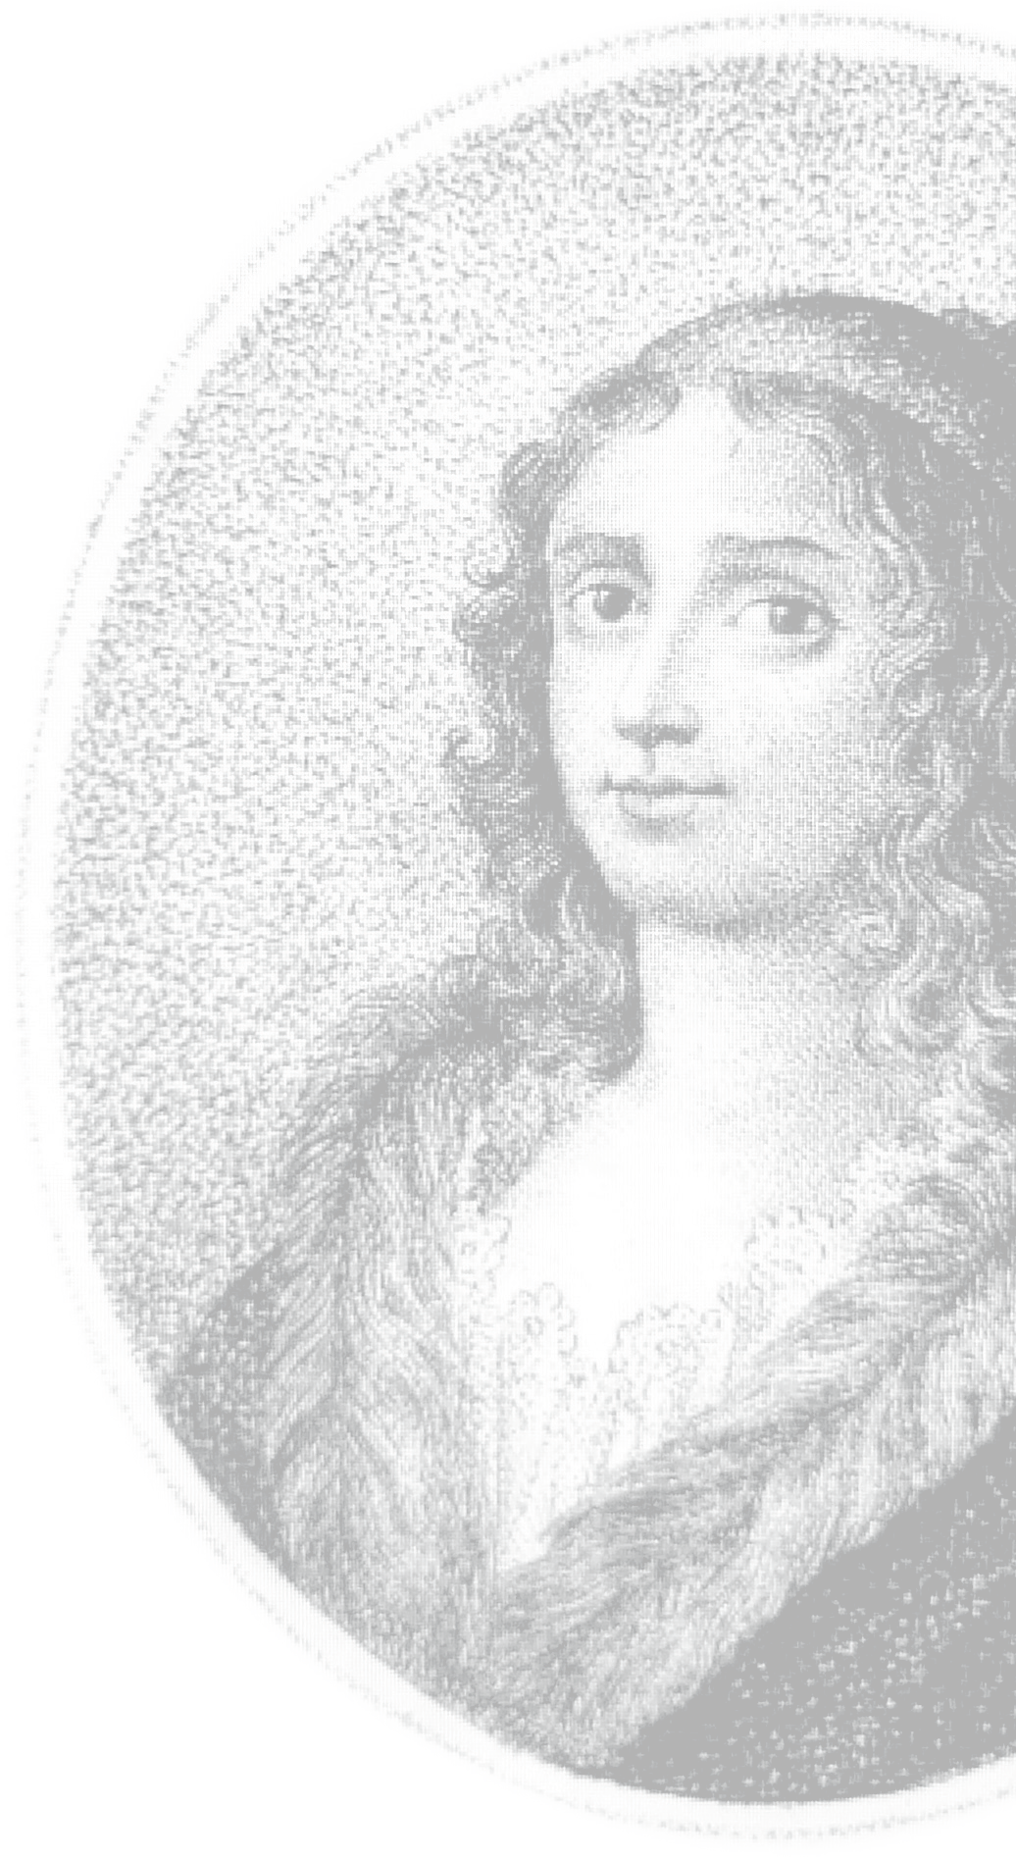
Petrus Montanus (1669)

Schurmanniana Series no. III

Provily Pers
Dedicated to the Reverend Laura Reedijk and Dr Otto Plassmann

In loving memory of my parents
J. van Beek and L. van Beek-Provily

‘Devoured by his love’: An unknown letter by Anna Maria van Schurman to Petrus Montanus (1669). Translated from the Dutch by Dineke Ehlers.
Schurmanniana Series no. III
© Pieta van Beek – Provily Press, Ridderkerk, 2015
Photographs: Pieta van Beek, Museum Martena, Franeker, Erik Heijerman, Germanisches Nationalmuseum, Nuremburg, Diane Niemantsverdriet
Cover illustration: Anna Maria van Schurman, in: Christian August Vulpius, Pantheon berühmter und merkwürdiger Frauen, Volume 3. Leipzig, 1812.
See also www.annamariavanschurman.org
Contact author: p.vanbeek@uu.nl and pvb@sun.ac.za

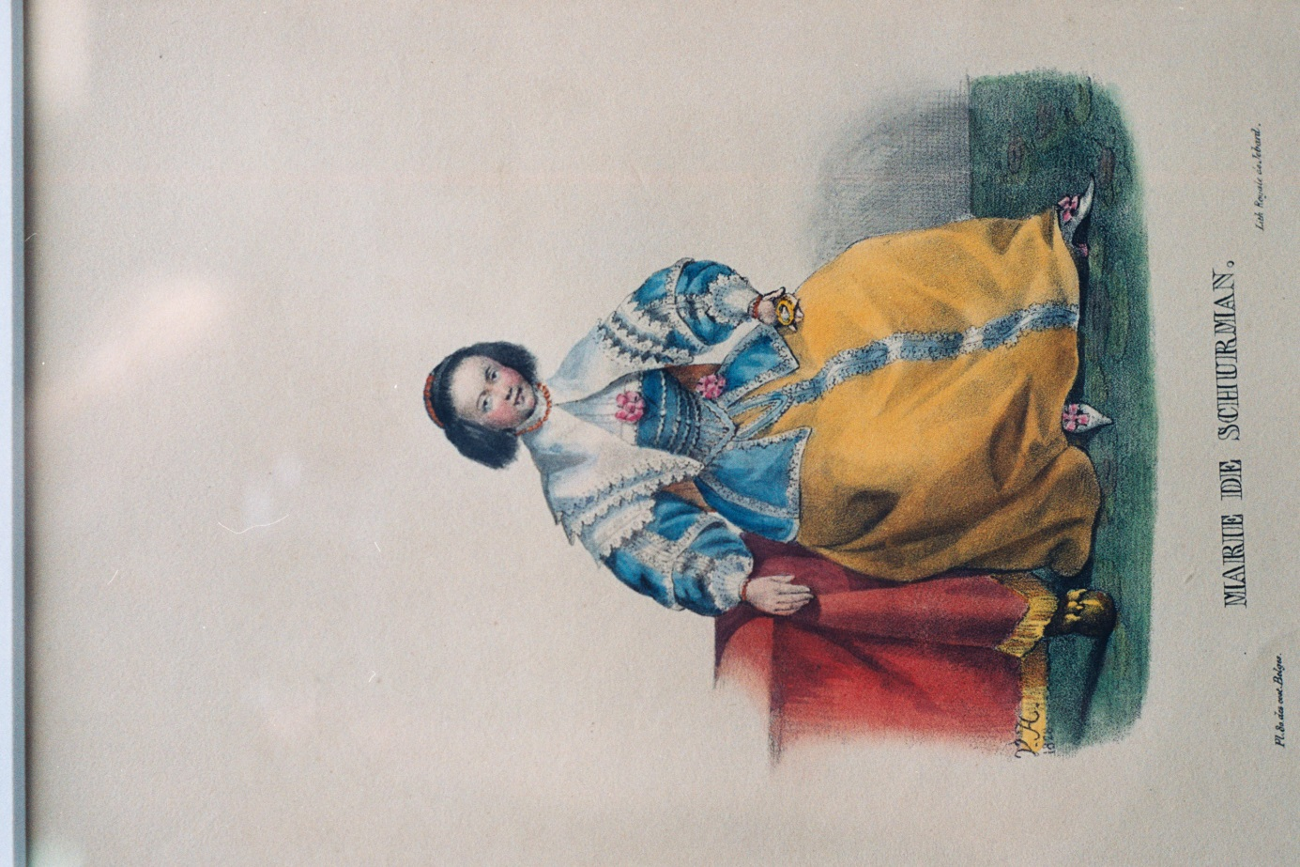
Anna Maria van Schurman as a young woman, portrayed in flowery, colourful clothing; illustration taken from a book on costumes dating from 1830. The portrait has been collated from elements of earlier portraits taken from the works of Cats since 1637. The table with its leg representing a lion’s foot we find on the painting by J.W. van der Wilde dating from 1637 (Museum Martena, Franeker, S0078) and the jacket we recognise from the time M. van Miereveld portrayed her (ca. 1640, Museum Martena, Franeker, S0052). Artist: Jean Louis van Hemelrijck. Illustration from: Costumes Belgiques, anciens et modernes, militaires, civils et religieux. Brussels: La Lith. Royale de Jobard, 1830: plate 80 (Anne-Marie Vanschuurman, Marie de Schurman, 1828).
Preface
In the Schurmanniana Series some (small) source publications about Anna Maria van Schurman will be published, in Dutch as well as in English. Over the past few years I have discovered much previously unknown and undiscovered material. Even though subsidies for philological publications have decreased substantially in recent times, it remains important that sources on and by Anna Maria van Schurman are translated, contextualised and published.
This third publication deals with an unknown letter written in French by Anna Maria van Schurman from Amsterdam to the Utrecht clergyman Petrus Montanus. The letter is dated 15 October 1669, only a few weeks after Van Schurman joined the suspended Walloon minister Jean de Labadie (1610-1674) and a group of his followers, and had moved with them into a house situated at the Lauriergracht in Amsterdam.
Following a short introduction about the life and work of Anna Maria van Schurman (each time containing some new information) as well as the life and work of the practically unknown Utrecht minister Petrus Montanus, the French letter itself is placed in the focus of the research. A transcription and translation are followed by a number of observations and comments on the letter. The passionate glow emanating from the letter is exceptional. It remains open for debate whether one could define this glow as being mystical in nature.
My heartfelt gratitude goes to Chantal Westrate, Erik Heijerman and Dr Otto Plassmann for their enlightening insights.

Pieta van Beek Houten, April 2022

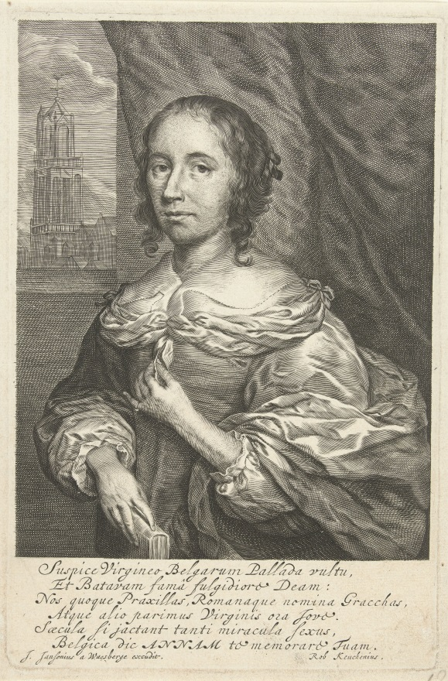
Anna Maria van Schurman against the backdrop of the Utrecht Dom, sometime after 1657, artist J. Van Waesberge, including laudatory poem by Rob Keuchenius. Rijksmuseum Amsterdam, Rijksprentenkabinet.

Anna Maria van Schurman (1607-1678)
At the end of the 1650s the Dutch lawyer, philologist, poet and professor Robert Keuchenius from Arnhem wrote a poem on the Dutch goddess of wisdom. Just like Rome of old could boast of its women of fame, such as Cornelia, the mother of the Gracchi brothers, and Greece of its poetesses such as Praxilla, in the same way the Netherlands could be proud of Anna. He published the poem in his work Musae Juveniles (1662), and included some more laudatory poems dedicated to her. Keuchenius was one of many Europeans who wrote elogia to the learned woman of Utrecht. His poem was placed underneath a famous portrait, yet another version of a painting Cornelis Jansen van Ceulen had made of her in 1657. Who was this learned woman, portrayed with her left hand on her bosom and her right hand on a book, with the Utrecht Dom (Cathedral) as its backdrop? And who was this person described as the goddess of wisdom?
Anna Maria van Schurman was born in 1607 in Cologne as the only daughter of Frederik van Schurman and Eva von Harff, who also had three sons. They fled in 1610 to the family castle of Dreiborn, near Schleiden in Germany, after Protestants started to be persecuted in the Catholic city of Cologne. As of approximately 1615, they moved to Utrecht where she would live the greatest part of her life on and around the Dom Square in Utrecht. As a girl of nearly eleven years old she could finally convince her father that she, although she was a girl, should also learn Latin. This decision was crucial for the further development of Anna Maria van Schurman. The Latin language was the lingua franca of all of Europe: people corresponded in that language, it was used as a medium of instruction at universities, and the text books were written in Latin. In short, it was the language of learning. By way of her knowledge of Latin, Van Schurman as it were received an ‘entry ticket’ into the European Republic of Letters, the circle of learned people corresponding with each other.
Just before her father died in November 1623, she had to promise him that she would never marry. He wanted her to forsake the world in order to be able to blossom as an extraordinary talented woman. She indeed remained celibate all her life and dedicated herself to the arts and science. As of that time she would write her life motto (also called symbolon) next to her signature: the Greek adage ὁ ἐμος ἐρως ἐσταυρωται, my love has been crucified, which was also the motto of the martyr Ignatius of Antioch. The motto did not only refer to the crucified Christ, but also to her own crucified earthly love. Often she would combine the motto with her signature, resembling two halves of a stone, as the other side of her identity. She herself made poems on the motto in German and in Latin (for example the poem ‘In Symbolon suum’ in which she exhorted herself to excel for the heavenly Bridegroom), but so did others, for example the poet Philippus von Zesen, the geographer Johannes de Laet and the aforementioned Robert Keuchenius. The latter made an impressive anagram on her life motto, in which he uses wordplay with ‘amas’ (Latin for ‘you love’) and the initials of her name A.M.A.S. (Anna Maria à Schurman). According to him, the paradox existed in the fact that she who, according to the initials of her name should live in terms of love, rejects a worldly lover, but does not reject the unmarried goddess of wisdom, Pallas Athene, and also not God as personified in the crucified Jesus. He is indeed her Bridegroom:
Ad ANNAM MARIAM a SCHURMAN de ejusdem symbolo: Amor meus Crucifixus est.
[On ANNA MARIA A SCHURMAN in respect of her life motto: my love has been crucified ὁ ἐμος ἐρως ἐσταυρωται]
Why, o beautiful figure worthy of the marriage bed do you despise lovers while you actually dwell in love? Look at your name: you love, ANNA MARIA A SCHURMAN.
Or is it the case that you, being a virgin, reciprocate the love of the goddess Pallas; since through her praise you, as an unmarried woman, can blossom? Look at your name: you love, ANNA MARIA A SCHURMAN.
Or is it the case that you, being a virgin, respond to the love of God through Christ in his blood, namely love crucified? Look at your name: you love, ANNA MARIA A SCHURMAN
Anna, I will agree that it is correct to believe that He [Christ] is your Bridegroom, because you do love. Why? Because you love the Divine, not because you love your own name Anna Maria à Schurman).
In 1636 professor Voetius asked Van Schurman to mark the opening of the University of Utrecht by writing a laudatory poem in Latin. She used this opportunity to complain about the exclusion of women from this institution and pleaded for their admission to the university. She herself obtained such permission and thus she became the first female student at the university. By way of her studies in literature, theology, philosophy and medicine she became the most learned woman of her time. She was proficient in at least fourteen languages (German, Dutch, French, English, Italian, Latin, Greek, Hebrew, Aramaic, Arabic, Syriac, Persian, Samaritan and Ethiopian). She wrote a grammar for the Ethiopian language in Latin. She wrote poems in various languages; her miniature works of art and her calligraphic multilingual specimen pages were sought after for various collections. By way of her correspondence with a large number of learned people all over Europe, as well as by her publications, especially those written in Latin, her fame rose to previously unknown heights.

Everyone agreed: si vir esset, had she been a man, she would have become a professor. Her fame can be measured from the large number of books, poems, portraits and laudatory writings (elogia) in which she is the recipient of admiration. From Scandinavia to Siberia, from Ireland to Italy, from the Netherlands to Hungary, her name and books travelled through Europe. She received thousands of letters and visitors. These visitors to her house Achter de Dom in Utrecht also carried her name and fame back to their homes and thus around the world – not only students, scholars, poets and politicians (for instance the English visitors James Harrington and the member of parliament and antiquarian Simon D’Ewes), members of the Dutch house of Orange and other statesmen, but also queens, such as Christina of Sweden, Maria de Medici, Henrietta Maria of England and Queen Marie Louise Gonzaga of Poland. The latter visited her on the second day of Christmas 1645 and together with her courtiers, engaged in conversation with Van Schurman. She admired Van Schurman’s works of art and had her own picture drawn by Van Schurman.
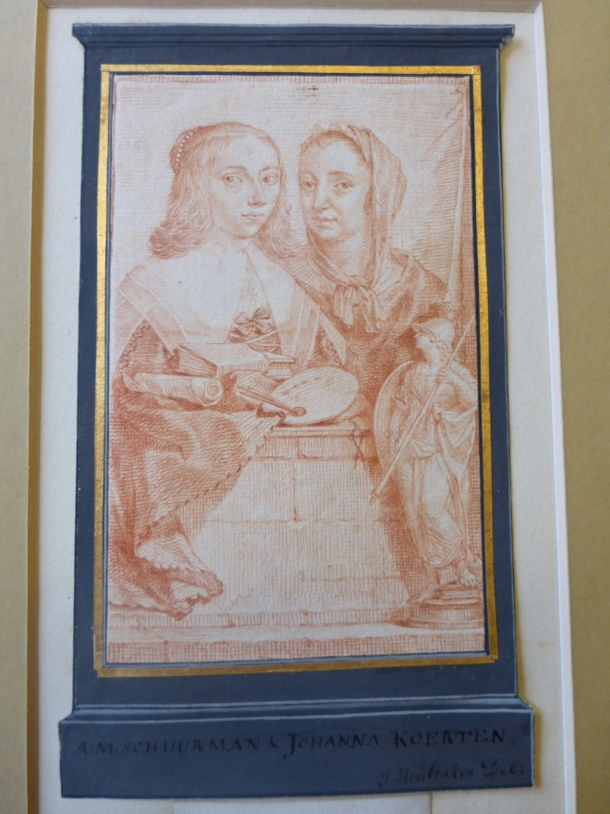
Portrait by Jacobus Houbraken of Anna Maria van Schurman and Johanna Koerten together with the goddess Pallas Athena. Near Johanna Koerten scissors are visible; she was a well-known papercut artist. Van Schurman, who also practised papercutting, is portrayed with books, a paper scroll and a painter’s palette. Underneath the portrait a small picture of Pallas Athene, the goddess of wisdom, is watching. Rijksmuseum Amsterdam, Rijksprentenkabinet

Being pious, of noble descent, celibate and learned was a combination not often found in women; thus, the following was written:
Wie Schurman noemt, noemt in dit woord,
Al wat geleerdheid is in elke stad, elk oord
Er is geen taal ter wereld oyt geweest,
Die zij niet kent, niet spreekt, niet leest.

[Whoever mentions Schurman, mentions in this word
all that is learned in every city, every place
There has never been any language on earth
which she does not know, does not speak, does not read.]

In 1648 she published her major work Opuscula Hebraea Graeca Latina et Gallica, prosaica et metrica at the renowned Dutch publisher Elzevier; a book of which three reprints are known today, namely 1650 (Elzevier, Leiden), 1652 (Van Waesberghe, Utrecht), 1749 (Leipzig), but which was known to her biographer Mollerus in 1744 in more printed editions, dating from 1672, 1700 and 1723. Aside from some new work such as scholarly letters in Latin, Greek, Hebrew and French, some Latin letters and elogia, the Opuscula also contains her previously separately published and printed work De Vitae Termino, dating from 1639, as well as her Dissertatio de ingenii muliebris ad doctrinam et meliores Litteras aptitudine (1641), an essay on women’s ability to study. This dissertatio logica was very influential and was partly translated into English and French.
While living for over a year in her city of birth, Cologne, during 1653-1654, together with her brother and her two maternal aunts Sibylle and Agnes von Harff in connection with a legal battle to win back an expropriated house belonging to her family, she expressed her longing for Utrecht in the poem ‘Aenmerkinghe over ’t onderschijt tussen UITRECHT en CEULEN’ (Remarking on the difference between Utrecht and Cologne), in which she compared Utrecht to Jerusalem and Cologne to Babylon. She usually published her Latin poems, but this Dutch poem was never published, just like most of her other poetry in Dutch. At most these would appear in anthologies or as introductory poems in the work of others, or sometimes printed on a so-called plano (an unfolded folio sheet printed on one side only).

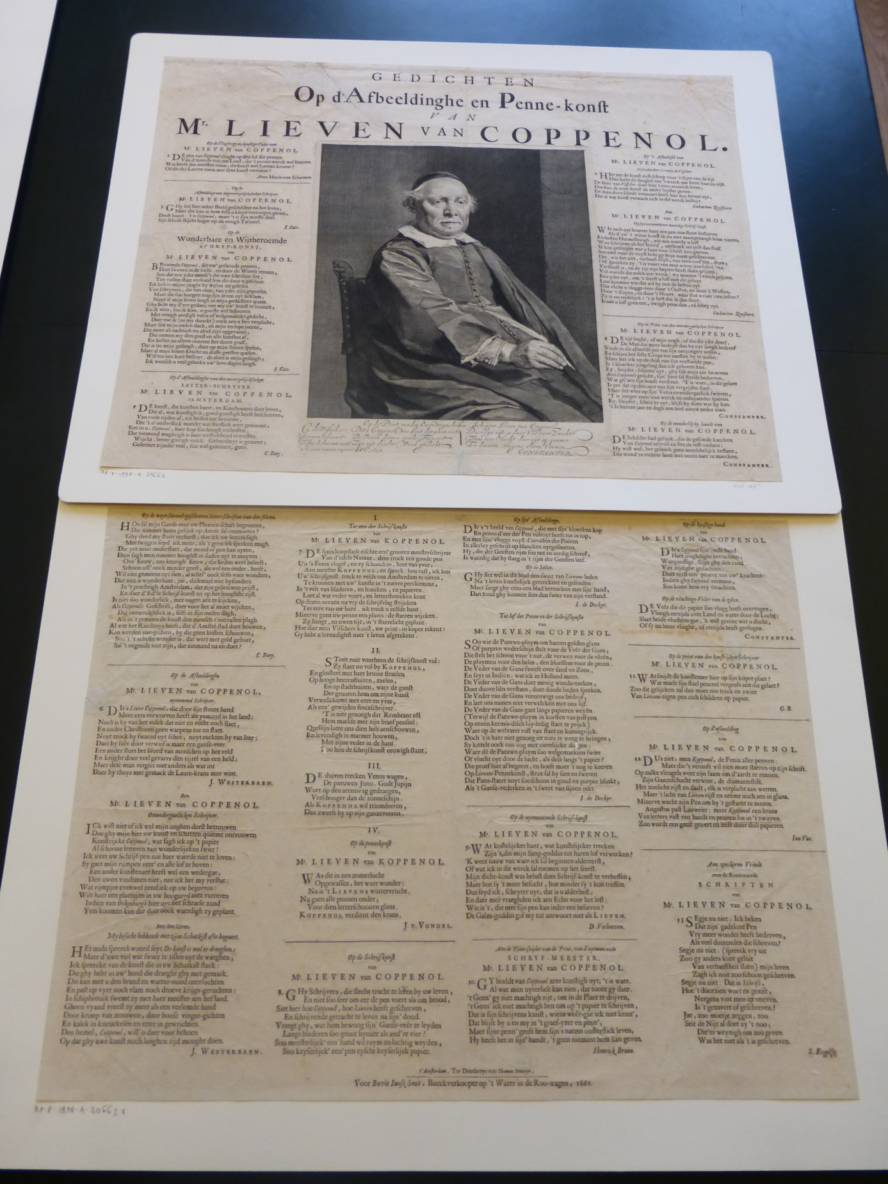
This plano contains 28 poems on the calligrapher Lieven van Coppenol, with Van Schurman’s poem standing first. 1661. Amsterdam, Rijksprentenkabinet

On her return to Utrecht she started to withdraw from, and utter criticism on, the Dutch Reformed Church. She was still receiving visitors and continued to write poetry, among others for the Dutch calligrapher Lieven van Coppenol, which she did together with a number of other Dutch poets. These poems were published in plano format; the print also showed a portrait of him painted by Rembrandt. Her poem in Dutch – as an exception this is not a devout poem – she wrote in her role as a fellow calligrapher; it is a laudatory poem praising the feather or pen used by Van Coppenol:

Op de Vlughtige en Konstige Veder van
Mr. LIEVEN van COPPENOL
De pen van Coppenol vlieght op den lof der pennen
Van d’Arends van ons Land, die ’t pennewerk wel kennen.
Wie heeft den meesten roem, die Kunst met Lauren kroont?
Of die der Lauren roem sijne kunst vertoont?

[On the quick and artful feather of
Mr LIEVEN van COPPENOL
The pen of Coppenol flies on the praise of pens
from the eagles of our country, who know all about calligraphy
Who deserves the most praise – he who crowns art with laurels
or he who shows the fame of the laurels in his art?

She became more radical in her views after meeting the passionate former Jesuit Jean de Labadie. Her learned and pious environment was shocked to the core, especially her former professor, minister and neighbour Gisbertus Voetius, when she left the city, church and university of Utrecht in 1669 and joined a group of radical Protestants led by Jean de Labadie, who called themselves the ‘particuliere gereformeerde, ofte sig reformerende kleine rechtsinnige huijskerke’ (private reformed (or reforming itself continuously), small, orthodox house church). As a passionate member and co-leader of this ‘nomadic’ group she defended this choice in her autobiography Eukleria seu meliores partis electio (Choosing the best part); in this work she labelled much of her former work as vain and frivolous.
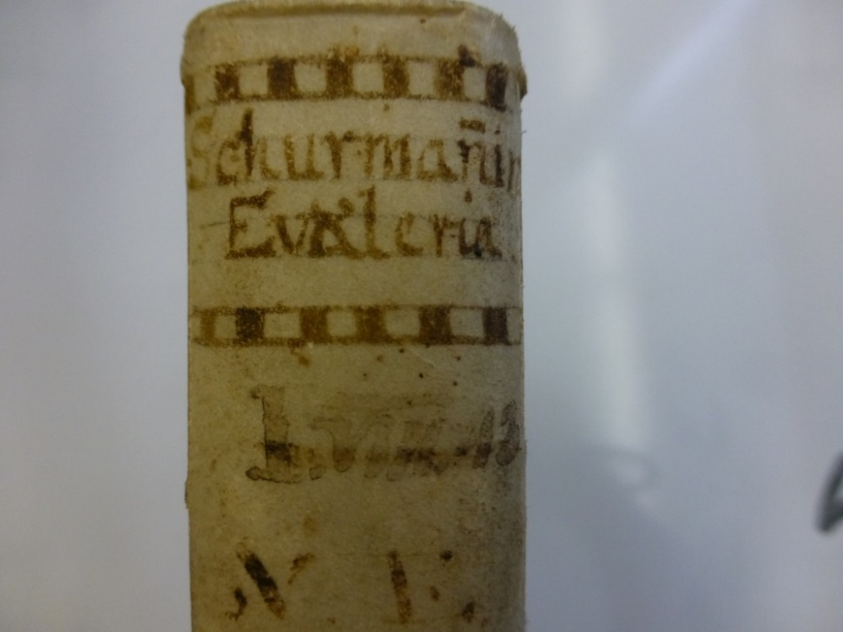
A copy of Van Schurman’s Eukleria in an European university library. On the spine of the book her name is written as ‘Schurmanin’; a name following the pattern of Genesis 2 where Adam names his wife Eva ‘manninne’ (‘woman’).
After having wandered with this group to Germany (Herford) and Denmark (Altona), she died in May 1678 in the Frisian town of Wieuwerd. She was mourned deeply within the circle of Labadists, but outside this group only a handful of people commemorated her passing; one of them being Daniel Meijer, minister in Dreischor near Zierikzee who lamented her death in a beautiful Mnemosynon. In spite of this, her name and fame were rekindled time and again after her death, with a well-deserved Renaissance taking place at present.
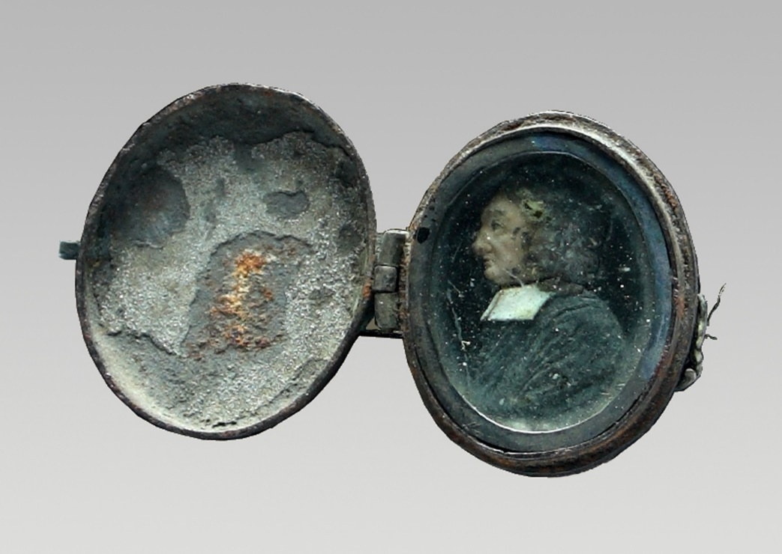
Anna Maria van Schurman, Medaillon with wax sculpture (size 2 cm) of Jean de Labadie. Museum Martena, Franeker
Where exactly Van Schurman was buried, remains a mystery to this day. Her grave has never been found. Was she buried at Waltha Estate, the beautiful Frisian estate where the Labadists lived at the time? Nothing remains today of Waltha Estate but for a row of bricks in a ditch. Van Schurman’s wish, according to a description in her autobiography, was to be buried next to Sara Moot, a friend from the Hague, in the graveyard of Wieuwerd. It is unclear whether this happened. Stories abound about how she would have been buried halfway under the church wall and halfway outside of it, but that is a bizarre story which better fits the later mystification of her person. The possibility also exists that she is one of the remaining mummies found in the church of Wieuwerd, or that her remains form part of the chest with human remains in that church. This can only be confirmed by doing DNA research on the remains.
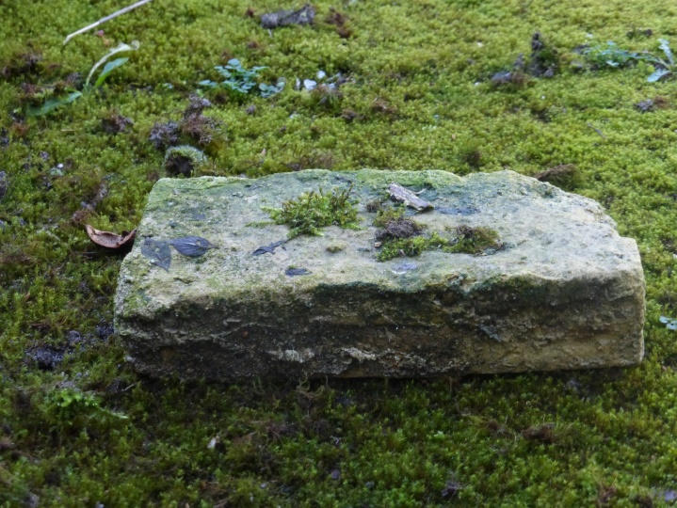
A brick of Waltha Estate, Wiewerd (at present private property)

Petrus Montanus (Amsterdam, 1639 – Utrecht, 1679)
Petrus Montanus was a Protestant church minister in Utrecht. Although he was part of the circle surrounding Voetius, he is one of its least well-known members. He was born as son of the church minister Johannes Montanus and Maria Freilingius in Amsterdam. Just like his father, he enrolled at the Utrecht University to study theology, in 1647. At the time Carolus de Maets was its rector and Voetius one of the professors. Subsequently Montanus continued his studies in Zürich, where he befriended professor Johann Heinrich Hottinger (1620-1667), as becomes clear from surviving letters. Montanus concluded his study on 1 May 1650 with a dissertation under the supervision of Voetius, entitled Problematum De Merito Christi. Until 1653 he continued with formal studies. His first congregation became the so-called Heymelike kruys-kerk binnen Keulen (secret church under the cross in Cologne). The congregation was referred to as being ‘under the cross’ since the Catholic city, once a safe haven for dissidents such as Coornhert and Vondel, had changed into a stronghold of Catholic power. For instance, in 1652 a decree was issued that all assemblies of Protestants were prohibited. Even under these circumstances Petrus Montanus was confirmed on 15 April 1654 as pastor clandestinus:
De nieuwen dienaar D. Montanus is in de tegenwoordige vergaderinge ten eersten male verscheenen, en ingelevert hebbende behoorlijke attestatie van sijne qualificatie tot desen heiligen dienst, is daarop van alle de leden des kerckenraats verwellekomt en als haren ordinaren herder en leeraar in name der gemeynte aangenoomen. De Heer wil sijnen dienst voorspoedigh maken.
[The new minister D. Montanus has appeared for the first time before the present meeting; having submitted certification of his qualification to serve in this sacred service he was welcomed by all members of the church council and accepted as their regular pastor and teacher in the name of the congregation. May the Lord make his service fruitful.]
Aside from a Lutheran congregation and a seafarers’ church of Protestant signature, there existed three congregations ‘under the cross’ in Cologne, grouped according to language (German, French and Dutch). Once a year they held a mutual consultation, but in general they operated independently from each other. Nevertheless, Montanus served the Dutch as well as the French congregation. He held sermons, baptised children and confirmed marriages. For example, on 21 May 1655 he read the notice of marriage between the theologian and professor Frederik Spanheim junior from Heidelberg and Lucretia Elisabeth Bilderbeeck, who subsequently married each other in the free congregation of Mülheim. At a later stage they would become his brother- and sister-in-law.
In 1655 Montanus also attended some services in the English-speaking congregation. However, he criticised them for being too Catholic in their liturgy. He was also annoyed with their practice of kneeling when attending the Lord’s Supper. He himself preferred people to remain standing, although it was Dutch practice to seat oneself at the Lord’s table. In February 1658 Montanus was called to serve the Dutch congregation of Schellingwoude, but for the rest of his life he would remain in close contact with Cologne. For instance, he collected 200 Dutch guilders from the Dutch heirs of Miss Damen, who promised a gift of money to the Cologne congregation while still alive. Petrus Montanus even went to Cologne in 1663 to be married to Anna Maria Bilderbeeck, one of the daughters of the prominent Dutch inhabitants of Cologne Hendrik Bilderbeeck and Anna Franssens. His father-in-law had previously been resident of the Dutch States General.

Den 5 novembris is door den dienaer alhier getrouwt dominus Petrus Montanus met Anna Maria de Bilderbeck ende is van kercken wegen tegenwoordigh broeder N.H., nadat getuygenisse was ingelevert, welke betuyghde, dat de huwelijxproclamatien onverhindert gegaen sijn.
[On the 5th of November the minister here married the Reverend Petrus Montanus to Anna Maria de Bilderbeeck. From the side of the church brother N.H. was present, after evidence had been submitted which confirmed that there was no legal objection to the marriage proclamation.]
By way of this marriage he did not only become the brother-in-law of professor Frederik Spanheim junior (who was married to Lucretia Bilderbeeck), but also of Hendrik Bilderbeeck (news correspondent for the ‘Winter Queen’ Elizabeth Stuart), of the Heidelberg professor in Theology Johan Ludwig Fabricius (who was married to Agnes Sibylle Bilderbeeck) as well as of the court preacher in Berlin, Benjamin Ursinus.
Petrus Montanus was a true follower of Voetius. As a result he was called to Utrecht, where he was confirmed as minister by Voetius, together with Daniel van Hengel and Cornelis van der Vliet, on 22 May 1664. However, his connection with Cologne remained strong. He and other (former) Utrecht professors and ministers such as Lodenstein and Bogaard were often called upon for advice when a vacancy in this congregation had to be filled. They clearly had a say in the appointment of the following ministers in Cologne, namely Arnoldus Nieupoort (serving until 1661), Jacobus Wilting (serving until 1670) and Jacobus de Graef (serving from 1671).
He and his wife Anna Maria Bilderbeeck had four children together: Johannes Henricus (baptised on 31 July 1664 in the Jacobi church), Anna Maria (baptised 6 December 1665 in the Dom church), Fredericus (baptised on 22 February 1667 in the Dom church) and David (baptised on 15 March 1668 in the Catharijne church).
In the disaster year 1672 the French invaded the country and occupied the city of Utrecht. The Dom church was plundered, the furniture damaged by flogging and once more Holy Mass in the Catholic tradition was celebrated in the church building. On Sunday 21 July 1672 Petrus Montanus held such a fierce sermon against these ‘scandalous activities of the papacy’ that he was banned from preaching by the Utrecht city council, who wanted to avoid problems with the occupying forces. His colleagues Jodocus van Lodenstein and Cornelis van Vliet were taken hostage by the French and interned in Fort Rees. Petrus Montanus was one of the 17 guarantors who assisted in paying the ransom of 20 000 guilder in order to free the ministers who were held hostage.
During this annus horribilis Montanus asked the Cologne congregation for financial assistance ‘during these sad times of war’ and indeed received an amount of 50 rixdollars from them:
Is ingekomen verzoeck van dominus Montanus, leeraer in de gemeente tot Utrecht, nopende eenich soulagement voor de arme en nootlijdende gemeente aldaer bij desen bedroefden krijchstijdt; is op ratificatie der duytsche en fransche broeders toegestaen de somme van 50 rd.; ‘tselve is geconsenteert en sal uyt der passanten kas betaelt werden.
[Have received a request from the Reverend Montanus, minister of the congregation of Utrecht, asking for some relief for the poor and financially distressed congregation there during these sad times of war, after ratification by the German and French brothers it was decided to allow the sum of 50 rixdollars, which has been approved and will paid from the daily cash funds.]
Soon after his appointment in Utrecht, Montanus complained about the heavy workload in the large church of Utrecht. The church needed more ministers; one minister for 3000 souls was definitely inadequate. Other minsters complained about this as well, but in the case of Montanus his compromised health would have played a role as well. He was often ill and had to be excused from his duties. In order to reach members of his congregation in spite of his ill health, he published a sermon in 1670 entitled Ernstige op-weckinge om te yveren voor ’t Huys des Heeren. Bysonderlick noodigh in dese laetste verdorvene tijden; Over de woorden Psalm 69 vers. 10. Den yver van u Huys heeft my verteert (Grave exhortation to continue the work for the House of the Lord, especially needed in these wicked end days, on the words of Psalm 69 verse10: ‘For the zeal of thine house hath eaten me up.’)
A number of occasional poems from the hand of Petrus Montanus are known, for instance the elegies for his colleagues Gisbertus Voetius and Andreas Essenius. Montanus shows himself to be a pious, somewhat unconventional man who did not always accept without question the opinion of Voetius or the line taken by the church. This became clear already when he attended an English church service in Cologne where he preferred to celebrate the Lord’s Supper with attendants standing up, while the Dutch used to sit down and the English used to kneel down. In addition, Montanus very closely followed the exciting story circulating at the time, of the three Jewish tribes Gad, Zebulun and Ephraim settling in Palestine, although Voetius relegated this story to the realm of myths. Montanus wrote a letter to Hottinger stating that Comenius had written to him that a large ship had set sail from Bristol to Palestine, filled with people who wanted to ascertain the truth with their own eyes.
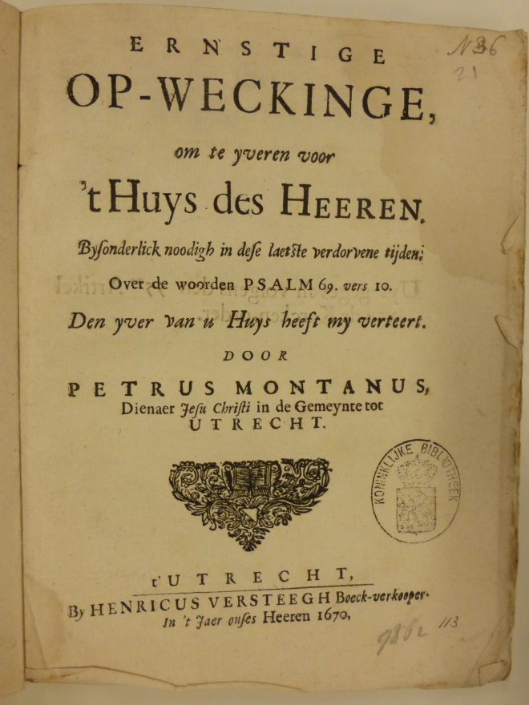

Title page of the published sermon Ernstige Op-Weckinge

In spite of this, Voetius remained favourably inclined towards Montanus; as late as 1676 he still dedicated the third volume of his work Politica ecclesiasticae to Montanus and to some other Utrecht colleagues and ministers, namely Johannes van Heymenberg, Petrus van Breen and Cornelius de Rijp. The intimate connection between Voetius and Montanus also becomes clear from the description of Voetius’ deathbed in 1676. This deathbed attracted numerous visitors, including Montanus. A dialogue between them ensued; the one would cite a sacred text, the other would complement the citation. For instance, Voetius cited some lines from a hymn ascribed to Bernard of Clairvaux, ‘Desidero te milies Mi Jesu, quando venies? (My Jesus, I long for You a thousand times; when are You coming?), complemented spontaneously by Montanus with ‘Me te laetum quando facies? Me de te quando saties? (‘When are You coming to let me rejoice, when to saturate me?’). Subsequently Montanus cited Tertullian: ‘Al verginck de werelt, als ik maer mijne lijtsaemheid beware’ (Even if the world was coming to an end, as long as I could retain my resignation), to which Voetius replied with a suitable citation from Tertullian: ‘Sulcken sekeren bewaerder van onse geduldigheid is de Heere’ (Such a true custodian of our patience is the Lord). In the ensuing conversation Montanus cited from Ambrose of Milan: ‘Ten verdriet my niet geleeft te hebben, ick vreese ook niet te sterven’ (It does not cause me grief to have lived; neither do I fear death), the dying man man gravely replied with the famous words of St Augustine: ‘Wee selfs het prijselijckste leven des menschen indien, ’t buiten Gods barmhertigheid werdt aengemerkt’ (Woe to the most praiseworthy life of a person when it is noted down outside the grace of God). The exchange did not serve to show off their mutual learning, but entailed comforting the other with deeply familiar Latin texts which both knew by heart. After Voetius’ death Petrus Montanus wrote an epitaph in which he contrasted Voetius’ short stature with his huge intellect:
In deze kleine urn wordt Gisbertus Voetius gehouden.
Groot van verstand, klein van lichaam was hij.
Het kleine lichaam wordt in de geringe urn verteerd,
maar laat die geest zich verheugen in bovenaardse streken.
De bedroefde Petrus Montanus heeft dit voor zijn eerbiedwaardige vroegere leermeester en latere collega neergelegd.
[In this small urn Gisbertus Voetius is held.
Large was his intellect; small was his body.
The small body will be consumed in the modest urn
but the mind will rejoice in divine regions
The mourning Petrus Montanus wrote this down for his venerable former mentor and later colleague.]
Suffering from ill health, Petrus Montanus took early retirement. Just one month after becoming an emeritus minister he passed away, on the second Christmas day in 1679. He was buried in the Jacobi church in Utrecht.

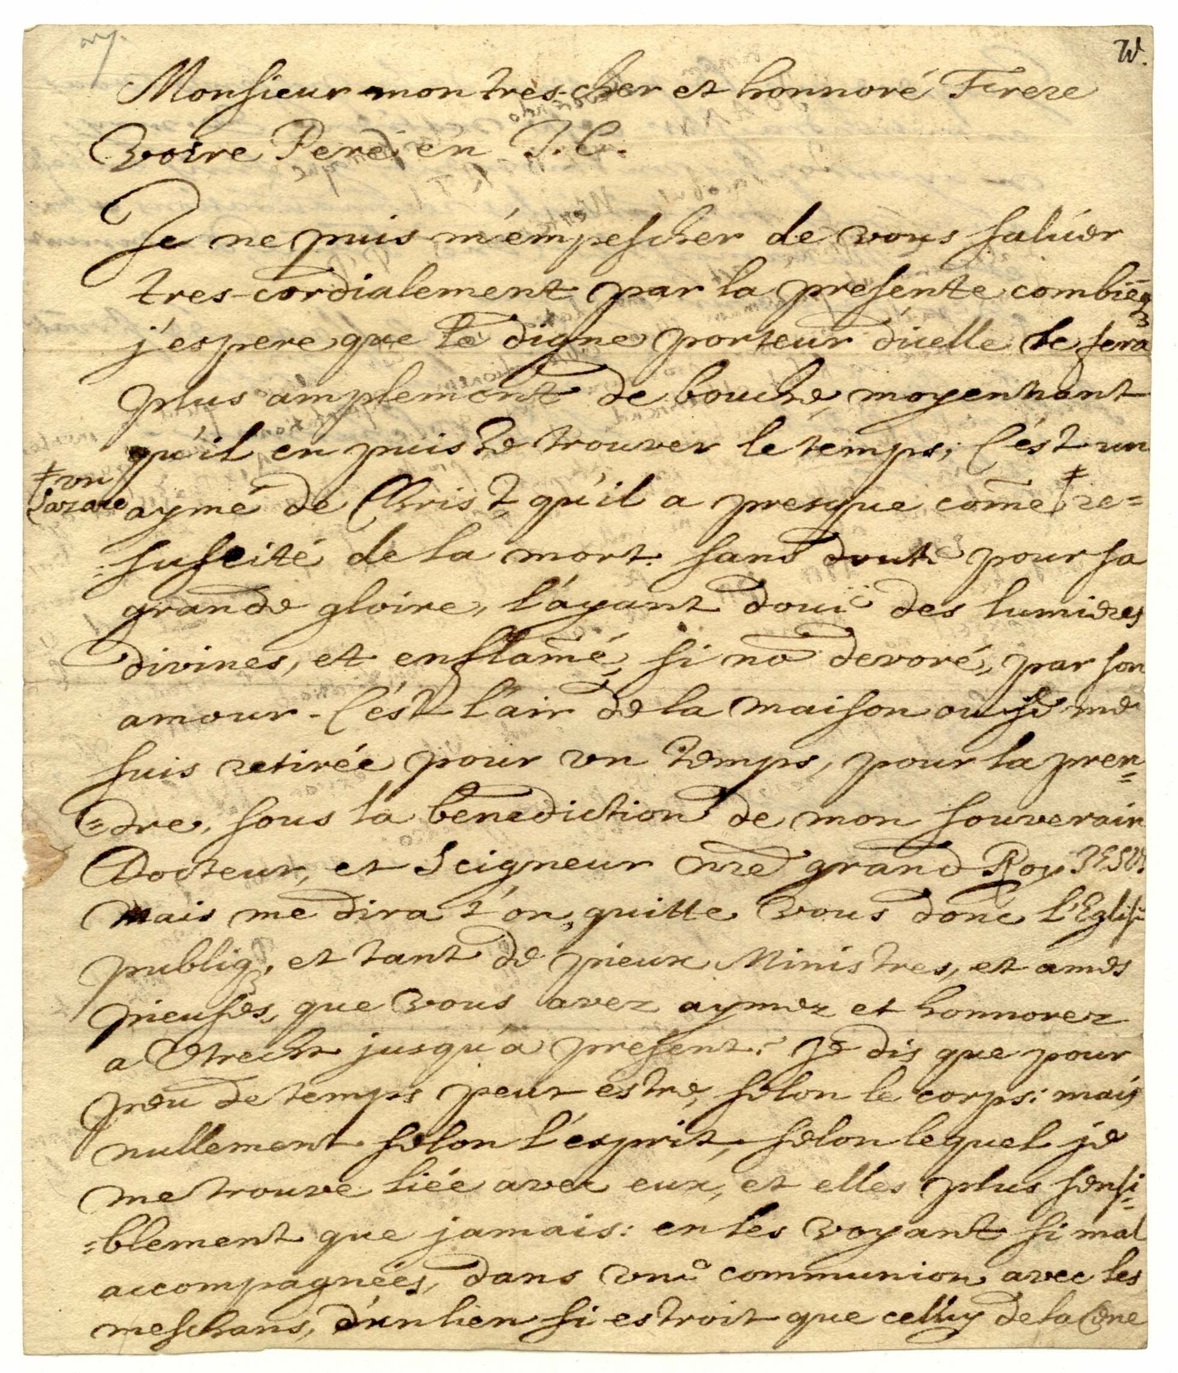
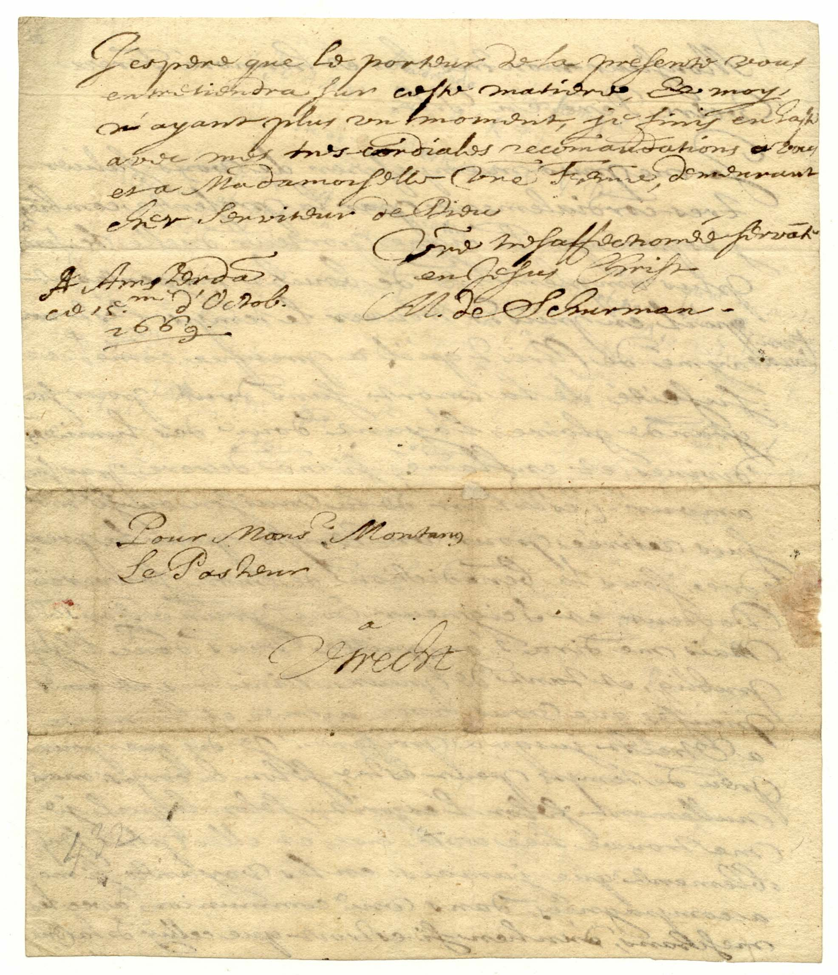
French letter written by Anna Maria van Schurman to Petrus Montanus
Germanisches Nationalmuseum, Nuremberg

Letter written by Anna Maria van Schurman to Monsieur Montanus in Utrecht
Monsieur mon très-cher et honnoré Frere
Votre Pere en Jesus Christ

Je ne puis m’empescher de vous saluer
tres-cordialement par la presente combienque
j’espere, que le digne porteur dicelle le sera
plus amplement de bouche, moyennant
qu’il en puisse trouver le temps; C’est un
aymé de Christ, qu’il a presque comme un Lazare re-
suscité de la mort. Sans doute pour sa
grande gloire, l’ayant doué des lumieres
divines, et enflammé, si non devoré, par son
amour. C’est l’air de la maison ou je me
suis retiree pour un temps, pour la pren-
dre, sous la benediction de mon souverain
Docteur, et Seigneur notre grand Roy JESUS
Mais me dira t’on, quitte vous donc l’Eglise
publique et tant de pieux ministres, et ames
pieuses que vous avez aymez et honnorez
a Utrecht jusqu’a present? Je dis que pour
peu de temps peut estre, selon le corps, mais
nullement selon l’esprit, selon lequel je
me trouve lieé avex eux, et elles plus sensi-
blement que jamais: en les voyant si mal
accompagneés dans une communion avec les
meschans, d’un lieu si estroit que celluy de la Cene
J’espere que le porteur de la presente vous
entretiendra sur ceste matiere. Ex moy,
n’ayant plus vn moment, je finis en hâte
avec mes tres cordiales recommandations a vous
et a Madamoiselle votre Femme, demeurant
cher Serviteur de Dieu
Votre tres affectionneé servante
en Jesus Christ
AM de Schurman
Amsterdam,
ce 15e d’Octobre
1669

Pour Monsieur Montanus
Le Pasteur
A Utrecht

Translation
My lord, my very dear and honoured brother,
Your Father in Jesus Christ [be with you]
I cannot desist from greeting you from the heart by way of this letter, although I hope that the dignified bearer of this letter will convey these to you in much more detail by mouth, on the condition that he will find time to do so. He is beloved by Christ, and has been almost woken up from the death just like Lazarus. Without doubt this was done to God’s honour, because he has been endowed with Godly light, and he is enflamed, if not devoured, by his love.
This is the atmosphere as well of the house where I have retreated for a while, to taste this [love] under the blessing of my sovereign Doctor and Lord, our great King Jesus.
But, people will ask me: Are you thus leaving the official church of Utrecht and so many devout ministers and devout souls whom you loved and honoured?
My reply is that it is perhaps only for a short time, in the body but not at all in spirit, by which I feel still united with them, even more intense than ever before: because I see them being accompanied by sinners in a sinful way, at an event where this distinction is so important, namely the Lord’s Supper.
I hope that the messenger carrying this letter will engage in discussion with you on this matter. Regarding myself, I have run out of time, and am ending [this letter] in a hurry, with my heartfelt greetings to you and to madame your wife, all the while remaining, dear servant of God,
Your very affectionate maidservant in Jesus Christ
A.M. van Schurman
Amsterdam, 15 October 1669

Comments
This letter from Amsterdam is the first known document written by Anna Maria van Schurman after her departure from the city of Utrecht, joining Jean de Labadie in Amsterdam. She was not only a sympathiser of De Labadie, she also felt responsible for him, ever since he had arrived in the Dutch Republic in 1666. It was in particular his passionate demeanour which had touched her brother Johan Godschalk van Schurman so deeply when he met De Labadie in Geneva, when he decided to live under De Labadie’s roof for a full three months. Inspired by her brother’s stories and letters, she desperately wanted to meet this ‘man of God’. After her brother’s death in September 1664, she continued to correspond with De Labadie; it was thanks to her letter that she wrote to him on behalf of the Utrecht church council that he had been persuaded to come to the Dutch Republic and had accepted the call from the Walloon Church in Middelburg, Zeeland. In the three years that he remained a minister there, Anna Maria van Schurman regularly travelled to Zeeland to attend his church services, accompanied by friends who ‘loved devoutness’ as she did. After having been unjustly deposed in a tumultuous struggle in Middelburg and Veere, he moved to Amsterdam with his ‘disciples’ Pierre Yvon, Pierre Dulignon and Jean de Menuret, where Van Schurman was one of the first followers to join them.
She left the city of Utrecht at the end of September or beginning of October 1669 and joined the religious community to live with them – although not immediately. She knew how much criticism she would encounter when she, as an unmarried woman (even at the age of 61, even though she led a life of celibacy) would move into the same house as a number of unmarried men; therefore she tried other avenues at first. But Amsterdam experienced a huge housing shortage at the time; in spite of an extensive search, she and her friend Catharina Martini as well as her woman servant Cecilia van Neel could not find suitable lodgings. For that reason, they returned to Utrecht and later made a second attempt, but once again could find nothing to rent. At this stage Jean de Labadie offered them the use of the ground floor of the house they occupied on the Lauriergracht, near the Prinsengracht. But she did not move into the house on her own; she was accompanied by a second cousin (possibly Johan Abraham, born 18 November 1655) as well as her friend Catharina Martini, who moved with her into the ground floor of De Labadie’s house. They were joined there by two widows (one of them Elisabeth Bisschop-van der Poorten) with three or more children as well as three servant girls who took care of the household tasks, among them also Van Schurman’s woman servant. A number of members from the De Labadie’s Middelburg congregation also joined them. Over time, some 25 to 40 people came to live in the house; from all over the Dutch Republic as well as from the Rhineland (among others Anna de Veer from Dordrecht, the sisters Van Aerssen van Sommelsdijck, the sister of mayor Van Beuningen), but the Swiss citizen Antoine Lamarque and his brother Simeon would also be accommodated in the community’s lodgings, which would be extended to three adjoining houses on the Lauriergracht. Some relatives of Van Schurman also moved into the house; for instance Aemilia and Vincentia van der Haer as well as Levina van der Haer-Ockerse.

Since her promise of celibacy at the deathbed of her father, Anna Maria van Schurman had lived a celibate life; although this did not mean that she had never doubted this decision or experienced feelings of infatuation. Men such as Constantijn Huygens and Caspar Barlaeus had made coarse jokes and even wrote poems alluding to Van Schurman’s virginity, but many others, nationally and internationally, seemed to respect her choice. But when she moved into the same house as Jean de Labadie, even though numerous other men, women and children joined them, all restraint was set overboard. Writers tried to outdo each other in accusing her and the so-called ‘family’ of sexual escapades. It was said that she married De Labadie in secret; Constantijn Huygens wrote about ‘die Franse haan die meende haar de godsvrucht in te moeten gieten’ (that French rooster who thinks he should pour devotion into her). But Jean de Labadie hit back on her behalf and wrote that Voetius ‘Juffrouw Schuurmans, toen ze jong was om zoo te spreeken, aangebeden en tot zyne Afgodinne had gemaakt en dat hy ze onder de voet trapt en leelyk uitmaakt, nu zy oud van jaaren [...] is’ (had worshipped Miss Van Schurman and in a manner of speaking had made her into his female idol in her youth, and now that she is of old age, he tramples her underfoot and maligns her).
We do not know much work from the hand of Anna Maria van Schurman dating from her sojourn in Amsterdam. Their stay there was tumultuous, and soon, at the end of 1670, the group of Labadists would leave Amsterdam for Herford in Germany. Aside from this letter to Montanus we are aware of her defensive letter to the Utrecht church council and the sharply worded letter to her cousin (probably to Abraham van Schurman). This letter contains arguments for her decision to join the Labadists: ‘Aengaende mijn verblijf met een goedt ghetal van godvruchtige zielen, zijnde te samen vergadert in een Huys alhier tot Amsterdam’ (In connection with my sojourn, together with a good number of devout souls, who are gathered together in a house here in Amsterdam). In the letter to Petrus Montanus she is still of the opinion that she will only stay in Amsterdam for a short time. However, only a few short months later she would indeed sell her house in Utrecht and use the revenue of the sale for the upkeep of the group.
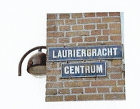
Lauriergracht in Amsterdam, near the Prinsengracht. It is not yet clear which house(s) the Labadists occupied. They rented the houses from one of the richest men in Amsterdam, Jeronimus de Haze. The German theologian Johann Georg Gichtel lived across the street, and the alderman Huydecoper van Maarseveen near to them; both had their addresses at the Lauriergracht.

Why?
Various explanations have been given for Van Schurman joining the Labadist movement, for instance the following: she followed her desires and as an old spinster she chased a man; her judgement had become clouded; she was deeply disappointed about the decline of true Christianity within the Reformed Church; she wanted to follow and imitate Christ; she wanted to bring the description in Acts 2 into practice; she wanted more room for her role as spiritual leader; she was sick and tired of her fame; the death of her nearest relatives brought her, as a single woman, into an identity crisis which could be resolved by belonging to the group of Labadists.
It is indeed the case that from her writings the disappointment with the church she belonged to comes to the fore, just like the themes of the imitation of Christ, her preference for practices of the early Church and her fascination with De Labadie (in a spiritual and not sexual sense). For her, he took the place of her dead brother. Furthermore, the Labadists allowed her more freedom of expression as a theologian. For a single woman the community of Labadists, which functioned as an extended family, would also have been attractive. The longing for martyrdom which she had experienced since childhood and which had always fascinated her, also played an important role, as well as her indignation about the unjust deposition of Jean de Labadie as a minister.
From this letter written in Amsterdam, two issues come to the fore. The courier of the letter, just like everyone in the Amsterdam community, is ‘filled with love’. Van Schurman herself is also breathing in this spirit of love, and that is the reason why her letter glows with love – love for the ‘great King Jesus’; love which puts them to fire and sword and devours them. Van Schurman had written earlier about the glow of passionate love, in her poem ‘Gezang over het Geestelijk huwelijk tussen Christus en de gelovige ziele’ (Song on the spiritual marriage between Christ and the faithful soul), but in that case the description had been much more distant (see below).
Aside from the focus on love which attracted her, there was also her disgust with the practices of the (Utrecht) church. According to Van Schurman, the church was filled with ‘un-Christians’ as well as true believers. People who clearly led a wild and promiscuous life and who thus did not practise what was preached, joined the true faithful on the church pews and even partook in the Lord’s Supper together with the true believers. This had been a thorn in her flesh since the early 1660s, long before she made Jean de Labadie’s acquaintance. In ever stronger terms and with increasing passion she had challenged this ‘decline of Christianity’, this ‘corrupted’ Christianity, in her letters and poems, for instance in this poem that she wrote on 6 September 1665 at the Abbinga estate near Leeuwarden:
Verbastert Christendom! Waer is u eerster luijster?
Van liefde, hoop, geloov? hoe schijnt u licht zo duijster?
[Corrupted Christianity! Where is your former lustre?
Of love and hope and faith? Why does your light shine so darkly?]
However, in this poem she still is hopeful; despite the decline of Christianity, she laments: ‘God laet ons van herstel noch blijven in verwachtingh’ (God still allows us to expect restoration). In the second part of the poem, she praises some Frisian ministers who try to curb this decline.
At an earlier stage, in 1663, she had complained about the same issue and had set out her opinion in a letter to minister Johannes Arnoldi; this letter was later published in part in a volume published by F.S. (Frederik Spanheim junior):
… waer uyt blijken kan dat ik al lange voor desen so eene droevige en schrikkelijk vermengde Kerke neffens andere, getracht hebbe te ondekken; en de Voorgangers der selve tot haer herstel, en tot scheyding der gelovigen van de ongelovigen aen te setten.
[… from which it will become clear that I for a long time have attempted to expose such a sad and horribly mixed Church as well as other matters, and have exhorted its leaders to expedite its restoration and to separate the faithful from the unbelievers.]
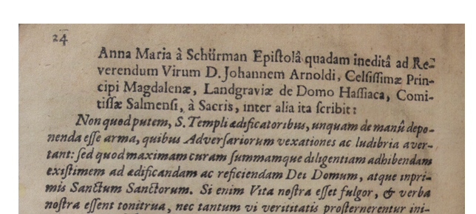
Latin letter by Anna Maria van Schurman to Johannes Arnoldi

As early as 1660 she writes the following in the poem ‘Bedenckingen over de toekomst van Christi Koninkrijk’ (Contemplations on the future of Christ’s Kingdom):
Doch nu een doodtsche nacht heeft onse tijt bekropen,
En dat de wereld self is in de kerk geslopen
Soo datmen CHRISTI vriend, noch vijand onderkent;
Nu sietmen meenig doorn, die CHRISTI kroone schent.
En nu men ’t Christen-heyr soo verre siet verbastert,
Dat meest om harent wil haer Koning wort gelastert,
Nu wacht men weer een vier, dat al het schuym verteer,
Tot dat een suyver Volk sijn Name weer vereer. (lines 89-96)
[...]
Nu, yder ooge siet, hoe dat de hooge wallen
Van ’t waer Jerusalem zijn tot den grond vervallen,
En hoe des Heeren huys dient weder opgeciert;
Te meer nu d’aerdsche mensch het sijn te cieren giert.

[But now a deadly night has descended on our time,
since the world itself has made the church its home
in such a way that one cannot distinguish Christ’s friends or foes
Many a thorn is visible which violates Christ’s crown
and now that one sees the Christian hosts so corrupted
that because of their behaviour their King is slandered,
Now we await a fire, which will devour all the scum
until a pure community will honour his name once again.
[…]
Now everyone can see how the high walls
of the true Jerusalem have been razed to the ground,
and how the Lord’s house should be redecorated again
even more now that worldly people wish to decorate their own houses so much.
On 12 March 1669 she published a pamphlet at publisher Jacob van Velsen; a poem entitled Pensées d’A.M. de Schurman sur la Reformation necessaire à present à l’Eglise de Christ (Thoughts of A.M. van Schurman on the reformation needed at present in the church of Christ’) in which she attacks the church:
Mais Dieu n’habite point aux Temples faits de mains,
Où les bourgeois des Cieux se joignent aux mondains

[But God does not live in temples made by hands
where citizens of heaven join those who have frivolous worldly concerns]

She also wrote from Amsterdam to her cousin, in a fierce defensive letter on the topic of ‘Kerckelijcke Consideratie’ (Considerations on the church), even referring to the church as ‘diepte des satans’ (depth of Satan):
… dat men ‘de grond-regelen des Christendoms so verre onder de Christenen heeft kunnen vergeten, dat sy haer met de wereld, en de onchristenen, hoedanighe alle onbekeerde, en aerdschgesinde menschen zijn, soo naeuw, selfs in een kerkelijk lichaem t’samen vereenigen, dat men schier van alle deselve seggen moet, dat de wereld in de Kerk is, ja dat de Kerke de wereld geworden is.
[… that the ground rules of Christianity have been forgotten among Christians so completely that the church aligns itself with the world, and with the unfaithful, thus holding all unrepentant and world-oriented people in such a close connection and unifying them in one body of the church, that one has to say of nearly everyone within the church that the world is inside the church; yes, even that the church has become the world.]
But in the letter under discussion, dated 15 October 1669, the tone is milder and still friendly; she is still under the impression that her sojourn in Amsterdam will only be for a short time. She promises to return to the church of Utrecht, but only when this church has purified itself, in spite of her love for this church and the church’s love for her. That is why she writes to her friend, the Utrecht minister Petrus Montanus; she wants to persuade him to follow her example.
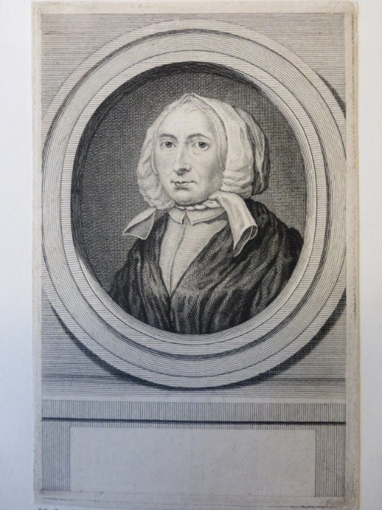
Self-portrait of Anna Maria van Schurman as a Labadist. Amsterdam: Rijksprentenkabinet

Adressee: Petrus Montanus
Van Schurman had known Petrus Montanus from the time of his university study in Utrecht. She had also been in close contact with him during the time when he was pastor clandestinus in Cologne during the time she temporarily lived in this city with her brother Johan Godschalk and her aunts Agnes and Sibylle von Harff (1653-1654). In her poem on the differences between Utrecht and Cologne she sings the praises of Utrecht as being Jerusalem and condemns Cologne as being Babylon, even though her city of birth was beautifully located, had great food, and its inhabitants were friendly and welcoming. However, she was not able to attend church in the city:
Al zijn der kerken veel, sij sijn ons alle tegen
Wij moeten over Rijn door sneeu en regen.
[Even though there are many churches here, they are all against us
we have to cross the Rhine through snow and rain.]
In this poem, written in early February 1654, she does speak of other believers who joined her in facing the dangers, but she does not mention Petrus Montanus; neither does she do so in the letter which she wrote shortly afterwards to her friend Van Soulekercken. Petrus Montanus would only arrive in Cologne as the new minister several months later.
From Cologne, Montanus wrote about Anna Maria van Schurman in his letter to Professor Hottinger in Zürich, for instance when she and her brother left Cologne again in August 1654:
Clarissima Domina Schurmanna et frater eius hic aliquo tempore habitarunt sed nunc Ultrajectinum redierunt.
The very famous Lady Van Schurman and her brother have lived here for some time, but they now have returned to Utrecht.
During his time as a minister in Utrecht, he also sent letters to Professor Hottinger in Zürich in which he conveys greetings from Van Schurman as well as from his professors and colleague ministers.
In her Amsterdam letter to Montanus, Anna Maria van Schurman does not only send her regards to Petrus Montanus, but also to his wife Anna Maria Bilderbeeck, one of the daughters of Hendrik Bilderbeeck and Anna Franssens. She married Petrus Montanus in 1663 and together they had a number of children. But Anna Maria van Schurman knew Anna Maria Bilderbeeck personally from the time she spent in Cologne. The prominent Bilderbeeck family held a central position within the secret congregations under the cross. For instance, Petrus Montanus had his mail sent to the address of the Bilderbeeck family to reduce personal danger.
Aside from the fact that Van Schurman was close to Montanus and his wife, and also was aware of the fact that he was born and bred in Amsterdam, she also knew how closely he identified with the ideals of the Dutch Second Reformation (‘Nadere Reformatie’). She did not write to all ministers in Utrecht, but selected Petrus Montanus on purpose.

Content
Anna Maria van Schurman writes a letter from Amsterdam to Petrus Montanus in order to defend herself and to persuade him to accept her point of view. She now lives in a house where love reigns supreme, where the ‘great King Jesus’ reigns. She poses the rhetorical question asked by so many people: why did she leave the Utrecht congregation which she once held so dear? She tries to reassure Montanus by stating that she still cherishes that church, and that in spirit she is still intensely connected to the Utrecht congregation. She has just left in body, and this only for a short time. But as long as the Utrecht church consists of true Christians as well as Christians only in name; as long as the Lord’s Supper is served to true believers as well as to heathens or Christians only in name, she will stay away from this church, however much she feels connected to it. She stresses the point that the courier of the letter will explain her point of view in more detail, and then ends the letter in a hurry and with kind regards to him and his wife.

Courier
Who could have been the courier of this letter which Van Schurman wanted to be delivered in person to Montanus? She repeats the promise that the courier will further explain the letter to him. In any event it would have been a convinced Labadist. Each of the three ‘disciples’ of Jean de Labadie used to travel for missionary purposes: Pierre Yvon, Pierre de Lignon and Jean de Menuret. But the letter-bearer had been ‘almost raised from the death, like Lazarus’, a reference to the well-known Bible story from the Gospel of John (11:1-44) where Lazarus, after having spent three days in the grave, is raised from the death by Jesus. It could metaphorically refer to a person who was raised from spiritual death to new life – a new convert. But this metaphorical use is to the best of my knowledge unknown in the religious parlance of the time. It is more likely that Pierre Yvon was the courier – the best-known and most learned follower of De Labadie, who later became his successor. Yvon had indeed just recovered from a deadly disease. Furthermore, he had undertaken several missions in the past, making it more likely he was the messenger being used. At previous missions he had visited Utrecht, where he spoke with Voetius. He was highly educated, erudite and proficient in numerous languages. It seems plausible that Pierre Yvon, with his capabilities, was chosen to confront Petrus Montanus.

Language
The letter has been written in elegant French. It is known that Van Schurman was praised nationally and internationally for her command of the French language, among others by Andreas Rivet and Balzac, not only for her letters written in that language, but also for her poems. In respect of the letters written in French: she wrote to a number of noblewomen, such as Mmes De Vervou, De Merveil, De Brunswick et Luneburg; to the princesses Elizabeth of Bohemia and Anne de Rohan; to professors Du Moulin, Saumaise, Spanheim; to the wives of professors Coutel and Saumaise; to the French learned women Marie Jars du Gournay and Marie du Moulin, and to the Frisian high-level official Philip Ernst Vegelin van Claerbergen. French was spoken everywhere at the time: at court, in the civil service and in the higher echelons of society. In her capacity as a Labadist member she wrote in French to, among others, Antoinette Bourignon and princess Sophie of Bohemia. The letter to her friend princess Elisabeth of Bohemia (also known as Elisabeth of the Palatinate), who became abbess of the Lutheran convent in Herford, Germany, has been lost, just like so many other letters.
Having mainly used Dutch as her language of faith in her pre-Labadist period, as a Labadist she now also starts to use French and Latin for this purpose. She writes in Latin especially when she deals with learned opponents or sympathisers, but French is used much more frequently; thus she writes a letter in fluent French to Montanus. Why she chose to write a letter in French to Montanus, who was born and bred in Amsterdam, and to send it to him by personal courier, is unclear. Why to him, and why not in their shared native tongue Dutch?
In the first place this had to do with the strict selection process applied by the Labadists in Amsterdam. Using their personal networks, they approached (mostly well-to-do) truly devout people to join the movement. Van Schurman knew Montanus personally and knew he was proficient in French, since he had served the Dutch as well as the Walloon congregations in the Cologne church under the cross. Through his marriage, he had joined the higher echelons of society where it was also fashionable to speak French. Even more important was the fact that she now lived in an environment where French was the native language of its leadership as well as that of many of its members, for instance Jean de Labadie, Pierre Yvon, Pierre du Lignon and Jean du Menuret. In this way, French became the language of her flaming new tenets of faith, and she is using this here in a tactical way by addressing him, a member of the official church (‘l’Église publique’), as being one of the many pious ministers and devout souls (‘tant de pieux ministres et ames pieuses’) in Utrecht.
For the first time in her writings Van Schurman here uses the phrase ‘notre grand Roy Jesus’ (our great King Jesus). This probably shows the direct influence of Jean de Labadie, who had published the book Le Héraut de Grand Roy Jesus (‘The herald of the great King Jesus’) in 1667. According to Saxby, this book title is significant and Jean de Labadie was the first to use the notion of ‘Great King Jesus’. Formerly much was written on the infant Jesus, and the infant was referred to as ‘le petit roi’ (‘the little king’) in comparison with God the Father as the King. Van Schurman had read De Labadie’s book but also heard him speak and preach about it on a daily basis.

‘Devoured by his love’
Van Schurman’s letter overflows with religious turns of phrase. She begins the letter with greetings and a blessing. The blessing is a new element: ‘Votre Père en J.C.’ (Your Father in Jesus Christ [be with you]). The greeting is not yet as extensive as those found some years later in her Latin letters to Schütz, where she greets him as ‘geliefde broeder, dappere kameraad in de wapenen en vredelievende dienstknecht van onze Heer Jezus Christus, Hij die zowel leeuw als lam is’ (beloved brother, courageous comrade-in-arms and peace-loving servant of our Lord Jesus Christ, He who is Lion as well as Lamb), or ‘aan mijn excellente mededienaar van Jezus Christus, koning der Koningen en zeer geliefde en vereerde vriend in Zijn naam, Johannes Jacobus Schütz (to my excellent co-servant of Jesus Christ, King of Kings, and the much beloved and honoured friend in his name, Johannes Jacobus Schütz). As from 1668, she signs her letters to the ministers Theodorus Noordbergen and Johannes Vollenhove with ‘uw ‘dienaeres in Christus Anna Maria van Schurman’ (your servant in Christ Anna Maria van Schurman), but the blessing in the salutation she does not yet include.
Van Schurman writes in a nearly lyrical way about the letter’s courier; he is ‘enflammé, si non devoré par son amour’ (he is enflamed, yes, if not devoured by his love [namely that of Jesus]). This could also be said of Van Schurman herself; the whole letter is glowing with this same enflaming passion. She is now living among like-minded people, with a charismatic preacher at their head; someone who, when he still was minister in Middelburg or Geneva, could captivate huge audiences for four hours or more with his preaching. She is breathing the air of God’s love which is radiating from all those present in this community; none of them being Christians only in name. By living in the presence of this ‘man of God’ she can heighten her own love. This same passion probably also exuded from her French poems (as yet undiscovered) which highlighted her new-found convictions.
Van Schurman’s writing in this letter resembles that of someone deeply infatuated: ‘enflamed, yes, if not devoured by his love’. These words are reminding the reader of glowing, passionate earthly love. But she has in mind here the Heavenly Bridegroom, the ‘great King Jesus’. In the usual jargon of the pietism (the so-called ‘tale Kanaäns’), this is usually referred to as the ‘soul being in its bridal state’. Is this now showing evidence of mysticism, or are these words typical of orthodox or experiential pietism?
Op ’t Hof has the following to say about this:
Bevindelijk taalgebruik hoeft geen mystieke bewoordingen te impliceren, maar kan het wel en doet dat ook als het om de diepst doorleefde geestelijke gevoelens en ervaringen gaat.
[Language used in experiential pietistic faith does not necessarily imply mystic utterances, but it can and does make use of such mystic phrases when describing the deepest felt and most intense spiritual feelings and experiences.]
However, it remains problematic to typify Van Schurman’s work as being mystic in nature only after she has joined the Labadists. This is done, for example, in an article by Bo Karen Lee on the topic of self-denial in Van Schurman’s work. Lee limits her research to the Latin work Eukleria volume 1 (1673) as well as the Latin letters by Van Schurman to Johannes Jacob Schütz (1674-1678). According to Lee, Van Schurman would only after she had joined the Labadists process the themes of Catholic mysticism, including the theme of self-denial. It is indeed the case that this theme comes to the fore in the works Lee has examined. But self-denial was already discussed by Van Schurman, among others in her Dutch poem ‘Over het onderscheid tussen Utrecht en Keulen’ (On the differences between Utrecht and Cologne) dating from 1654, where she characterises a true Christian as someone who denies him- or herself:
[...] Hoe dat men doot sijn alderlieste lust
en hoe men sigh verlicht en anders vint sijn rust
Hoe dat men moet zijn sin verstant en wil versaken
Aleer men Godes gunst in Christo komt te smaken.
[[…] How one should kill one’s own dearest desire
and how one alleviates oneself of the burden and finds rest elsewhere
How one should forsake one’s own sense, understanding and will
before being able to enjoy God’s grace in Christ.
Furthermore, although mysticism was originally of Catholic origin, after the Reformation it was also found in the work of orthodox pietists such as Willem Teellinck, Theodorus and Wilhelmus à Brakel, Guiljemus Saldenus and Herman Witsius. It was also visible in the works of Voetius and Van Schurman as well as Lodenstein. Books written by mystics such as Tauler, Thomas à Kempis, Bernard of Clairvaux, and authors professing the so-called ‘Modern Devotion’ were read in these circles as well.
Another theme typical of mysticism, that of emptiness, is already being described by Van Schurman in her poem ‘Gezang over het Geestelyk Huwelyck van CHRISTUS met de Gelovige Ziele’ (Song on the spiritual marriage between Christ and the faithful soul; ca. 1660):
Maar Hy wil Zyn grootste Schat
Leggen in een ledig vat.
[But He wants to put his greatest treasure
in an empty vessel.]

The love for Christ also comes to the fore in this hymn:
Maar d’Oneindelyke Liefde  Daar Hy Zynen Bruid mee liefde  D’Onveranderlyke Trouw  Die Hy haar bewyzen wouw;  Daar alleen van zal ik roemen  En Hem Liefde Zelve noemen  Want hy is het die gewis  Ligt en Liefde Zelven is.  (lines 129-144)  [But the unending love  with which He loved his bride  the unchangeable loyalty  which He wanted to show her;  I want to praise this above all  and call Him love personified  because He is without doubt  Light and Love personified. | Dan verheft zy haar gedagten  Om van Jesus ’t Al te wagten!  En ’s herkende het grote goed  Dat hy hare Ziele doed,  Dat de grote God wou lyden  En haar van de dood bevryden  En zyn uitgestorte Bloed!  Zet haar in een Liefde gloed.  (lines 281-288)  Then she [the Bride] exalts her thoughts  to expect from Jesus everything  and recognised the greater good  which he administers to her soul,  namely that the great God was prepared  to suffer and free her from death  and his blood thus shed  surrounds her with a blaze of love.

The topic of this hymns contains mystic elements: the love between Christ and his bride, being the faithful soul or the church. However, the verses are not exalted in nature. Maybe this is the case because according to the title page, Van Schurman planned the hymn to be a didactic poem, naming it a ‘Vertoog’ (‘Discourse’). This caused the hymn to be dogmatic and too distant in nature. However, it does contain the central theme of mysticism, namely the love between Christ and the faithful soul. Elements of mysticism are thus found in her work from a far earlier date, and not, as Lee asserts, only after she had joined the Labadists.

The letter in paper
The letter’s format is smaller than the letter she sent to Johannes Vollenhove (see Schurmanniana Series no. 2/II). The paper is also of a poorer quality – thinner and more transparent. The paper seems to have been used more than once; the letter seems to be written on previously used paper. She folded the letter according to the art of letterlocking to form an envelope and sealed it with her own wax stamp.

In a hurry
Just like the letter she wrote to Johannes Vollenhove she wrote this letter in haste, in French ‘en hâte’. She even seems to make a mistake in her French usage by writing the word ‘haine’ (meaning ‘hate’) instead of ‘hâte’ (‘hurry’); she was in such a hurry. The courier was already waiting. In this letter the flying hurry can also be deduced from the handwriting. That is no wonder; she was not seated behind her desk in her Utrecht home, but in Amsterdam, in a huge house which she had to share with many others. Peace and rest were not easy to come by, even though she shared with Catharina Martini a ‘seer bequame kamer van de ander afgescheiden’ (a very comfortable room separated from the others). There was a lot of work to be done, among others the ‘mission’ to persuade others. But she was happy in this circle of like-minded people. She had followed Jean de Labadie and his home church (‘zijn huyskerk’) to Amsterdam, and would have been willing to follow the movement ‘tot Indien’ (to India).

The result
We do not know the details of the conversation between the letter’s courier and Petrus Montanus, but it seems her letter to Montanus was counterproductive. Petrus Montanus did not join her in Amsterdam, but passed her letter on to Voetius and the other colleagues. Voetius had been deeply aggrieved by her transition to the Labadists, especially since this entailed her having chosen another spiritual leader where he had always fulfilled this role in her life until recently. Now she also started to cause unrest among his friends and colleagues.
In his own home he complained to a visitor that De Labadie had cajoled her into leaving him; at the university he organised so-called disputations – meetings where theses were defended or rejected. On 30 October and 13 November 1669, he had a number of such theses debated against ‘that Amsterdam convent’; theses such as the following:
No-one is allowed to leave the church or refuse to partake in the Lord’s Supper on the ground that unfaithful people also attend church.
No-one is allowed to join such a convent-like group, which does not engage in much more than meditating and organising meetings.
Everyone should avoid such private meetings in order to avoid the appearance of evil.
It started an effective national smear campaign. An avalanche of ‘vituperatio’ writings was directed at her: vitriol, criticism and libel.

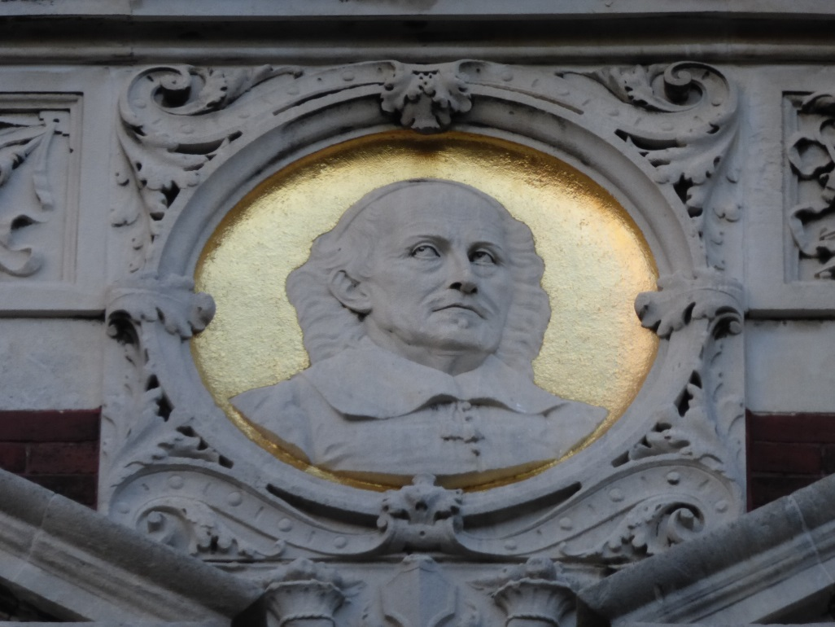
Depiction of Voetius on the Academy Building of the University of Utrecht
To stay with the reaction from Utrecht: Voetius published his theses more than once, and had them translated and published before the end of 1669 in Amsterdam. The Utrecht church council wrote a letter to Van Schurman reproaching her for recruiting among its members; the Utrecht minister Cornelis Gentman published his ‘Bedenckingen over de Kerkscheuringe’ (‘Thoughts on division of the Church’); Lodenstein apparently wrote her a fatherly letter (not yet found). Petrus Montanus joined in as well. His work Ernstige op-weckinge om te yveren voor het Huys des Heeren (Earnest inducement to strive for the House of the Lord (1670)) also contains warnings against false spirits which were omnipresent. His criticism of the Labadists becomes clear from the following statement:
Van eenige jaren af is ten selven eynde van andere plaetsen veler ooghe op Utrecht gheweest/ alwaer sich een deure der hope scheen open te doen tot meerder verbetering der zeden/ en bijgevolge van daer yet bijsonders ten besten van Godts huys verwaghtende. Maer (God betert!) ’t goede werck is als in den geboorte blijven staen/ en in plaetse van te vorderen/ schijnt men nu veel verachtert te sijn.
[In this regard during the past few years all eyes have been on Utrecht, where a door of hope seemed to open to an increased realisation of morals, and consequently raising the expectation of something special happening there to the glory of God’s house. But (may God improve on this) the good work has been stalled as if in its birth, and instead of having progressed it seems matters have been stunted.]

Nachleben
What did Petrus Montanus do with the letter? In any case he did not destroy it, but kept it safe. But how and when and via which ways it became part of the collection of the Germanisches Nationalmuseum in Nuremberg is completely unclear. The letter was never allotted an accession number and its provenance is thus unknown. This course of events leads to speculations such as ‘robbed’, ‘stolen’ ‘donated’, ‘found’ or ‘bought’; but no evidence for any of this could be found, and thus my pen finds its limit here.

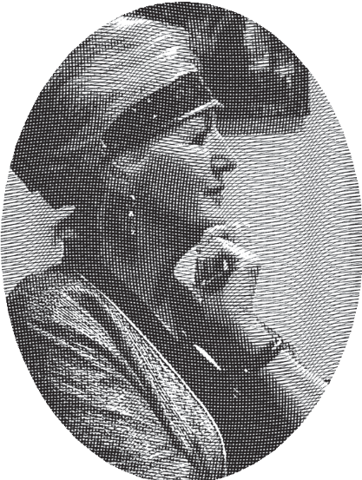
Curriculum vitae
Pieta van Beek (1958) studied Dutch language and literature at the University of Utrecht (MA 1987), Classical Languages (DLitt; Stellenbosch University, 1997) and Ancient Near Eastern Studies (MA cum laude, Stellenbosch University, 2004). She taught Classical Languages as well as Dutch and Afrikaans at schools and universities. In 1997 she was awarded a doctorate with a thesis on Anna Maria van Schurman’s Opuscula Hebraea Graeca Latina et Gallica, prosaica et metrica. In 2004 she published De eerste studente: Anna Maria van Schurman (1636), in 2010 translated as The first female university student: Anna Maria van Schurman (1636) (available in digital form at http://igitur-books.library.uu.nl/bookdetails.php?bookid=022). She is a research associate at both the University of Utrecht and Stellenbosch University, South Africa. With Dineke Ehlers she co-authored Oranje Boven: Nederlands voor Zuid-Afrika (2004, 2007); with Annemarié van Niekerk she co-authored a comprehensive anthology of writings by forgotten women writers of South Africa who wrote in Dutch/Afrikaans. She has lectured on the Dutch poet Ida Gerhardt at the HOVO of the Erasmus University in Rotterdam as well as the Radboud University in Nijmegen.

For a list of her publications on Anna Maria van Schurman, forgotten South African women writers writing in Dutch/Afrikaans and on Ida Gerhardt, see the following:

www.annamariavanschurman.org
http://www.uu.nl/medewerkers/PvanBeek/0
http://www.stellenboschwriters.com/vbeekp.html

Published in this series:
Schurmanniana Series no. 1
Pieta van Beek, ‘Over God’: een onbekend florilegium van Anna Maria van Schurman (ca. 1625). Ridderkerk: Provily Press, 2013.
Schurmanniana Series no. I (English version)
Pieta van Beek, ‘On God’: An unknown florilegium by Anna Maria van Schurman (ca. 1625). Ridderkerk, Provily Press, 2014 (translated by Dineke Ehlers)

Schurmanniana Series no. 2:
Pieta van Beek, ‘Uw lieftalige brief’: een onbekende brief van Anna Maria van Schurman aan Johannes Vollenhove. Ridderkerk: Provily Pers, 2014.
Schurmanniana Series no. II (English version)
Pieta van Beek,‘Your charming letter’: An unknown letter by Anna Maria van Schurman to Johannes Vollenhove. Ridderkerk: Provily Press, 2022 (translated by Dineke Ehlers)

Financial support
If you are interested in financially supporting the work of making accessible the work of Anna Maria van Schurman, please send an e-mail to p.vanbeek@uu.nl

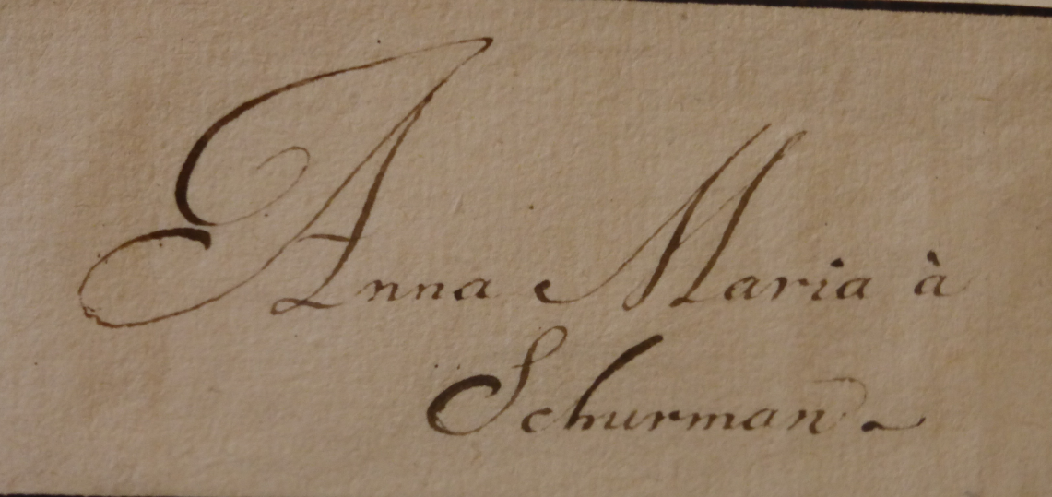

Endnotes

Pieta van Beek, The first female university student: Anna Maria van Schurman (1636). Utrecht: Igitur, 2010. Available at http://dspace.library.uu.nl/handle/1874/235540 (3rd improved digital edition; English translation of De eerste studente: Anna Maria van Schurman (1636). Utrecht: Matrijs en Utrecht Universiteit, 2004, 2007 (2nd ed.); idem, ‘Anna Maria van Schurman’ in: Encyclopaedia Aethiopica, ed. Siegbert Uhlig, Volume 4. Wiesbaden, Harrasowitz, 2010: 578-579. idem, ‘Habent sua fata libelli’: The influence and adventures of Anna Maria van Schurman’s work in Scandinavia’ in: Acta Conventus Neo–Latini Upsaliensis, ed. A. Steiner-Weber. Leiden/Boston: Brill, 2013: 199-209; idem, ‘Anna Maria van Schurman’ in The Oxford Guide to the Historical Reception of Augustine, ed. Karla Pollmann, Willemijn Otten et al., Volume 3. Oxford: Oxford University Press, 2013: 1704-1706; idem,‘Over God’. Een onbekend florilegium van Anna Maria van Schurman (ca. 1625). Ridderkerk, Provily Pers, 2013; idem, ‘On God’: An unknown florilegium by Anna Maria van Schurman (ca. 1625). Ridderkerk: Provily Pers, 2014; idem, ‘Anna Maria van Schurman, de Europese Pallas van Wijsheid’ in: Groniek.Vrouwen vechten tegen de norm (198) 2014: 35-47; idem, ‘“Het is dezelfde geest waardoor ik leef en ademhaal”: de spiritualiteit van Anna Maria van Schurman (1607-1678)’ in: Ora et Labora. Veertien opstellen over christelijke spiritualiteit in de praktijk, ed. Jaap van Amersfoort, Pieta van Beek en Gerrit Schutte. Hilversum:Verloren, 2014: 45-62; idem, ‘Your charming letter’: An unknown letter by Anna Maria van Schurman aan Johannes Vollenhove (1668). Ridderkerk: Provily Press, 2014; ‘Ὥς ῥοδον ἐν ἀκανθαις’ ‘As a rose among the thorns’: Anna Maria van Schurman and her correspondence in Greek’ in: Humanist Greek in Early Modern Europe. Learned Communities between Antiquity and Contemporary Culture. Acta Societatis Morgensternianae, eds Janika Päll and Ivo Volt, Vol. 6-7. Tartu: University Press, 2015. For all other, most recent and ad fontes publications on Van Schurman, see www.annamariavanschurman.org.
‘Of the Dutch, honour the Pallas with the virginal face and the Batavian goddess who is even more sparkling in her fame [than Pallas]. We also bring forth Praxillas and Roman names such as Cornelia, the mother of the Gracchi brothers, as in the Netherlands we bring forth the face of a virgin. When in world history female miracles are lauded, then you, the Netherlands, should remember ANNA.’ Thanks to Dr O. Plassmann for the Dutch translation.
A.M. van Schurman, Opuscula Hebraea Graeca Latina et Gallica, prosaica et metrica. Trajecti ad Rhenum: Johannis à Waesberge, 1652: 303-304; 340; R. Keuchenius, Musae Juveniles. Amstelaedami: Petrum van den Berge, 1662: 128; Pieta van Beek, Klein werk: de Opuscula Hebraea Graeca Latina et Gallica, prosaica et metrica. Stellenbosch, Universiteit van Stellenbosch, 1997: 309-316, available at http://www.dbnl.org/tekst/beek017klei01_01/; Van Beek 2010: 38-41; 127-130.
R. Keuchenius, Musae Juveniles. Amstelaedamia: Petrum van den Bergh, 1662: 128: Cur toties in amore morans, contemnis amantem / Digna toro facies? respice nomen: A.M.A.S / An, quia Virgo Deam redamas tibi Pallada: cujus/Innuba laude viges? respice nomen: A.M.A.S / An, quia Virgo Deum redamas in sanguine Christum / Qui crucifixus amor? respice nomen: A.M.A.S. / Anna fatebor eum quod ames, fas credere, Sponsum:Cur? quia numen amas, non quia nomen amas. Thanks to Dr O. Plassmann.
Joly, who was the chaplain of Anne Genevieve de Bourbon–Condé, laid eyes on this portrait, and also on that of Elisabeth Stuart, during his visit to Van Schurman in 1646. M. Ioly, Voyage fait a Munster en Westphalie, et autres lieux voisins, en 1646 et 1647. Paris: Jean de la Tourette, 1670: 150; Van Beek 2010: 193-195. Until now, the portraits have not been discovered and remain lost.
G.D.J. Schotel, Anna Maria van Schurman. ’s-Hertogenbosch: Muller, 1853: 38.
Rijksmuseum Amsterdam: Rijksprentenkabinet.
Schotel 1853: Aanteekeningen: 44-46; she had been a witness to the baptism of his son Daniël on 17 October 1660, just like her brother Johan Godschalk van Schurman had been for Meijer’s little daughter Maria in Augustus 1658. Regional Archive Schouwen-Duiveland, baptismal register Dreischor.
Aside from academic attention to Anna Maria van Schurman (see e.g. the bibliography in Van Beek 2010, the website www.annamariavanschurman.org) a number of events are also taking place on a creative level. Examples are the tower bell called Anna which was cast in 2010 and which is now installed in the tower of the Academy Building of the University of Utrecht; the beautiful novel La demoiselle savante. Histoire d’Anne Marie de Schurman (1607-1678) by Brigitte Hermann (Paris: Bartillat, 2003); the exhibition ‘Vrouw van de wereld’: Anna Maria van Schurman als internationale ster’ (‘Woman of the world’: Anna Maria van Schurman as international star’) in Museum Martena, Franeker (2007), The exhibition ‘Anna Maria van Schurman, de muze van het noorden’ (‘Anna Maria van Schurman, the muse of the north’) in the village church of Wieuwerd (2007), the solo exhibition by Sabine van den Berg (‘Horen, zien en zwijgen’) as well as by the collective ‘Facit en Anna Maria’ on Anna Maria van Schurman in the Museum Martena (2007); Janny van der Molen wrote a chapter on Van Schurman in Helden: mensen die de wereld mooier maakten (Heroes: People who embellish the world) (Amsterdam: Ploegsma, 2009, in 2015 already in its fourth print run); during the Festival Women INC., 5-6 March 2011 in Amsterdam Anousha Nzume interviewed Pieta van Beek on her book The first female university student: Anna Maria van Schurman (1636); writer Benno Barnard wrote about the work De eerste studente: Anna Maria van Schurman (1636) in his book Dagboek van een landjonker (Amsterdam: Atlas-Contact, 2013); the Australian-German artist-scientist Alex Martinis Roe directed a performance on Anna Maria van Schurman in the Aula of the Universiteit Utrecht and brought out a film about her in 2015; Susanna Honders wrote a youth novel Slimmer dan iedereen (Oosterbeek: Kontrast, 2015).
A.M à Schurman, Eukleria. Volume II. Amstelodami: Jacobum van de Velde, 1685: 35; H. Greebe, ‘Het testament van Anna Maria van Schurman met eenige toelichtingen’ in: Stemmen voor waarheid en vrede (15) 1878: 501-514; J. Hepkema, Wiewerd en zijn historie. De merkwaardige grafkelder. De geschiedenis der Labadisten. Het leven van Anna Maria van Schurman. Wiewerd, 1977.
This section is mainly based on the Latin letters written by Petrus Montanus to Johann Heinrich Hottinger, which are held in Zürich in the Zentralbibliothek and which date from 1653-1666 (Ms-F-051, Ms-F-066, Ms-F-071, Ms-F-084, Ms F-085); also on Petrus Montanus, Ernstige op-weckinge om te ijveren voor ‘t Huys des Heeren bysonderlijck nodigh in dese laetste verdorven tijden over de woorden Psalm 69:10. Den ijver van u huis heeft mij verteert. Utrecht: Henricus Versteegh, 1670; furthermore Melchior Veeris and Franciscus de Paauw, Vernieuwt kerkelyk Alphabeth. Enkhuyzen: Meinard Semeins, 1750: 144; A.C. Duker, Gisbertus Voetius. Three volumes. Reprint of 1897-1915. Leiden: Groen, 1989, passim; D. Nauta, ‘Petrus Montanus’ in: Biografisch Lexicon voor de geschiedenis van het Nederlands protestantisme. Volume 2. Kampen: Kok, 1983: 335.
Included in: G. Voetius, Selectarum Disputationum Theologicarum. Pars Secunda. Ultrajecti: Johannes à Waesberge, 1655: 228-238; this book was dedicated to Anna Maria and Johan Godschalk van Schurman after they returned from Cologne. In addition to Petrus Montanus, another four students held a disputation presided over by Voetius on the same topic De Merito Christi, namely Nicolaas Backer, Andreas Posthumus, Petrus van der Burcht and Abraham Migrodius (pp. 238-286).
R. Löhr and J.P. van Dooren, Protokolle der Niederländisch Reformierten Gemeinde in Köln von 1651-1803. I. Köln: Rheinland Verlag, 1971: 24.
Rudolf Löhr, Die Protokolle der drei heimlichen reformierten Gemeinden zu Köln 1602-1621. Köln: Presbyterium der Evangelische Gemeinde Köln, 1974; Rudolf Löhr, Protokolle der Wallonischen Gemeinde in Köln von 1600-1776. Köln: Rheinland Verlag 1975. Rudolf Löhr, Protokolle der Hoch-Deutsch-Reformierten Gemeinde in Köln von 1599-1794. Köln: Rheinland Verlag, 1976; see also Löhr and Van Dooren 1971:36-37.
Löhr and Van Dooren 1971: 85.
Löhr and Van Dooren 1971: 183.
Löhr and van Dooren 1971: 183, 185, 248, 285, 354.
Löhr and Van Dooren 1971: 81, 153, 154, 276-279, 287, 347, 354.
Het Utrechts Archief, 711.5 NH baptisms 1651-1665, p. 503; 711.6 NH baptisms 1665-1680, pp. 27, 77, 126.
Het Utrechts Archief, Notarissen van de stad Utrecht, 34-4 U059a003, d.d. 19-12-1673.
Löhr and Van Dooren 1971: 310 (12 juni 1673).
Johanni Voeti, Oratio Funebris in Obitum Reverendi Clarissimi ac Celeberrimi VIRI Andrea Essenii. Ultrajecti: Meinardi a Dreunen, 1677: 29-30.
Letter to Hottinger, dated 15 March 1666, Ms. 084.
G. Voetius, Politica Ecclesiastica. Volume III. Amsterdam: Johannes à Waesberge, 1676.
Cornelis Gentman, Allon bachuth, of lijck-predikatie, over de dood van den hoog-beroemden heere Gisbertus Voetius, Utrecht: Meinardus van Dreunen and Willem Clerck, 1677; Duker: 1989, Volume III: 344.
The poem was published for the first time in: Andreas Essenius, Gisbertus Voetius: sive Oratio Funebris. Ultrajecti: Meinardus a Dreunen, 1677: 4: Hic parvâ tegitur GISBERTUS VOETIUS urnâ / Ingeniô magnus, corpore parvus erat. / Exiguum corpus parvâ consumitur urnâ / Gaudet at AEtheriis Spiritus ille locis/ Venerando quondam Praeceptori et Postea Collegae in S. Minist. Moestus posuit PETRUS MONTANUS.
Gentman 1677: 30; see also Essenius 1677: 41-42.
The abbreviations have been written in full. The letter has been cropped a little too short on the right-hand side; therefor full stops were added at the end of lines.
T.J. Saxby, Jean de Labadie and the Labadists: The quest for the New Jerusalem. Dordrecht-London/Lancaster: Kluwer Academic Publishers, 1987; H.J. Meijerink, Reformatie en mystiek: Over Jean de Labadie en het Labadisme. Goes: Oosterbaan & Le Cointre, 1956.
A.M. van Schurman, Eucleria of Uitkiezing van het Beste Deel. Amsterdam: Van der Velde, 1684: 244-245, 247, 251; Saxby 1987: 173-192; Mirjam de Baar, ‘En onder ’t hennerot het haantje zoekt te blijven’: de betrokkenheid van vrouwen bij het huisgezin van Jean de Labadie (1669-1732) in: Vrouwenlevens 1500-1850. Jaarboek voor vrouwengeschiedenis. (8) 1988: 11-43.
Pieta van Beek, ‘Voetius en zijn Afgodinne Anna Maria van Schurman’ in: Historica (32): 24-26; idem ‘Liever een maagd dan een weduwe’: twee Latijnse erotische gedichten op naam van Anna Maria van Schurman’ in: Tydskrif vir Geesteswetenskappe (49) 2009: 333-349; Van Beek 2010: 26, 38, 41.
Van Beek 2004: 218.
Van Beek 1992: 132-136;146-158; F.A. van Lieburg, De Nadere Reformatie in Utrecht ten tijde van Voetius: Sporen in de gereformeerde kerkeraadsacta. Rotterdam: Lindenberg, 1989: 126-127.
Saxby 1987: 176.
Pieta van Beek, ‘Ardens martyrii desiderium’: on the Martyrdom of Anna Maria van Schurman (1607-1678) in: The Low Countries as a Crossroads of Religious Beliefs. Intersections. Leiden: Brill: 247-265; Van Beek 2010: 222-228.
Van Beek 1992: 126-131.
Van Schurman 1684: 8. The original letter is still lost; a reprint of a part of the letter is found in F.S. Collegium de Propaganda Fide. Hammonae: Bernhardi Wolphardt, 1668: 24-26.
Van Beek 1992: 85.
Van Beek 1992: 91, lines 225-229.
Van Schurman 1669: 183-184.
Van Beek 1992: 148.
Van Beek 1992: 66-81;139-140.
MS. F-01: p.793, 25 August 1654.
Saxby 1987: 171, 175-176.
Saxby 1987: 148-149.
In passing I bring to the attention that a similar change can be detected in letters from Petrus Montanus to Hottinger: from ‘Venerande en celeberrime Vir’ to ‘Salutem et pacem à Dominô qui pax nostra’. See MS-F-084, p. 344.
Van Beek 1992: 145; Van Beek 2013: 18.
C. van de Ketterij, De weg in woorden: een systematische beschrijving van piëtistisch woordgebruik na 1900. Assen: Van Gorcum, 1972: 171-173 ; Personal e-mail from Prof Dr W. Op ’t Hof dated 13 February 2015.
Bo Karen Lee, ‘“I wish to be nothing”: The role of self-denial in the mystical theology of Anna Maria van Schurman’ in: Women, Gender and Radical Religion in Early Modern Europe, ed. Sylvia Brown. Leiden/Boston: Brill, 2007: 189-216.
Van Beek 1992: 75.
A. de Reuver, Verborgen omgang: sporen van spiritualiteit in Middeleeuwen en Nadere Reformatie. Zoetermeer: Boekencentrum, 2002.
Van Beek 1992: 103, lines 155-156.
Van Beek 1992: 93-121.
Nadine Akkerman and Jana Dambrogio produced several videos an this topic. See http://techtv.mit.edu/collections/letterlocking as well as https://www.huygens.knaw.nl/letterlocking/.
Van Schurman 1684: 243, 245.
Van Beek 2004: 216-220.
We know of Lodenstein that his heart was longing for a pure and true church. He did not join the Labadists himself; however, he evaded to take his turn to deliver the sermon at the threemonthly Lord’s Supper (see Van Lieburg 1989: 136-137; Gisbertus Voetius, ‘Godts-geleerde Vragen, en Antwoorden Wegens de Scheydingen, en Afwijckingen, van de Kercken. Verhandelt door de Heer Gisbertus Voetius, der H. Theologie Doctor en Professor, in de vermaerde Academie, en wackeren Herder van de Kercke tot Utrecht. Getrouwelijck uyt het Latijn overgeset. Amsterdam: Abraham van Blancken, 1669; letter of the church council dated 18 July 1670 to Anna Maria van Schurman: ‘Alsoo u edele voor eenige maenden van ons is vertrocken, ende sich tot Amsterdam heeft neergeslagen ten huyse van monsieur De Labadie [...] ende dat ons stercke geruchten voorcomen dat u edele verscheyden personen tot de gemeynschap van de particuliere ende separate vergaderingen en diensten die bij de voornoemde heer De Labadie tegen alle ordre worden aengerecht, soude hebben getracht te induceren’ (‘Since you have left us a few months ago, and have travelled to Amsterdam to the house of Mr De Labadie […] and since we have heard strong rumours that you have tried to induce several persons to attend the community’s specific and separate meetings and services held by the aforementioned Mr De Labadie which are out of order’), cited in Van Lieburg 1987:125.
Montanus 1670: 36.
Elisabeth Liedke from the Germanisches Nationalmuseum wrote the following to me on 16 December 2014: ‘Dear Dr. van Beek, I am sorry to tell you that there is no accession number known for the letter by Anna Maria van Schurman. So we can’t look up how the museum received it. With best regards.’ Van Beek 1992: 121.

